Tabla de contenido

Module 2: Auto-Regressive and Moving Average Model 2

Module 2 Road Map 2

2.1: Introductory Concepts and Definitions 4

2.1.1 Basic Concepts 4

2.1.2 Basic Concepts: ARMA Simulation 7

2.1.3 Causal and Invertible Processes 12

2.1.4 Autocovariance and Partial Autocorrelation Function 16

2.2: Model Estimation 26

2.2.1(6) Parameter Estimation 26

2.2.2(7) Parameter Estimation: Simulation Example 30

2.2.3(8) Parameter Estimation: Maximum Likelihood Estimation 35

2.2.4(9) Order Selection & Residual Analysis 39

2.2.5(10) ARMA Modeling: Data Example 45

2.3: Other Models 53

2.3.1(11) Other ARMA Models 53

2.3.2(12) ARIMA Modeling: Data Example 57

# Module 2: Auto-Regressive and Moving Average Model

Module 2 Road Map   
*This lesson is an overview of the content covered in the second module of the Time series Course.*

**Course Road Map**

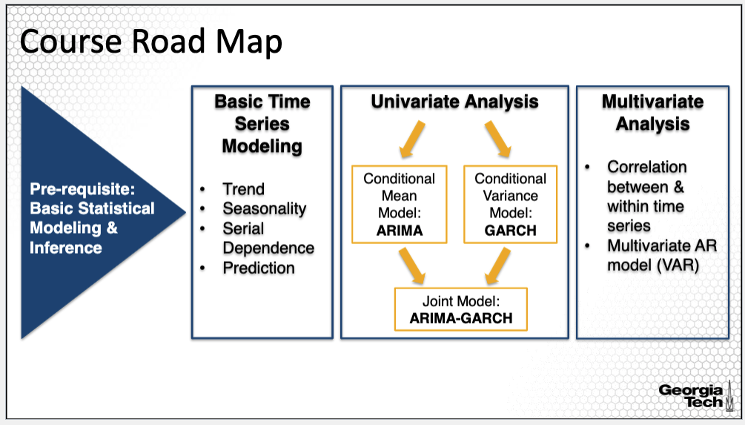

This course roadmap displays the material covered in the course starting with the pre-requisites needed for a better and deeper understanding of the different time series models introduced in this course. The course beings with basic concepts of time series analysis including trend and seasonality analysis as well as an understanding of the dependence in a time series. The rest of the course follows in presenting three main modeling approaches commonly employed in time series analysis; they are the ARMA, GARCH and VAR models. I will provide a more detailed reference on these models next.

**Course Road Map: Univariate Analysis**

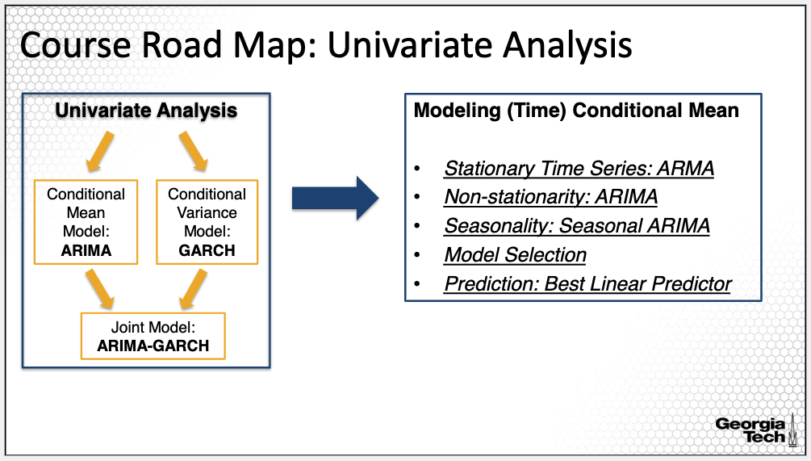

We will continue with modeling approaches for analyzing univariate time series; that is, analyzing one time series in isolation of any other exogeneous factors. We will differentiate between modeling the mean or the variance; more specifically, conditional mean and conditional variance since they depend on past data. One set of models will be developed for the conditional mean and another for the conditional variance.

Module 2 introduces one of the most common modeling approaches for time series analysis, specifically, the so called ARMA models; ARMA stands for Autoregressive Moving Average. ARMA models apply to stationary processes. However, we can extend the ARMA model to apply to non-stationary time series by applying differencing, a common approach used when a time series is non-stationary due to trend and seasonality. The resulting model is ARIMA, which stands for Integrated ARMA. If there is also seasonality in the time series, we can go one step further to the Seasonal ARIMA. Because the ARMA models are linear models, again we will apply the best linear predictor to obtain predictions for future data.

**ARMA Models**

What will this module cover? In the first part of this module, I will cover the fundamentals of the ARMA modeling, such as the decomposition of ARMA into the AR or Autoregressive component and the MA or Moving Average component. With that, you will learn about dependence in a time series measured by the auto-covariance and auto-correlation under an ARMA model. Last, you will learn about two important characteristics, causality and invertability.

The fundamentals of ARMA modeling are the grounding of many time series models, including GARCH and VAR models.

**ARMA Models (cont’d)**

I will next move onto ARMA model estimation, introducing multiple methods, including methods of moments as well maximum likelihood estimation. I will also illustrate how the autoregressive model can reduce to a linear regression model. For the fitting of an ARMA model, we also need to perform model selection and to evaluate the model. Last, I will describe the prediction approach using an ARMA model.

ARMA estimation and inference is used in model interpretation and evaluation hence it is important to understand those concepts.

**ARMA Models (cont’d)**

The basic ARMA model applies to stationary time series. What can we do if we have non-stationary time series? We can remove the trend and seasonality and then analyze the residual process using the ARMA process. But we can also use an extension of the ARMA model that applies to non-stationary time series called ARIMA or integrated ARMA. Further I will describe another extension the Seasonal ARMA that extends the ARMA to seasonal time series.

Because ARMA and its extensions apply to stationary and non-stationary time series, ARMA models can be applied broadly to many time series with various characteristics.

**Data Examples using R Statistical Software**

Throughout this module we will also experiment the main concepts using three data examples. In these examples, we will analyze the daily patient volume in the emergency department in a hospital over a period of five years, focusing on the trend and seasonality estimation as well as prediction, useful in staffing and management. A second example is the analysis of the IBM stock price; IBM was selected to be analyzed since it has been around for more than 50 years. Last, we will explore in detail the U.S. Fuel Consumption as proxy of energy consumption over 15 years of data. We will analyze these three data examples using the R statistical software. We will perform exploratory data analysis using visual analytics, we will evaluate the goodness of fit and the performance of the ARMA fit and we will use the ARMA model for predictions.

It is important to practice with real data examples because fundamentals of time series modeling are best understood by illustrating them using data examples.

**Summary:**

This lesson overviewed the main topics covered in Module 2. Let’s now begin with the lessons overviewing the main concepts of ARMA.

## 2.1: Introductory Concepts and Definitions

### 2.1.1 Basic Concepts

*In this lesson, I'll introduce one of the most useful time series models, the ARMA model, which is the basis of all the models introduced in this course.*

**Formal Definition**

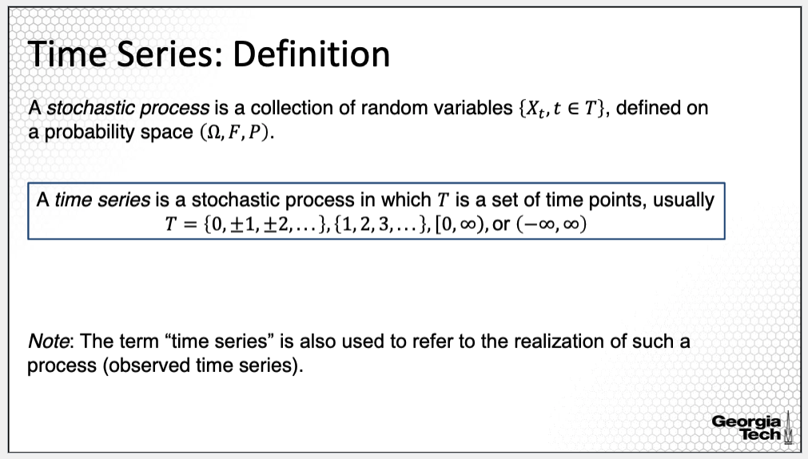

Let's recall the definition of a time series: It is a sequence or collection of random variables with some similarity in terms of the probability distribution, called a stochastic process. For a time series, the sequence of random variables is indexed by time and observed sequentially over fixed time intervals. We commonly refer to a time series as both the stochastic process from which you observe, and the realizations or observations from the stochastic process. It's important to highlight that the time series data are observations in practice, and thus come with uncertainty.

**Time Series: Stationarity**

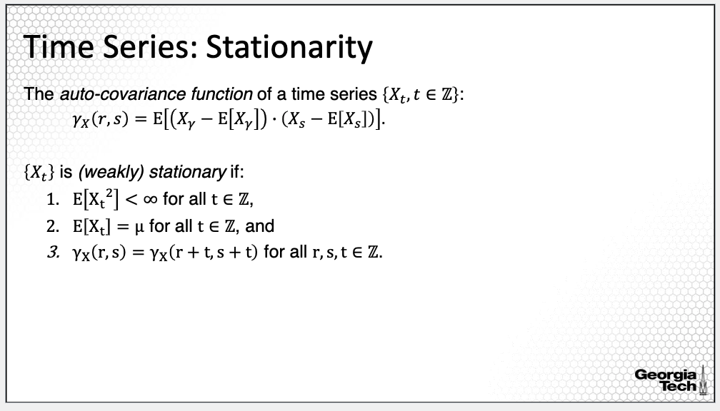

Let's also review important concepts related to the property of stationarity of a times series. The autocovariance function is the covariance of any two variables of the stochastic process. For example, if we consider the time points r and s, the autocovariance of Xr and Xs is the expectation of the product of the mean centered variables Xr and Xs as provided on the slide.

Further, we define the time series Xt to be weakly stationary if**:** it has constant mean for all time points, t; it has a finite variance, or more specifically, has a finite second moment; and the covariance function does not change when shifted in time. That is, the dependence between Xr and Xs is the same as for the shifted Xr + t and Xs + t. Note that I call it weakly stationary since the conditions are first & second-order properties of the distribution, referring to the mean, variance and serial correlation. As we will see later in this course, it is possible to have a weakly stationary time series with higher moments changing over time. Thus, there is also a concept of strict stationarity reserved for more rigorous conditions.

**ARMA Model: Definition**

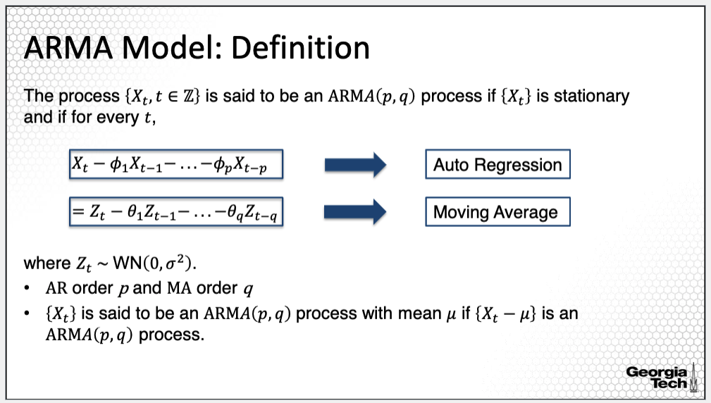

The model introduced in this lecture is the Autoregressive and Moving-Average Model, briefly referred to as ARMA. A time series is an ARMA process if 1. it is stationary *and* 2. for every time t, it is modeled as on this slide. The model consists of two parts.

The first, the AR or Auto Regressive part, modeling the relationship between Xt and past or lagged variables Xt-1, Xt-2 up to Xt-p. For example, if we observe a high GDP this quarter, we would expect that the GDP in the next few quarters are high as well. In this AR formulation, p is called the auto regressive order of the model. This first part is an intuitive way to model a time series based on past data.

The second is the so-called MA or Moving Average part of the model. Using the MA model, we can model the time series at the time t to not only be affected by the shock of time t, but also the shocks that have taken place before time t. For example, if we observe a negative shock to the economy, say a catastrophic earthquake or a storm or the impact of high transmissibility of a virus, like we had experienced during the covid-19 crisis, then we would expect that its negative effect would affect the economy not only for the time it takes place, but also for the near future. The moving average is a linear combination of white noise. In this formulation, q is called the moving average order of the model.

An ARMA model can include both or just one of the two components. It can simply be an AR process or an MA process. Practically if the AR order p is 0 then we only have an MA process, reversely if the MA order is 0 then we only have an AR process. Last, the ARMA model defined on this slide is for a process or a time series with mean 0. If the mean is mu then practically Xt - mu is an ARMA process as defined on this slide.

**ARMA Model: Notation**

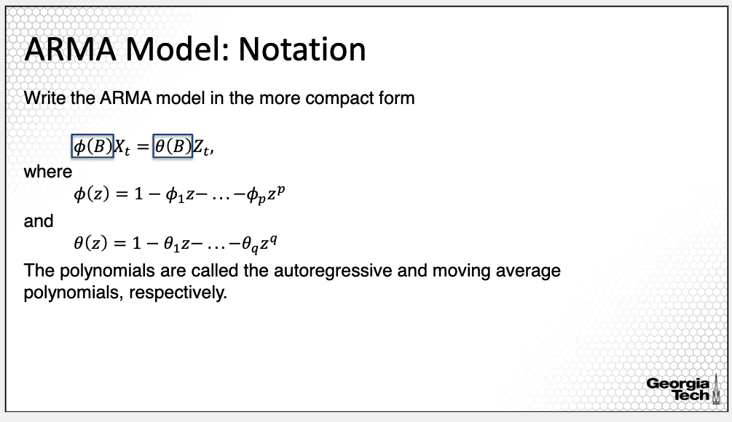

Let's establish important notation used throughout this module. We often write the ARMA model in a more compact form as provided on this slide. That is, we multiply Xt with phi of the operator B, representing the left portion of the model equation. And multiply Zt with the theta of the operator B, representing the right portion of the model equation. The functions phi and theta are defined further, as on the slide.

Phi is a polynomial of order p with coefficients given by the AR portion of the model. This polynomial is called the autoregressive polynomial.

Theta is a polynomial of order q with coefficients given by the MA portion of the model. The polynomial is called the moving average polynomial. The operator B in both polynomials is the so-called lag operator. When this operator is applied to Xt, we move the index of Xt back one time unit giving Xt-1. When applied multiple times to Xt, for example, k times, we move the index back k units, given Xt-k.

**ARMA Model: General**

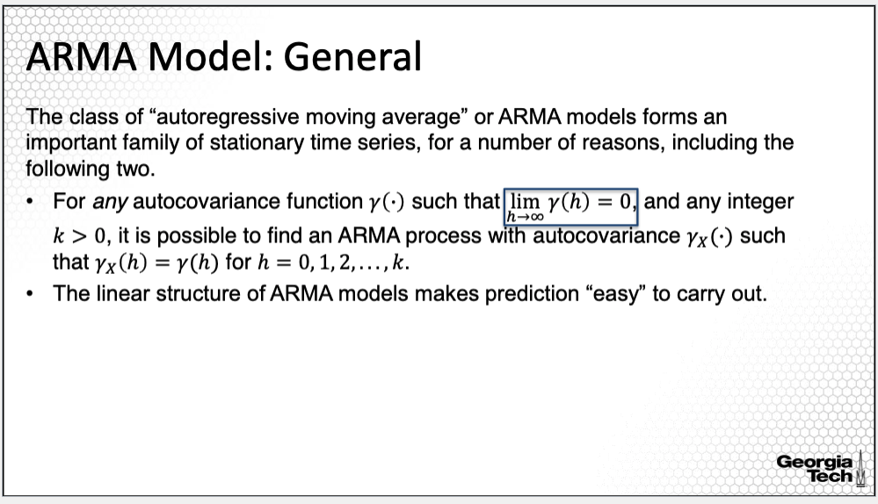

ARMA models are at the core of modeling time series for a series of reasons. First, recall that we defined the autocovariance function for a stationary process depending only on the shifting h lag. We'll continue to use this definition for an ARMA process.

The condition here that the covariance function decreases as we increase the lag h means that the dependence in a time series becomes smaller and smaller as we increase the lag between two time points of the time series. If this condition holds, then it is possible to find an ARMA process with the same autocovariance function. That is, there exists an ARMA process for any autocovariance function with this property.

A second important property of an ARMA process is that the linear structure for ARMA models makes prediction easy to carry out.

**Summary:**

In this lesson, I introduced one of the most important models in time series modeling, the ARMA model.

### 2.1.2 Basic Concepts: ARMA Simulation

*In this lesson, I will illustrate the ARMA model along with the corresponding estimated covariance function using a simulation study.*

**White Noise Process**

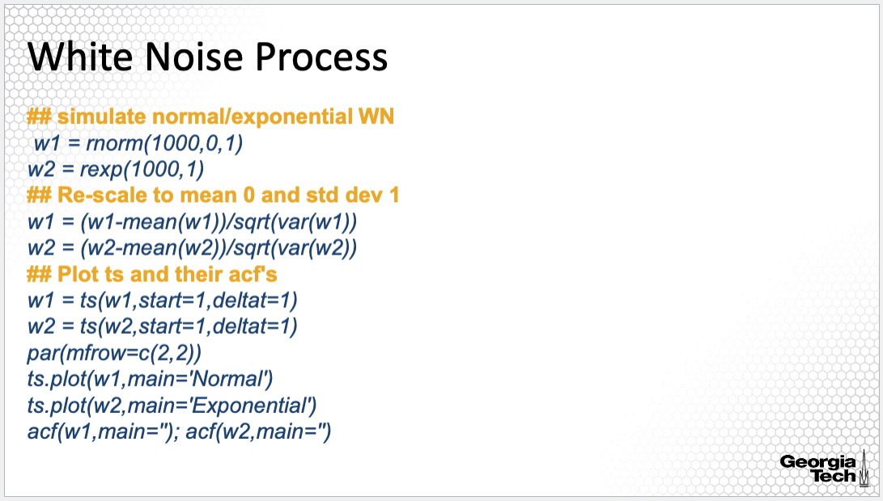

Let’s begin with the simplest ARMA process, the white noise process, which consist of a sequence of uncorrelated, random variables with equal mean, and equal variance. Note that the distribution of the random variables does not need to be normal. In fact, I simulated here in the example on the slide, a white noise with the random variables having a normal distribution and an exponential distribution. In this R code, w1 is a vector of randomly sampled, normally distributed variables with mean 0 and variance 1 of length 1000. And w2 is a vector of randomly-sampled exponentially distributed variables with rate 1 of length 1,000. I re-scaled both vectors to have to mean 0 and std dev 1 for comparison. I also converted the vectors w1 and w2 into time series using the ts() R command. Last, I plotted the time series w1 and w2 along with the plot of the sample autocorrelation functions.

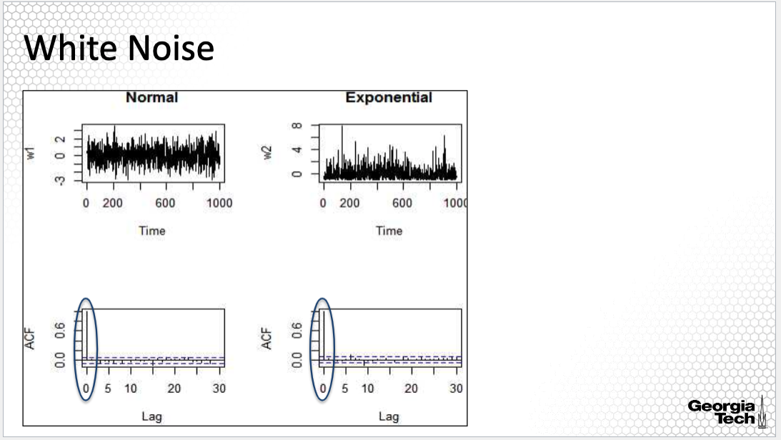

Here are the plots, the upper plots are the time series for normal on the left and exponential on the right. We do see a difference on how the observations of the two times series vary over time. For the normal distribution, they vary around zero quite symmetrically, while for exponential the distribution, the distribution of the residuals lacks in the symmetry we see for the normal distribution. But as explained before, both are white noise processes. The bottom plots are the sample autocorrelation functions. An autocorrelation function plot is a bar plot, where each bar corresponds to one lag h starting from 0 to the maximum lag. The height of each bar corresponds to the value of the sample autocorrelation for the corresponding lag. We can also provide similar plots for the sample auto-covariance function where the bars will be the values of the estimated auto-covariance function.

As highlighted in these two plots, we see that the sample autocorrelation is large for lag equal to 0. In fact, it's equal to 1. This means that for these processes the sample auto-covariance is small, approximately 0, for all lags, except for the 0 lag. This aligns with the property of the auto-covariance function of a white noise, which is nonzero at lag 0 and equal to the variance, but is 0 otherwise. The ACF plot of the two simulated processes will be similar for any other white noise process identified, regardless of the data generation process. In fact, we'll seek these characteristics to evaluate whether the process is a white noise or not, as we'll see in many examples in this course.

**MA Processes**

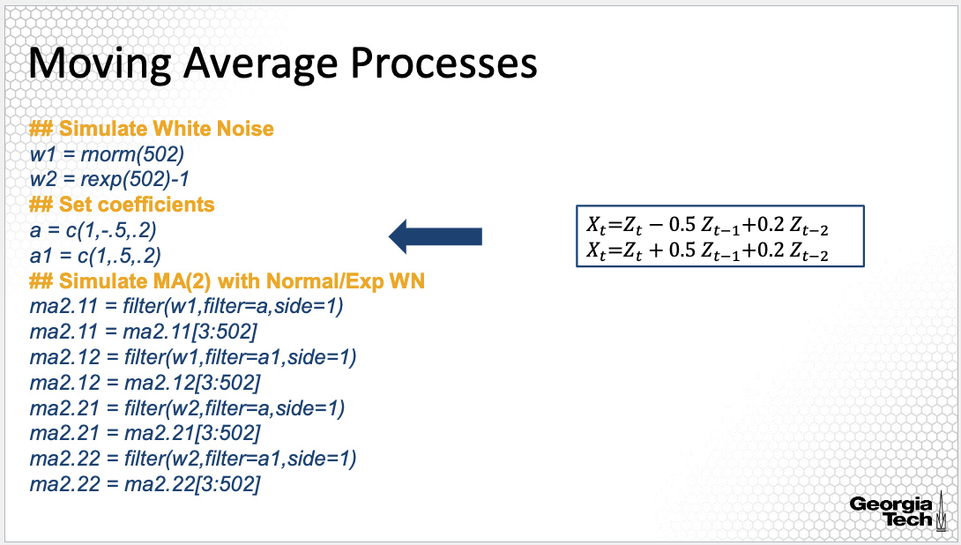

In the next simulation, I simulated again white noise from a normal and an exponential distribution, but this time, the white noise is filtered to obtain a moving average process. The two simulated processes are shown in the box on the right. The first process has coefficients -0.5 and 0.2, whereas for the second process, I changed the first coefficient from -0.5 to 0.5, to see how this change will be reflected in the autocorrelation function.

Next, I use the filter command in R to generate a moving average process given the white noise process as input along with the vector of coefficients and filter equal to a, and side=1, which means that we are generating an MA process. Last, I will only consider the process starting with the third time point since the first two values are lost because we need to generate the process X3 given Z1 and Z2. We apply this procedure to both sets of coefficients and for normal and exponential distributions.

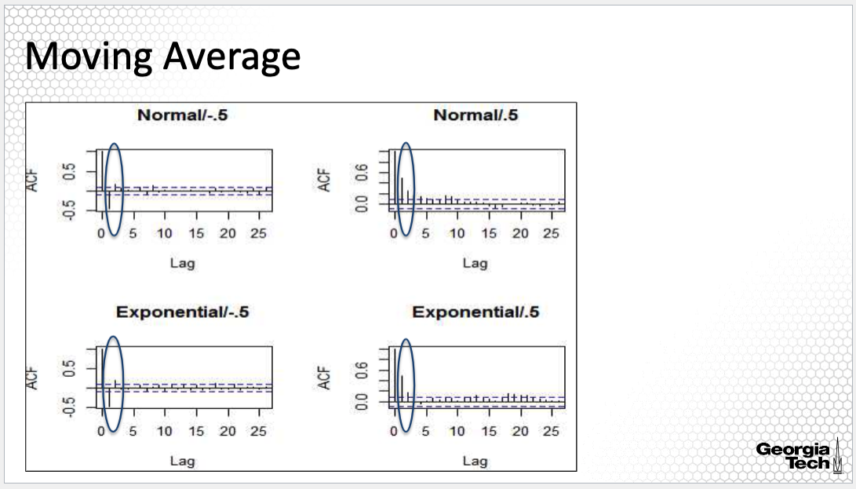

The ACF plots are here. The upper plots are for the normal and the bottom are for the exponential distribution.

Across all ACF plots, we see one important common characteristic. For all of them, the first two values, that is for the first two lags, are large, outside of the confidence band, whereas for other lags the sample autocorrelation is small close to 0. We'll see that this is a characteristic of an MA process. Last, there is a difference between the ACF plots for the two different sets of coefficients. The sample ACF is positive for the lag equal to 1 for the processes with coefficient 0.5 and it is negative for the processes with coefficient -0.5. We also see that the height of the two lags corresponds to the values of the coefficients of the MA processes. Last, from these examples, we see that although Xt is modeled as a moving average model, thus, a linear combination of white noise, the Xt and Xt-1 are still dependent on the sample sequence of white noise. Thus, they are correlated. This correlation is reflected in the ACF plots.

**Moving Average: Non-stationary noise**

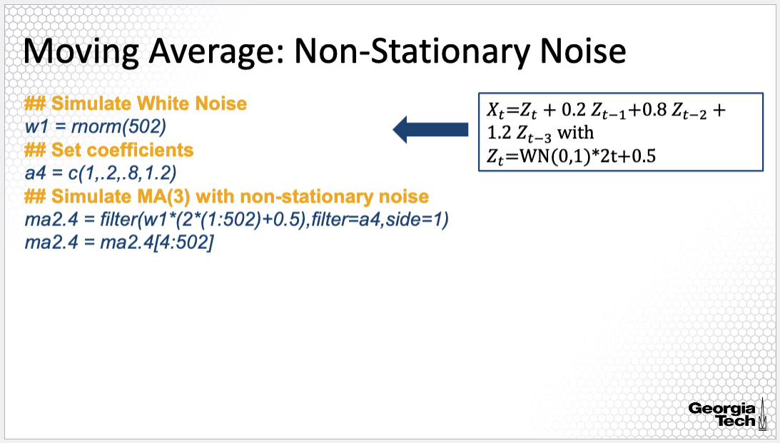

In the next example, we'll take a closer look at an MA process with a non-stationary noise Zt.

We begin by generating the white noise, then we filter a white noise such that it becomes non-stationary.

Specifically, the MA process has coefficients -0.2, 0.8, and 1.2. But the noise is white noise multiplied by 2 times t + 0.5, thus the noise is non-stationary.

The time series plot for this simulated MA process is here. From this plot, we see clearly that the process is non-stationary. Its distribution changes as time shifts. We also note a large variability at the later time points compared to the earlier time points.

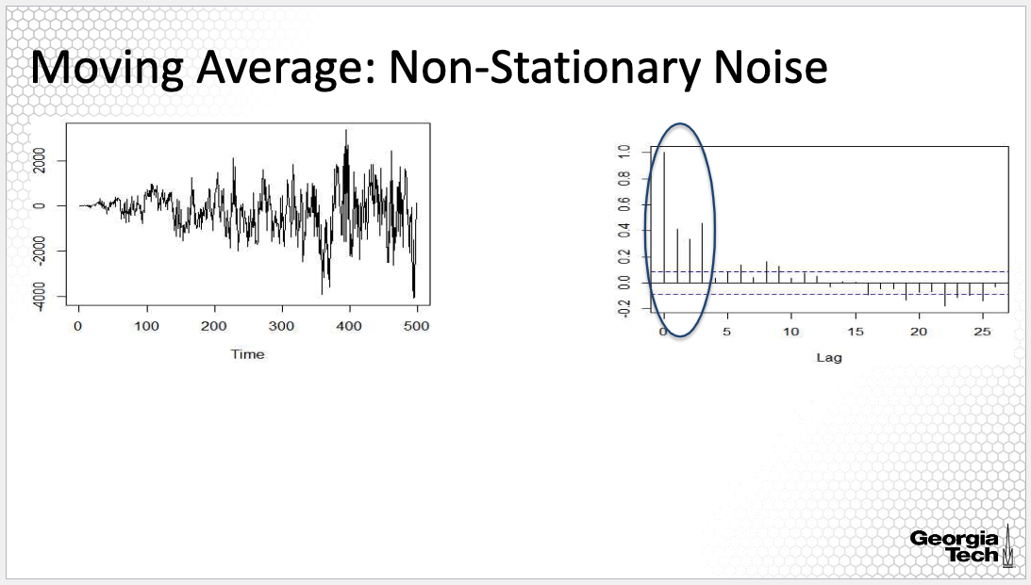

The ACF plot is provided here. The ACF plot does not indicate, however, non-stationarity. In fact, we see that the sample ACF is large for lag 0, 1, 2, and 3, but not for higher lags, which is an indication of an MA process. Thus, the sample ACF plot indicates an MA process of order three even though the noise Zt is non-stationary. This may not be the case for other processes with non-stationary noise.

**Autoregressive Processes**

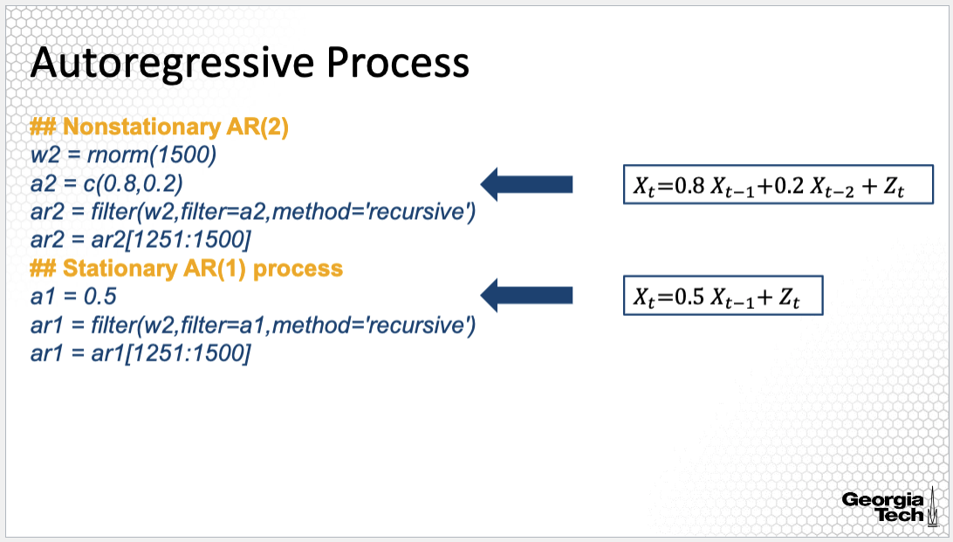

Last, let's take a closer look at Autoregressive processes. Here, I simulated AR processes with lags 1 and 2. To do so, I simulated the white noise first, then applied the filter() R command with a coefficient specified by filter equal to a2 or a1 and method=’recursive’ to specify that we simulate an AR process instead of an MA process. The coefficients of the first process are 0.8 and 0.2 whereas, for the second process the coefficient is 0.5. The AR(2) process is non-stationary whereas the AR(1) process is stationary. We will learn in the next lesson how to evaluate whether an AR process is stationary.

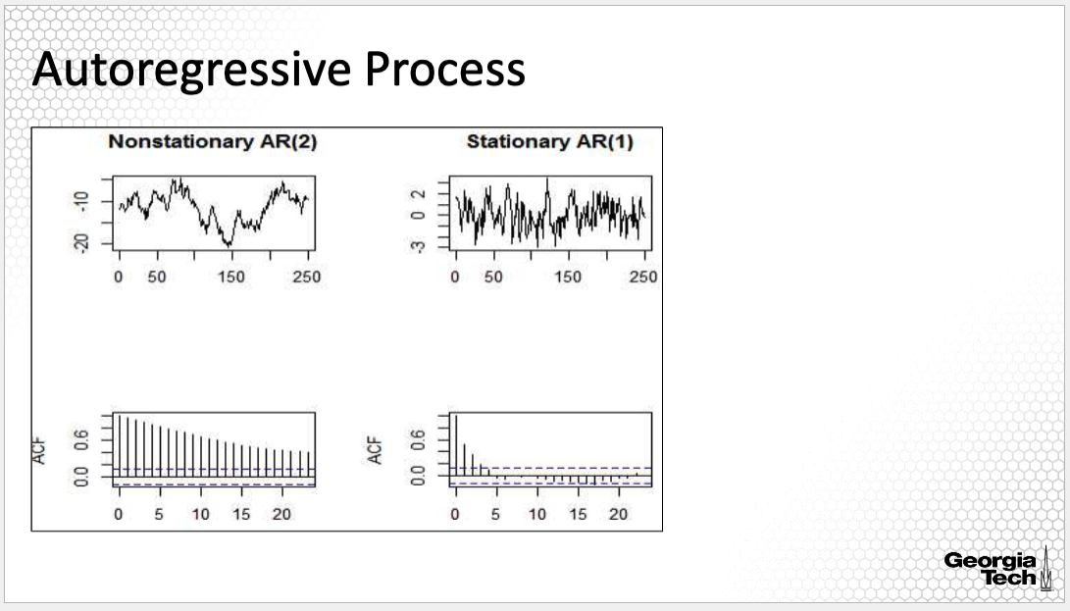

Here are the times series plots for the AR(2) and AR(1), along with their ACF plots. The time series of the non-stationary AR(2) process shows clear non-stationarity, since the distribution of the process changes as time shifts. The ACF plot of the non-stationary process also indicates non-stationarity. When the ACF values decrease slowly as for this AR(2) process, this is an indication of non-stationarity. On the other hand, for the AR(1) process, the sample ACF is large for lag 0, 1, 2, and 3 only. Note that we cannot use ACF plot to identify the lag of the AR process as we did for the MA process. We'll get back to this aspect in a different lesson in this lecture.

**Take Home Points**

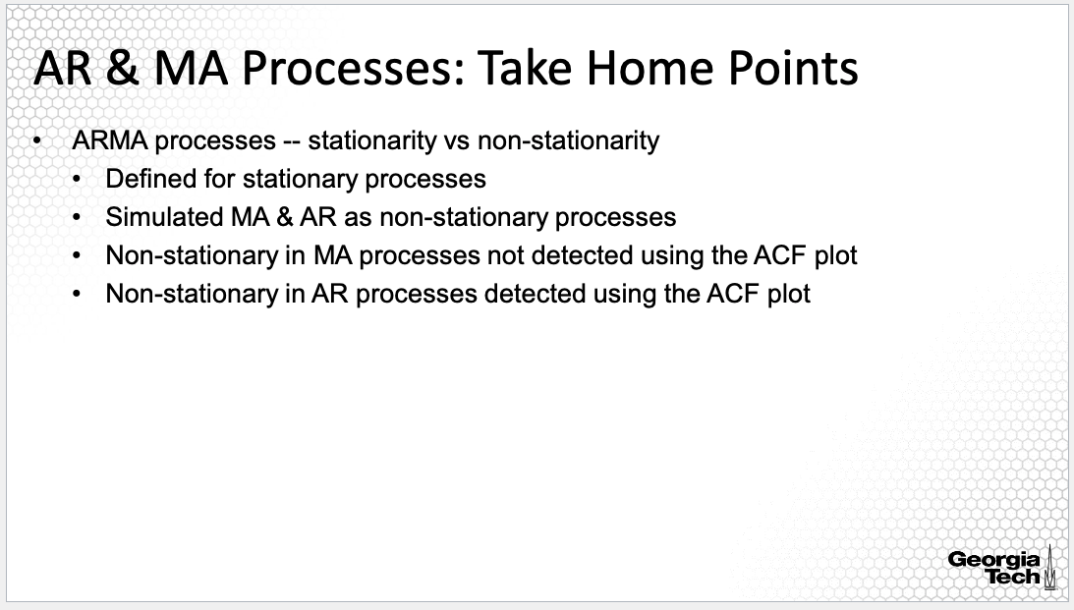

I will highlight here that in the previous lesson, I defined ARMA processes for stationary time series although we saw that we can have MA and AR non-stationary processes as illustrated in the simulations in this lesson. It is important to note that we only are concerned in fitting ARMA models to stationary time series although we can have non-stationary ARMA processes as we will learn in the next lesson. Hence, while ARMA is general, we will only apply ARMA to time series that are stationary, again as I will introduce in the extensions of the ARMA model. Last, we evaluated the ACF plot for both the MA and AR simulated processes; while for AR non-stationary process, we could detect non-stationarity from the ACF plot, it was not the same for the MA non-stationary process, for which we could not detect non-stationarity using the ACF plot. We will learn about a different approach for evaluating serial correlation and stationarity in a different lesson.

**Summary:**

To summarize, in this lesson I illustrated MA and AR processes using a simulation study.

### 2.1.3 Causal and Invertible Processes

In this lesson, I will introduce two important concepts characterizing ARMA processes, the causal and invertible properties of an ARMA process.

**ARMA Model: Notation**

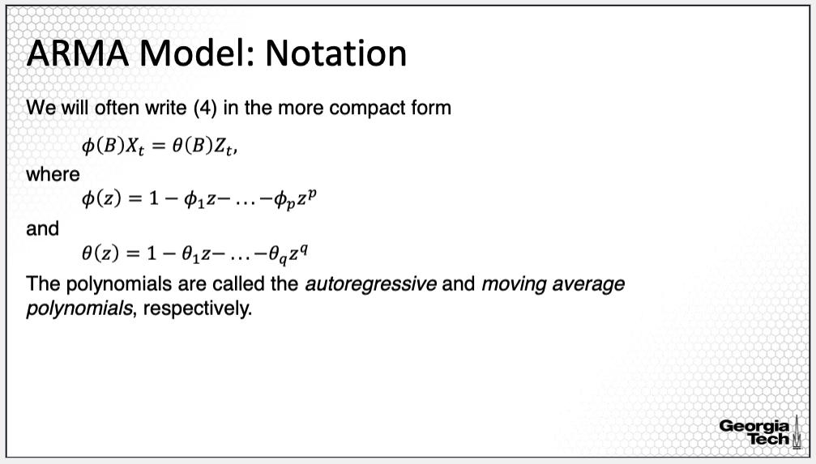

Let’s return to the notation of an ARMA model. We often write the ARMA model in a more compact form as provided on this slide. That is, we multiply Xt with phi of the operator B, representing the left portion of the model equation. And multiply Zt with the theta of the operator B, representing the right portion of the model equation. The functions phi and theta are defined further, as on the slide. Phi is a polynomial of order p with coefficients given by the AR portion of the model. This polynomial is called the autoregressive polynomial. Theta is a polynomial of order q with coefficients given by the MA portion of the model. The polynomial is called the moving average polynomial. The operator B in both polynomials is a so called a lag operator. When this operator is applied to Xt, we move the index of Xt back one time unit giving Xt-1. When applied multiple times to Xt, for example, k times, we move the index back k units, given Xt-k.

**ARMA Model: Stationarity**

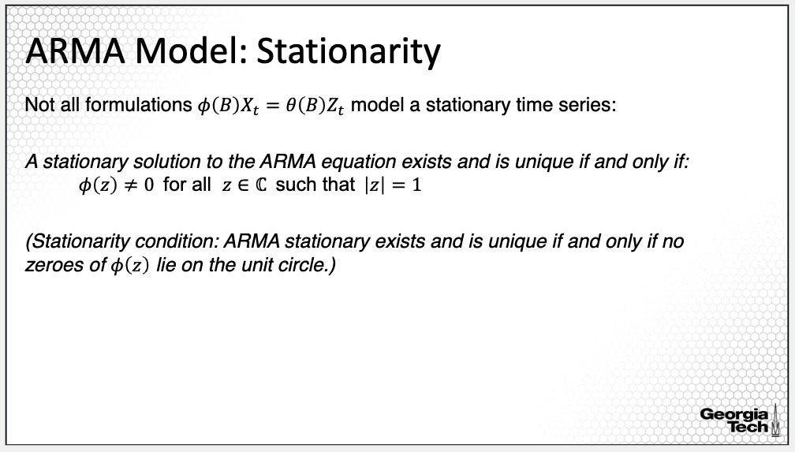

Here, we establish the necessary and sufficient condition for an ARMA model to be stationary. In the previous lesson, I highlighted that not all ARMA model formulations are stationary although we are interested on applying ARMA to stationary processes only. The question we'll address now is: *Is Xt stationary given its representation as an ARMA process.*

*When does the ARMA model generate stationary processes?* As provided on this slide, the stationarity condition only involves the AR polynomial phi; the condition says that the AR polynomial does not have solutions on the unit circle. In other words, the solutions of the polynomial phi(z) are not equal to 1 in absolute value. Thus, for checking whether an ARMA process is stationary, we simply need to get the solutions of the phi polynomial and check whether they are not on the unit circle; if at least one is on the unit circle, then the ARMA process with the specific phi polynomial is not stationary. As a side note, all MA processes are stationary. The stationarity condition will allow us to evaluate whether a fitted ARMA model is stationary. We will revisit this in the next lesson.

**Causal ARMA Model**

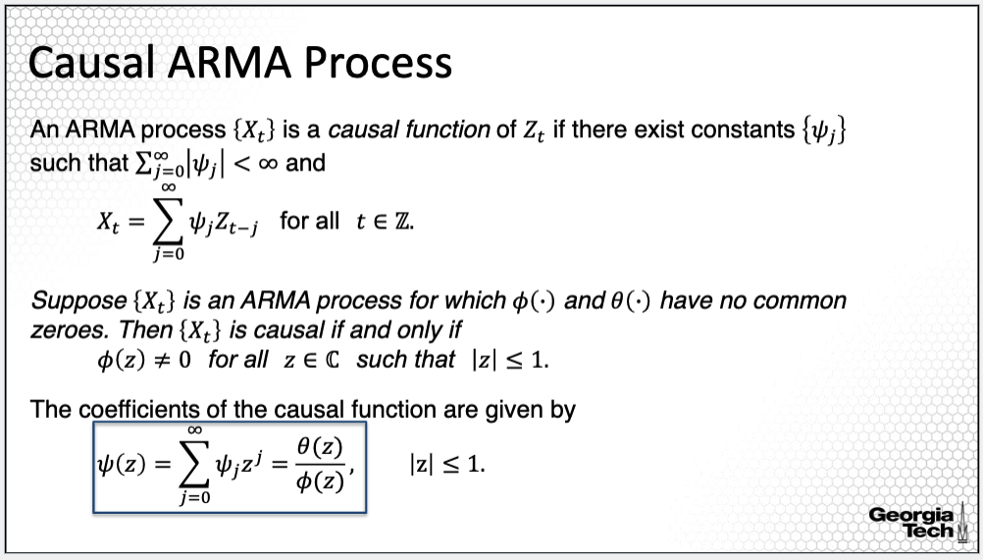

Given a time series model, usually, we can find multiple ways to represent it. Which representation to choose depends on the context of our problem. However, not all ARMA processes can be transformed from one representation to another. In this lesson, we'll consider under what condition we can invert an AR model to an MA model and invert an MA model to an AR model. We begin here with the concept of causal process. The concept of causal process means that we invert an AR or ARMA process into an MA process An ARMA process Xt is causal if we can express it as a linear process in Zt, which is a white noise, such that the sum of absolute values of the coefficients of the linear process is finite, or simply, an MA process. But not all ARMA processes are causal.

How can we evaluate whether an ARMA process is causal? First, we assume that the two polynomials phi and theta do not have any common zeroes. That means the solutions to the equation phi(z)=0 are not equal to the solutions of the polynomial theta(z)=0 0. Then a necessary and sufficient condition for the process Xt to be causal is that the zeroes of the AR polynomial are outside of the unit circle. In other words, we first solve the equation phi(z) equal to 0 to obtain all its solutions then evaluate if any of its solutions in absolute value is smaller or equal than 1. If all solutions in absolute value are larger than 1, then the process is causal. If there is at least one solution in absolute value smaller or equal than 1, then the process is not causal. Note that this condition implies that if a process is causal, it's also stationary but not the reverse. That is, there are stationary ARMA processes which are not causal.

Given the two polynomials of an ARMA process, we can then obtain the coefficients Psi of the linear process representation using this relationship. This relationship will come in handy in the estimation of the ARMA process and in prediction.

**Causal Process: Example**

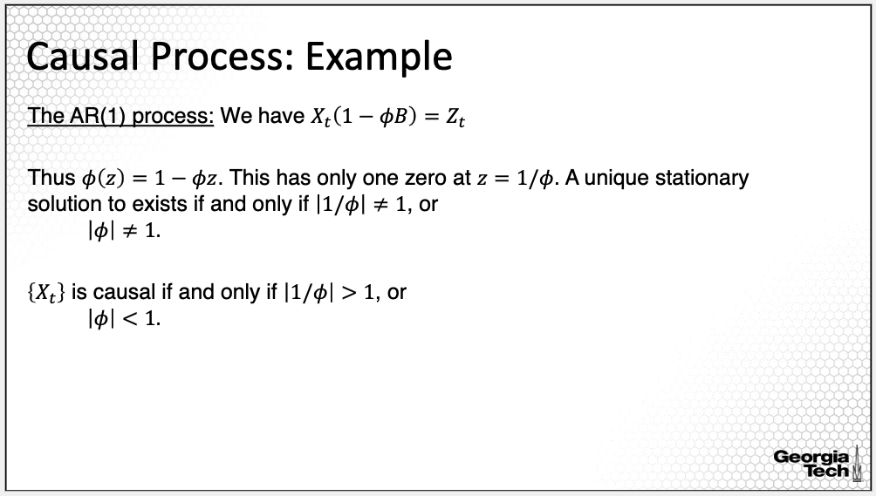

One simple example for a causal process is the AR of order one. The AR polynomial for such process is 1- phi(z); the solution to the equation for the AR polynomial to be equal to zero is equal to 1 over phi. Thus, Xt is stationary if and only if the solution is not equal to 1, or equivalently, phi is not equal to 1. Moreover, Xt is causal if and only if the solution 1 over phi is larger than 1 or equivalently phi is smaller than 1. Thus, for an AR(1) process, it is straightforward to check whether the process is stationary or causal, we simply check the value of the coefficient of the AR(1) process.

**AR(1) Causal Process**

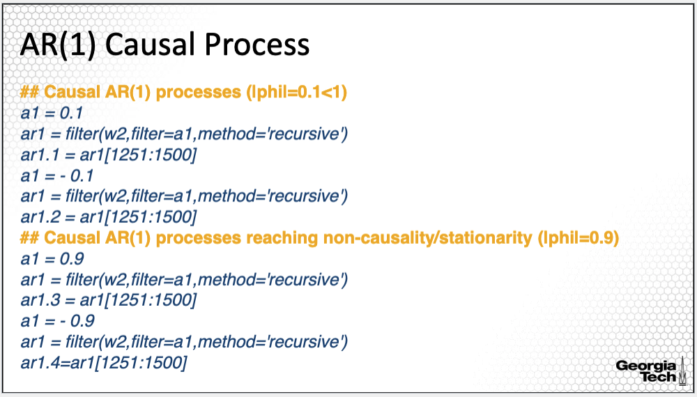

Here, I simulated AR(1) processes with phi = 0.1,- 0.1, 0.9 and -0.9. The simulation is similar as the one provided in the previous lesson. We first simulate the white noise, then we apply the filter command with method='recursive'.

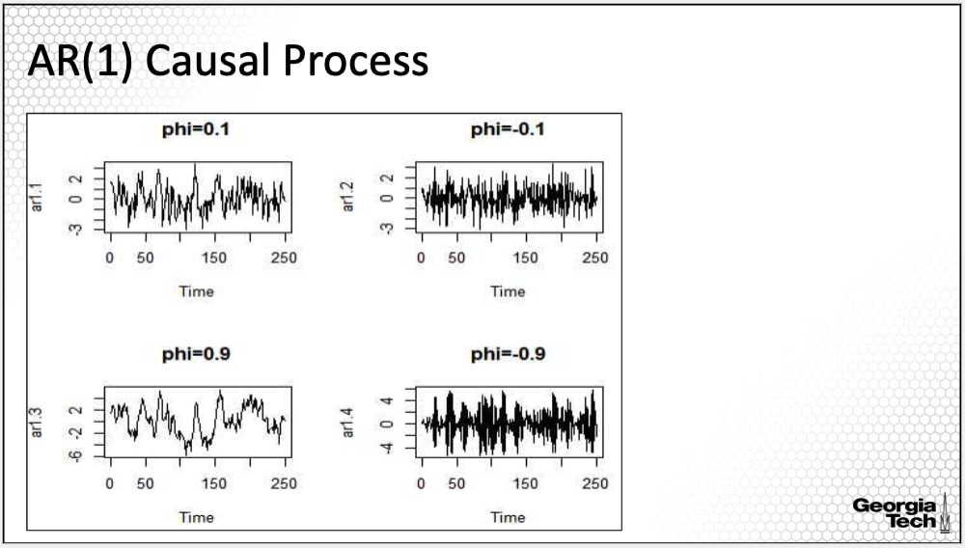

The time series plots are here. Upper plots are for phi = 0.1, or- 0.1, and lower plots are for phi close to 1, 0.9 or -0.9. The upper times series plots show clear stationarity as there is not a temporal pattern in this time series. On the other hand, the plots on the bottom show some sign of non-stationarity. The departure from the mean 0 is very prolonged. This is because the absolute value of the coefficient phi is 0.9, which is close to 1. As pointed out on the previous slide, an AR(1) is not stationary when the coefficient is 1 or -1. Thus, as a coefficient phi reaches 1 in absolute value, the processes also will show signs of non-stationarity.

**Invertible Process**

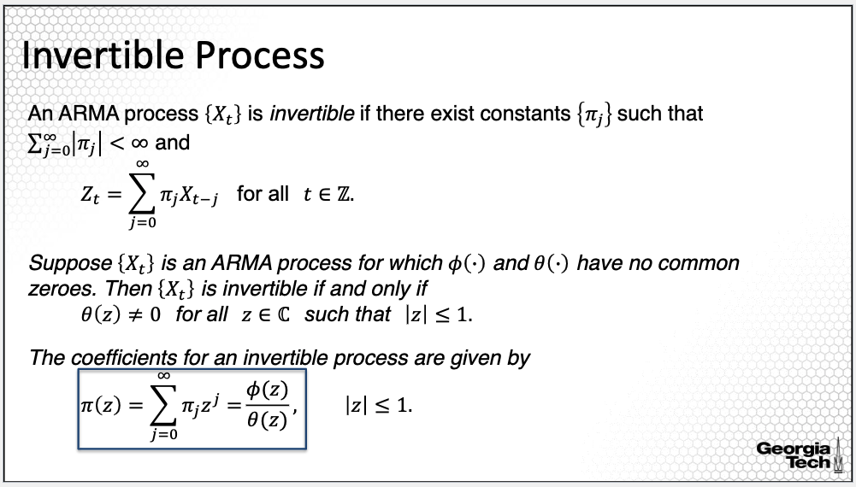

We can also go from an MA, or Moving Average process, or a more general ARMA process to an AR process, meaning that the ARMA process is invertible. More specifically, for a process to be invertible, there exists constants pi_j’s, where the sum of the absolute value of the constants is finite such that a linear combination of past Xt-j weighted by pi j is a white noise Zt. However, this definition only describes the fact that we can go from an ARMA to an AR process if invertible. It doesn’t tell us how to check whether the process is invertible. In order to evaluate whether an ARMA process is invertible, the necessary and sufficient condition is that the zeroes of the MA polynomial, theta(z), are outside of the unit circle. In other words, we first solve the equation theta of z equal to 0 to obtain all its solutions then evaluate if any of its solutions in absolute value is smaller or equal than 1. If all solutions in absolute value are larger than 1, then the process is invertible. If there is at least one solution in absolute value smaller or equal than 1, then the process is not invertible.

Given the two polynomials of an ARMA process, we can then obtain the coefficients of the linear representation using this relationship, which is an invertibility property of the MA polynomial. The invertibility property of an ARMA process in practice says that if we can invert an ARMA process to an AR process, we can also impute the value of Zt, which is not observable, based on all past values of Xt which are observable. If a process is non-invertible, then in order to find the value of Zt, we have to know all future values of Xt.

**ARMA Model: Properties**

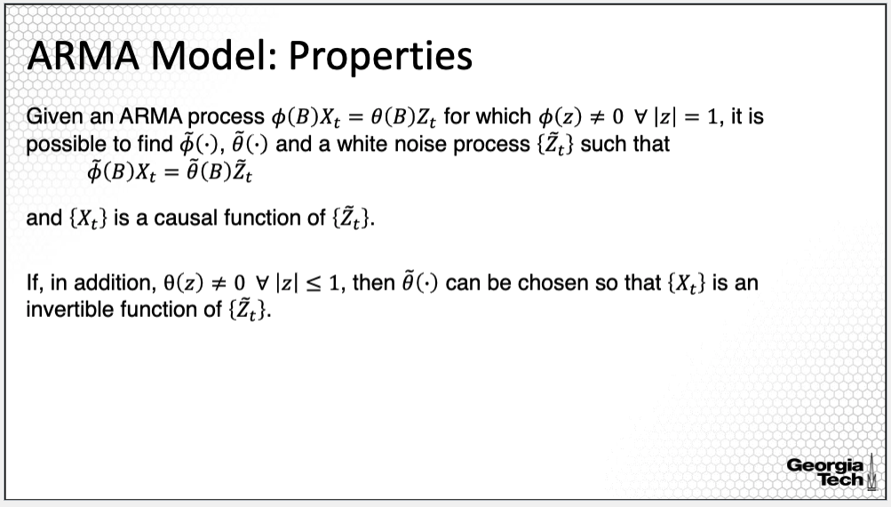

Here is why the property of causality is important. Given an ARMA process with AR and MA polynomials, phi and theta, if it is stationary, that is, the roots of the phi(z) polynomial are not on the unit circle, then there exists polynomials phi_tilde and theta_tilde, and a white noise Zt such that the resulting ARMA process with these polynomials as AR and MA polynomials is a causal ARMA process. What can we learn from this property? We can learn that any stationary ARMA process can be transformed into a causal process. As we'll see in the next lesson, we can derive the autocovariance function for an ARMA process using the invertibility property of the AR polynomial for a causal process. Most importantly, we can only provide forecast of an ARMA process only if causal. We will return to these aspects in other lessons in this module.

**Summary:**

In this lesson, I introduced two important properties of an ARMA process, causality and invertability.

### 2.1.4 Autocovariance and Partial Autocorrelation Function

*In this lesson, I'll introduce the estimation approach of the autocovariance function and also another dependence measure important for ARMA models, which is the partial autocorrelation function.*

**ARMA Model: Notation**

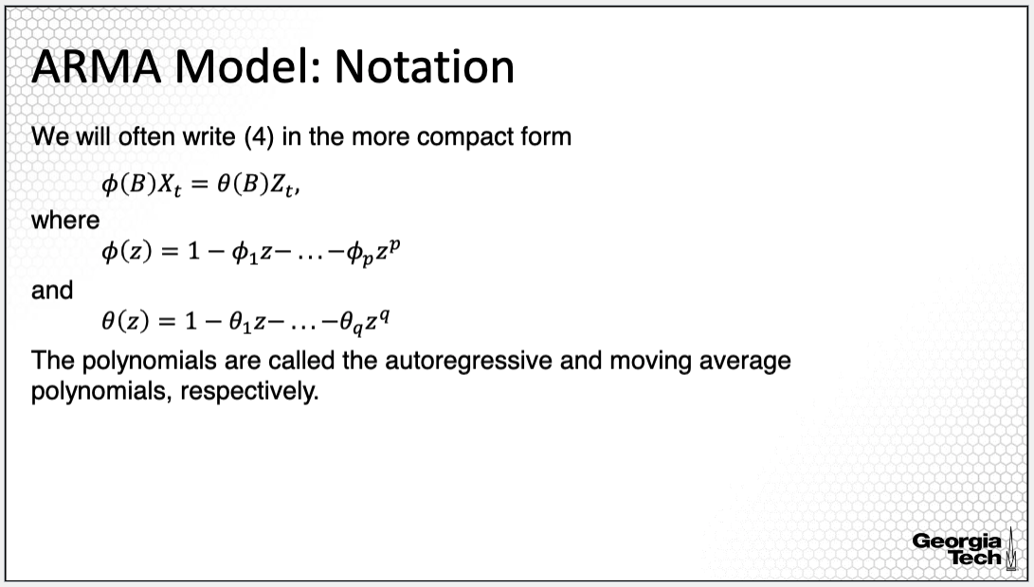

This slide is to remind you again about the notation for the ARMA model. I will use this notation for formally defining the autocorrelation function and the partial autocorrelation function for ARMA models.

**ARMA Model: Autocovariance Function**

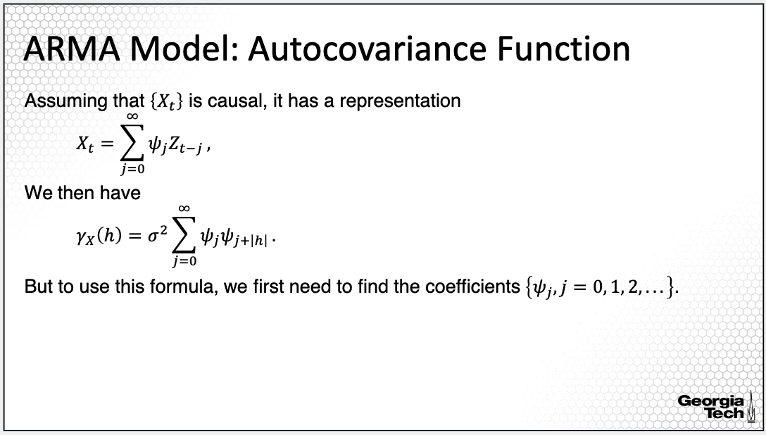

We have learned about the general definition of the autocovariance function. For a stationary process, the autocovariance function is very useful in describing the process. Here we'll learn about the property of the ACF for causal ARMA processes. Specifically, if Xt is a causal process with the resulting decomposition as a linear process, with psi j, the coefficients of the linear process, the ACF is equal to sigma squared times the sum of all products between psi j and its lagged coefficient psi j+ h. That is, the sum of the products of all combinations of the coefficients that are h lagged away from each other. However, in order to get the autocovariance function using this formula, we'll need to first derive the coefficients of the linear process, the psi coefficients.

**Autocovariance Function: Derivation**

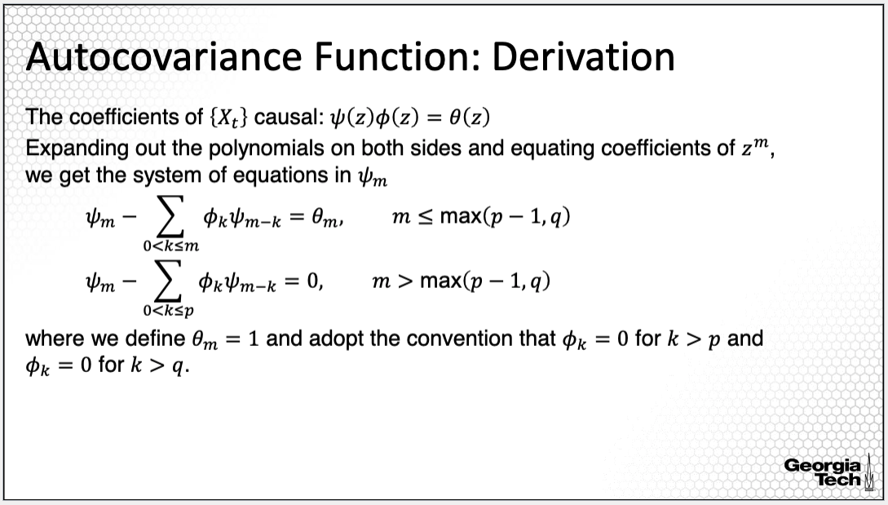

How to derive those coefficients? Recall that the relationship between the psi polynomial and the ARMA polynomials of the ARMA causal process is as on the slide. We can start with this relationship. Expanding out the polynomials on both sides and equating the coefficients of z to the power of m, for m equal to 0, 1, 2, 3, and so on, we get the system of linear equations where the psi's are unknowns. The system of equations is provided on this slide. The point I wanted to make with this derivation is that deriving the psi coefficients reduces to simply solving a system of linear equations.

**Autocovariance Function: Estimation**

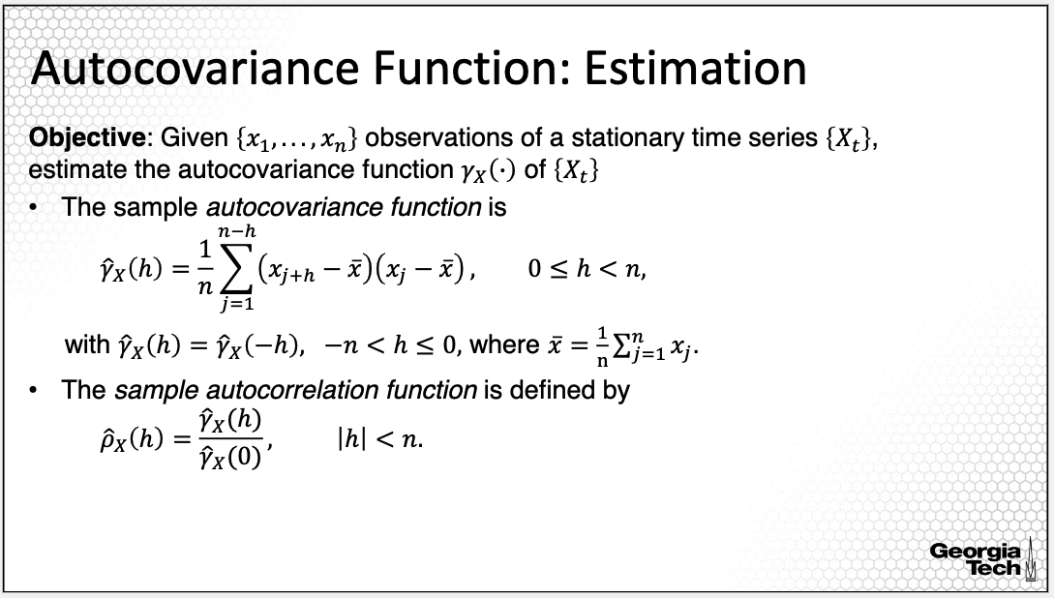

For estimation of the ACF for an ARMA model, we can use the same approach as for any other stationary process. Specifically, we can use the sample autocovariance function. We estimate the sample autocorrelation by dividing the sample autocovariance by the estimated variance, or the estimated covariance at lag zero.

**Partial Autocorrelation Function**

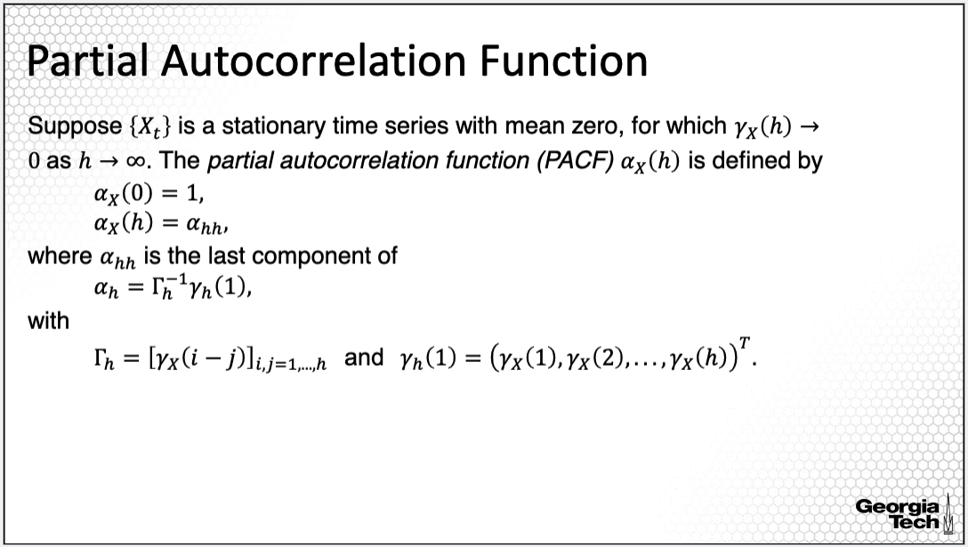

Correlation between two observations in a time series at two time points can result from a mutual linear dependence on observations at other time points called confounding. Another important measure of the dependence for a time series that accounts for this confounding is the partial autocorrelation function, which gives the partial correlation of a time series with its own lagged values controlling for, or conditioning on, the value of the time series at all shorter lags.

In contrast, the autocorrelation function does not control for other lags. This slide displays the formal definition of the partial autocorrelation function or abbreviated PACF. It is a function of the lag h. It takes value 1 at lag 0. For lags larger than zero, we go back to the derivation of the best linear predictor I introduced in the previous module. When I provided the derivation of the best linear predictor, I introduced the Capital Greek letter *Gamma with index n,* which is a matrix where the i,j elements in this matrix are the autocovariance functions at *i* minus *j*.

I also introduced the vector of coefficients, the vector *gamma n* at lag *h*. The Gamma matrix and the gamma vector can be used to derive the coefficients of the best linear predictor or the vector alpha_h obtained from multiplying the inverse of the matrix gamma h with the vector gamma h. The PACF for lag h is the last element of the alpha_h vector.

**PACF and Prediction**

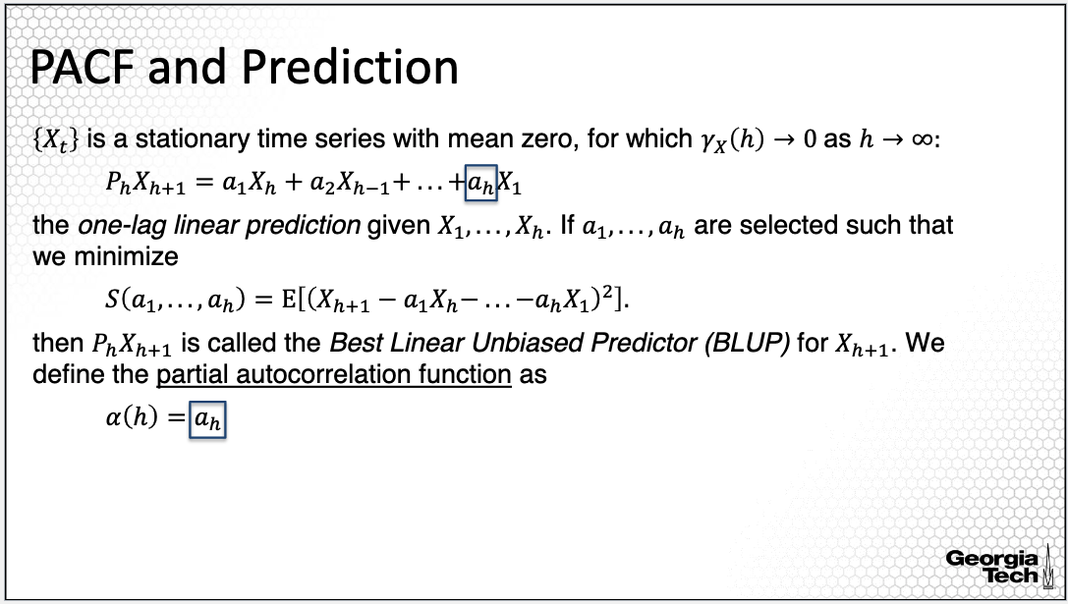

To review, there is a direct relationship between PACF and prediction of a stationary time series. Assuming that the dependence between any two variables in the time series reduces as we increase the lag between the variables, then the one-lag linear prediction is a linear combination of the past observations of the time series. If we derive the coefficients in this linear prediction by minimizing the mean squared error, then we obtain the so-called the best linear unbiased predictor or BLUP. Given this definition of BLUP, the partial autocorrelation is the coefficient ah in the best linear predictor, as defined here on the slide.

**Sample PACF**

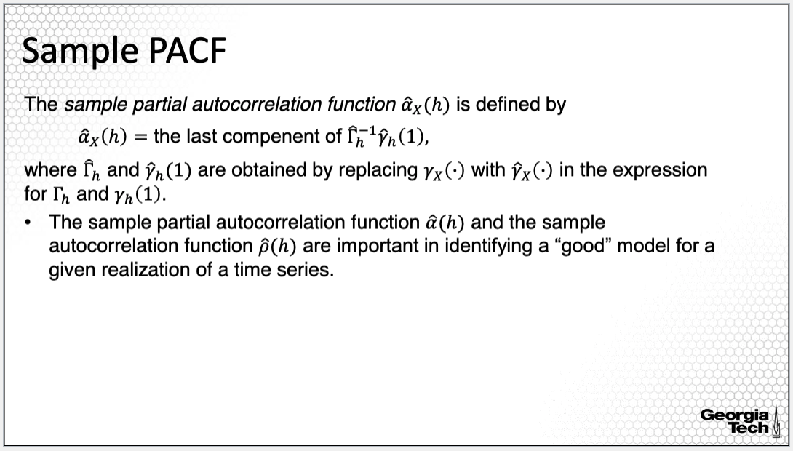  
In order to estimate PACF, we can first estimate the autocovariance using the sample autocovariance function and plug in the estimated values in Gamma_n matrix and gamma h vector to obtain their estimates. Then we can use the formula for the PCF, but this time, using the estimates as provided on the slide. The sample partial autocorrelation function and the sample autocorrelation function are important in identifying a good model for a given realization of a time series, as I will illustrate next.

**ACF and MA(q) Process**

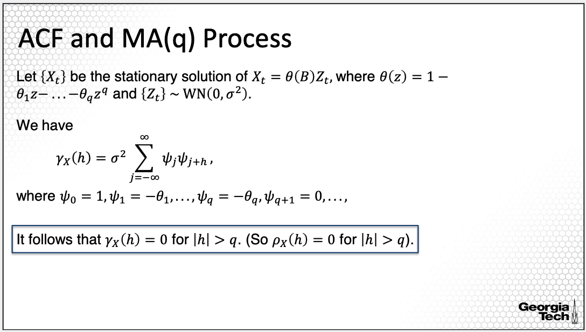  
We consider now Xt to be an MA model of order q as provided on the slide. An MA process is a causal process with a finite number of non-zero coefficients. Recall also the formula of the autocovariance function for a causal process provided on the slide. Now replacing the coefficients of the causal process with the coefficients of the MA process, it follows that the autocovariance function is 0 for all lags larger than q. Thus, we can identify the lag of the MA process used in the ACF plot.

**PACF and AR(p) Process**

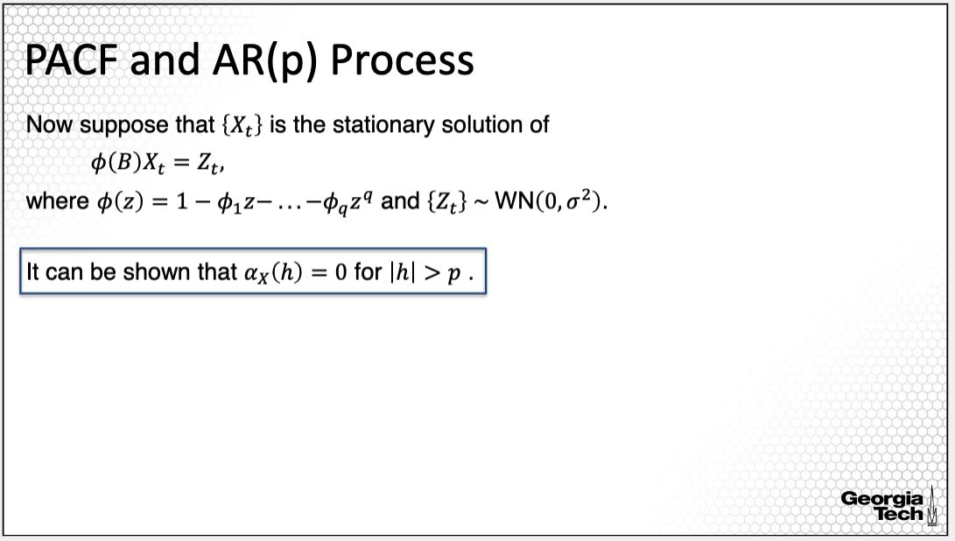

For an AR process, it can be shown that the PACF is equal to 0 for lags larger than the order p. Thus, we can identify the lag of the AR process using the PACF plot.

**MA(q) and AR(p) Processes**

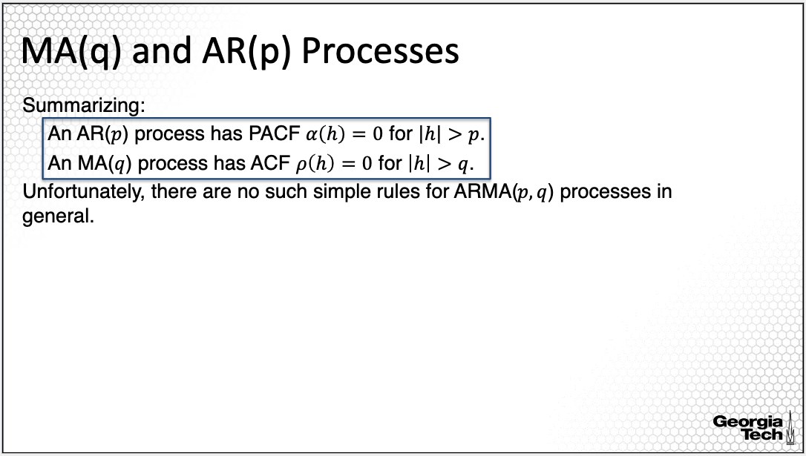

To summarize, if we have an AR process, we can identify the order of the AR process, p, using PACF, and if we have an MA process, we can identify its order q using ACF. Unfortunately, there are no such simple rules for ARMA(p,q) processes in general. We cannot use these rules to identify the orders p and q.

**Summary:**

In summary, in this lesson, I introduced the derivation and estimation of two dependence measures, particularly the autocovariance and partial autocorrelation functions, which are important in order selection and more generally in ARMA modeling.

2.1.5 ACF and PACF: AR & MA Simulation

In this lesson, I will continue the introduction of the concepts of the ACF and PACF, the two correlation autocorrelation functions, with a simulation study.

**Moving Average: Stationary Process**

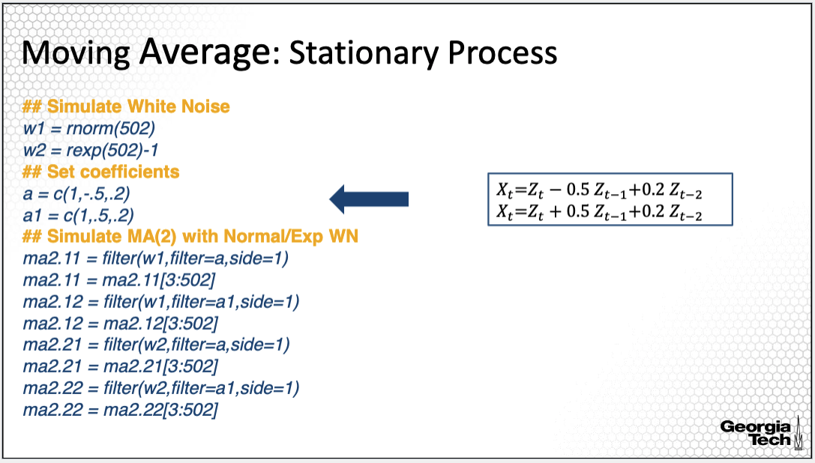

This is a simulation from a previous lesson, where I simulated MA processes as shown in the box in the right. The first process has coefficients 0.5 and 0.2, where in the second process, I've changed the coefficient from 0.5 to -0.5. We also used two different distributions for the white noise. Let’s see how the ACF plots look for these two processes to see whether the theoretical property of an MA process holds regardless of the distribution of the white noise.

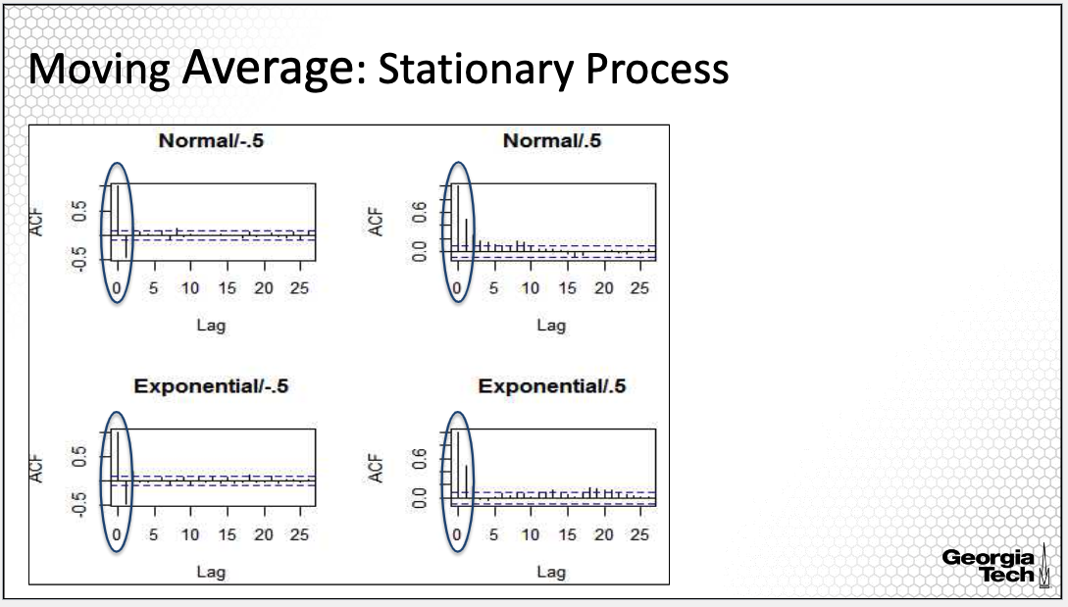

The ACF plots are here, the upper plots are for the normal distribution, and the bottom plots are for the exponential distribution.

Across all ACF plots, we see one important common characteristic. All of them have the ACF values for lags 1 and 2 outside of the confidence bands, that are shown in blue in the ACF plot. We will discuss the confidence bands in more details in the next lesson but for now what we need to infer is that the ACF values for the first two lags are significantly larger than zero.

For other lags, the sample autocorrelation is small, close to 0. Thus, these plots say that the sample autocorrelation is large for lags equal to 1 and 2, but approximately 0 for lags larger than 2. Note that we do not have the exact autocorrelation function, but an estimate of this function. Moreover, its estimate is not exact, but it's a random variable with a distribution as I will explain in more detail in a next lesson. Because of this, we do not expect the sample autocorrelation to be exactly 0 for lags larger than the order of the MA process, but to be approximately 0. Thus, the ACF plot indicates that the order of the MA process is 2, which is the order of the process we actually simulated.

**Moving Average: Non-Stationary Noise**

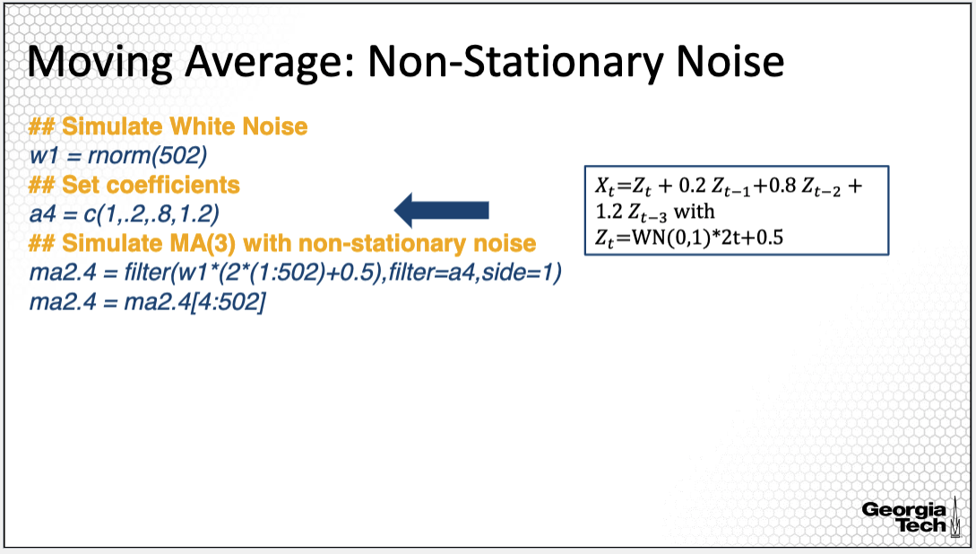

This is another example I used for illustration of ARMA processes. For this second example, I simulated an MA process, with the noise non-stationary. The process simulated in this example is in the box in the right.

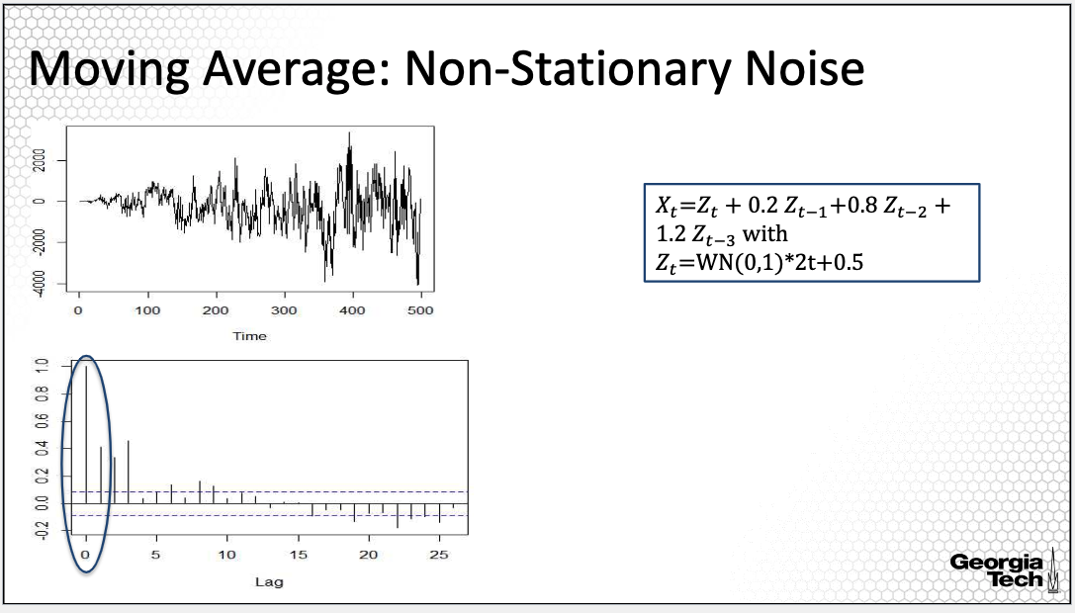

This is the time series plot and the ACF plot for this time series. The order of the simulated MA process is 3. From the ACF plot, we see that the sample autocorrelation is large outside of the confidence band for the lags 1, 2 and 3, but close to 0 for lags larger than 3, indicating once more that the order of the MA process is equal to 3. Note that the property of the autocorrelation function is only for stationary processes, while in this case, the simulated process is not stationary. However, even in this case, we find that the property of the autocorrelation function is maintained.

**Autoregressive Process**  
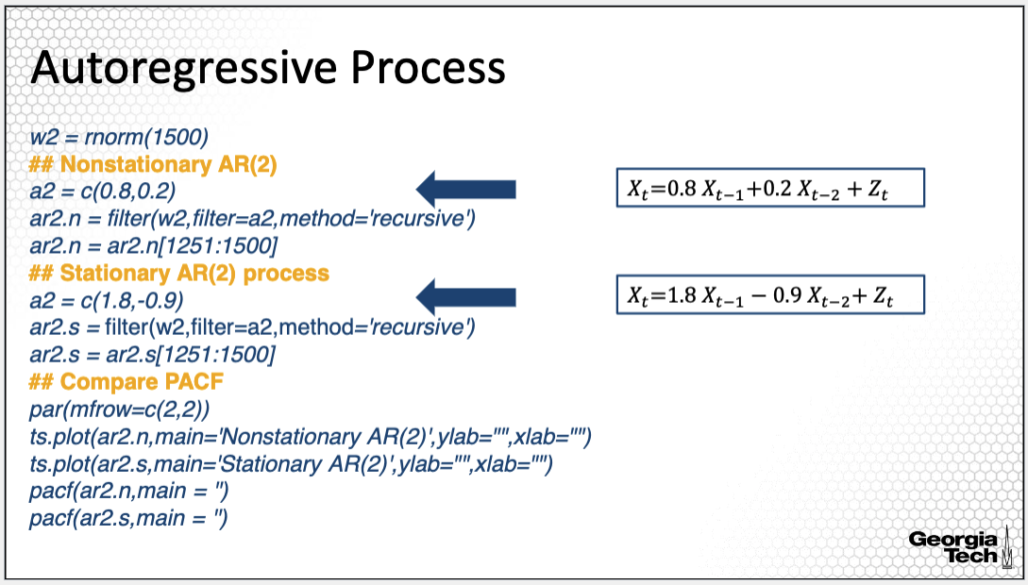

This is an example of simulated AR processes. For this example, I simulated AR processes with order two. The coefficients of the first process are 0.8 and 0.2, whereas for the second process, the coefficients are 1.8 and -0.9. The simulated error processes are in the boxes in the right. The AR polynomials of the simulated AR(2) processes are quadratic polynomials.

In order to evaluate whether the processes are stationary, we need to solve the equation of the AR polynomial as we learned in a previous lesson. For the first process, one solution to this equation is equal to 1, thus, this process is not stationary. For the second AR(2) process, none of the zeros of the AR polynomial are on the unit circle, thus, it is stationary.

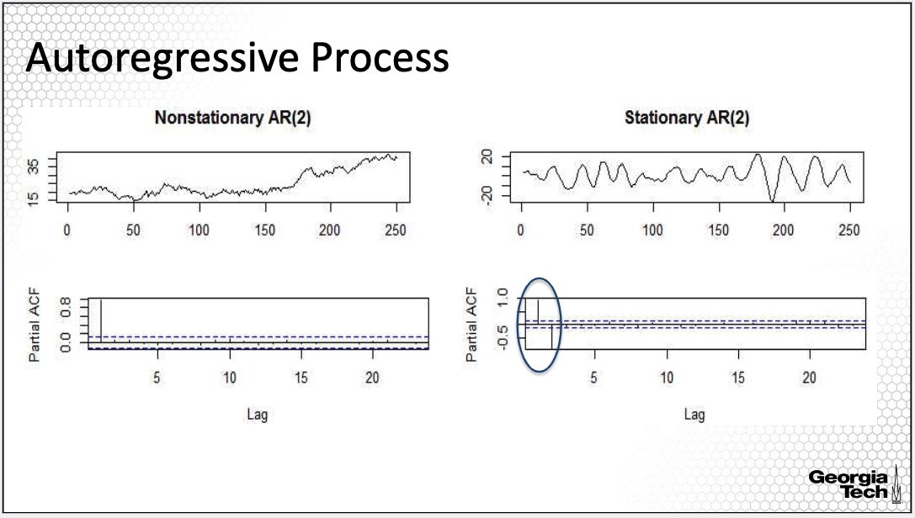

In this example, we are not going to look at the ACF plot, but the PACF plot, because of the property of the PACF for an AR process. The upper plots are the time series plots. From the time series plots, the first simulated AR(2) process is clearly non-stationary, as we note an increasing trend over time.

For the second simulated AR(2) process, there is not a clear trend, however, we do distinguish some sort of pattern. The PACF plots are on the bottom. The PACF plots are similar to the ACF plots in that they are bar plots with each bar corresponding to a lag. One difference is that the PACF plot begins with lag 1, not 0. The PACF plot of the non-stationary AR(2) process shows a large value only for lag 1, where all others are small, close to 0. If we use the PACF plot to identify the lag of this AR process, we identity an AR process with order one. However, the property of the PACF for an AR process does not hold for non-stationary processes.

On the other hand, for the AR(2) process, the PACF plot clearly indicates an order 2 AR process since the values of the PACF are large for lags one and two.

**ARMA Process**

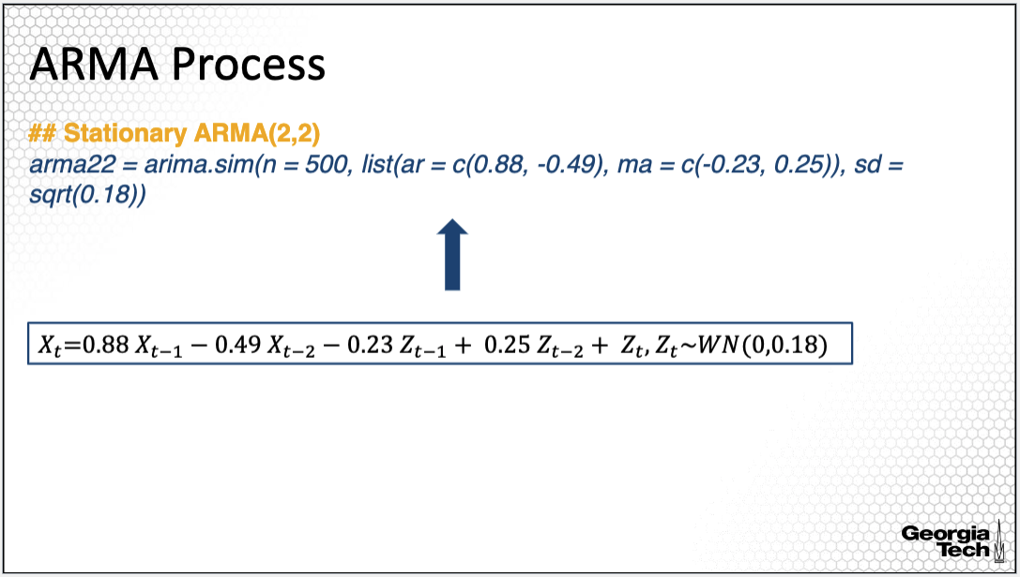

In order to simulate an ARMA process, I used a different R command, arima.sim(). To use this command, if the white noise is Gaussian, then you do not need to specify the distribution of the white note; otherwise, you need to specify through an option of the function called rand.gen. The important input of this command is the length of the process (here it is 500) and the AR and MA coefficients. The ARMA process generated here is in the box below. For this process, the orders are p = 2 and q = 2, thus, an ARMA(2,2) process. The AR coefficients are 0.88 and -0.49, and the ARMA coefficients are -0.23 and 0.25. I also specified a standard error for the white noise.

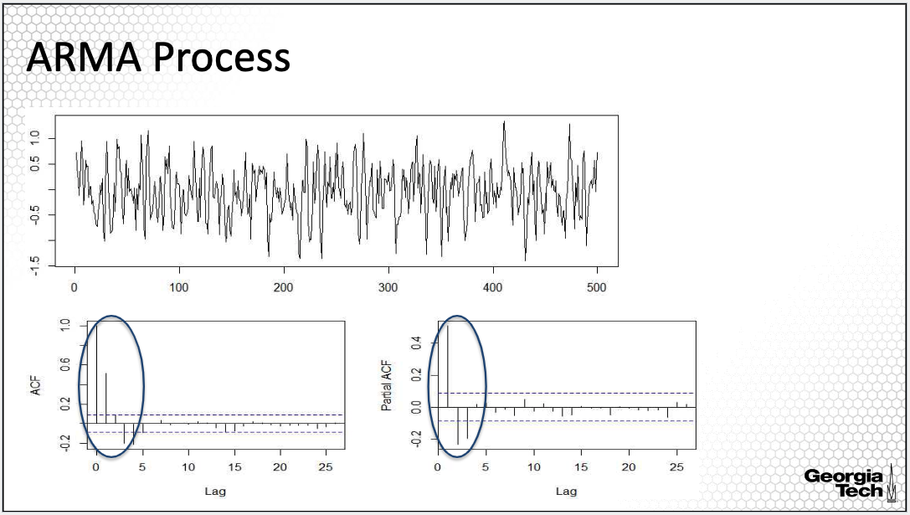

The time series plot is on the first row, along with the ACF and PACF plots on the bottom. The simulated ARMA process shows large volatility around the zero line with some pattern but quite choppy. The ACF plot is on the left and the PACF plot is on the right in the bottom. The sample ACF is large for lags up to four, and the sample PACF is large for lags up to three.

If we were to use this plot to identify the lags for the AR and MA, in the simulated ARMA process, we would identify an ARMA process of orders p = 3 and q = 4. However, the simulated ARMA has orders p = 2 and q = 2. As I pointed out in the previous lesson, we cannot use the ACF and PACF plots to identify p and q in an ARMA process.

**Summary:**

In summary, in this lesson, I illustrated the autocovariance and partial autocorrelation functions, using simulations of the AR and MA processes.

## 2.2: Model Estimation

### 2.2.1(6) Parameter Estimation

*This lesson introduces two estimation approaches for ARMA models based on the method of moments.*

**ARMA Model**

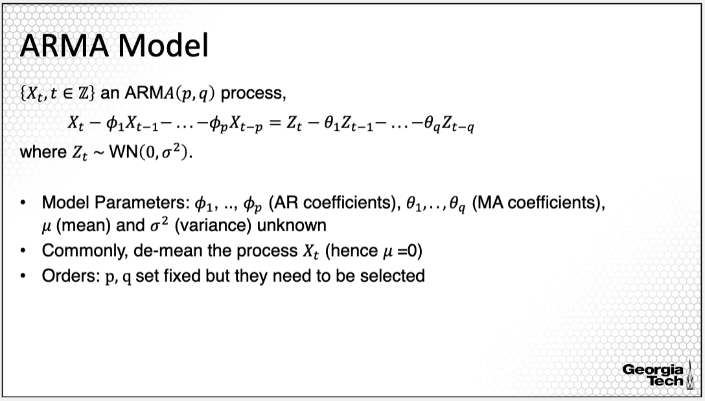

Let's review the parameters in the ARMA model. The AR coefficients denoted with phi_1 to phi_p and the MA coefficients denoted with theta_1 to theta_q are unknown parameters. But if the process has non-zero mean, then, mu, the mean of the process, is a parameter, along with the variance of the white noise Zt. Commonly, we estimate the mean first, and subtract it from the process, assuming then a zero mean process. Thus, we only estimate the AR and MA coefficients along with the variance parameter. Importantly, we estimate the parameters assuming fixed AR and MA orders p and q. However, when we fit an ARMA process, it's uncommon to know exactly the orders and thus we need to employ a rigorous approach to identify the orders p and q also. We'll discuss this aspect in the next lesson.

**AR Model: Linear Regression**

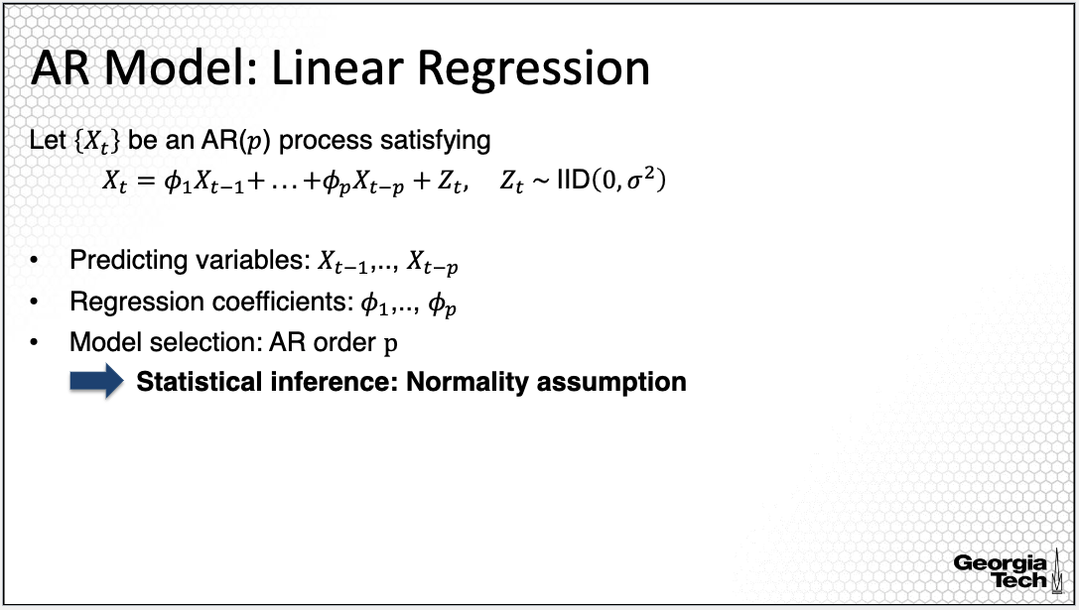

Let's begin with the simplest approach to estimate an AR process. The AR process describes the relationship between Xt and the lag observations of the time series Xt-1 to Xt -p in a linear fashion. It is natural to think of the lag observations Xt-1 to Xt -p to be predicting variables in a linear regression model. Thus, we set Xt -1 up to Xt- p to be predictors, and regress them onto Xt to estimate the AR coefficients or the linear regression coefficients, phi_1 to phi_p, and the variance of the white noise, sigma squared. Furthermore, we can select the order by using a model selection approach.

One important limitation of this approach is that statistical inference can be performed only by assuming normality of the white noise.

**AR Model: The Yule-Walker Equations**

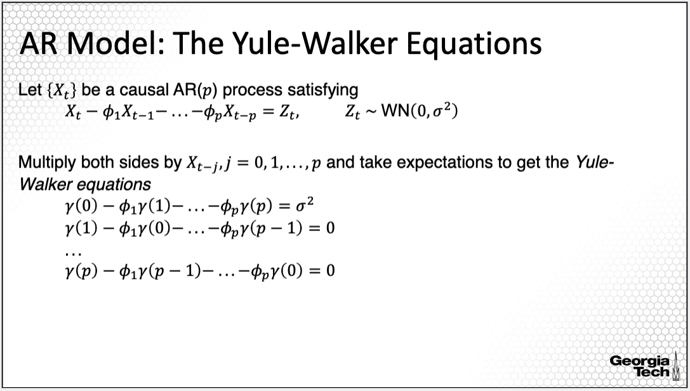  
Alternatively, we can use the so-called Yule-Walker equations, a method of moment estimation approach, to estimate the AR coefficients. To derive the Yule-Walker equations, we multiply both sides of the AR model equation by x_t-j, for j taking values from 0 to p. For each j, we obtain one equation as provided on the slide. We thus have p +1 equations to be used to estimate the AR coefficients and the variance of the white noise, a total of p + 1 parameters. The system of equations is linear and thus straightforward to solve if p is not large.

**The Yule-Walker Equations (cont’d)**

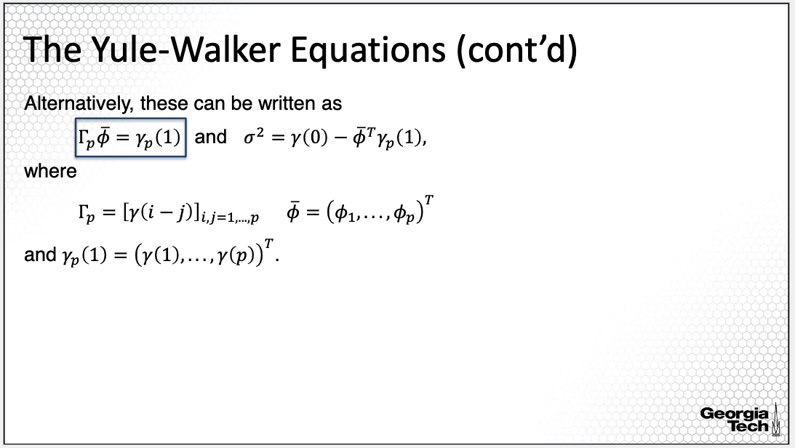  
We can alternatively write the system of equations in a matrix format as provided on this slide. Capital Gamma_p is the matrix where the ij element is the auto-covariance at (i- j) lag. The gamma p of 1 is a vector of the auto-covariance at lags 1 up to p.

We estimate the vector of coefficients phi from the equation on the slide. Furthermore, once we estimate the AR coefficients, we can use the first equation from the system of equations in the previous slide to estimate the variance.

**The Yule-Walker Equations: Estimation**

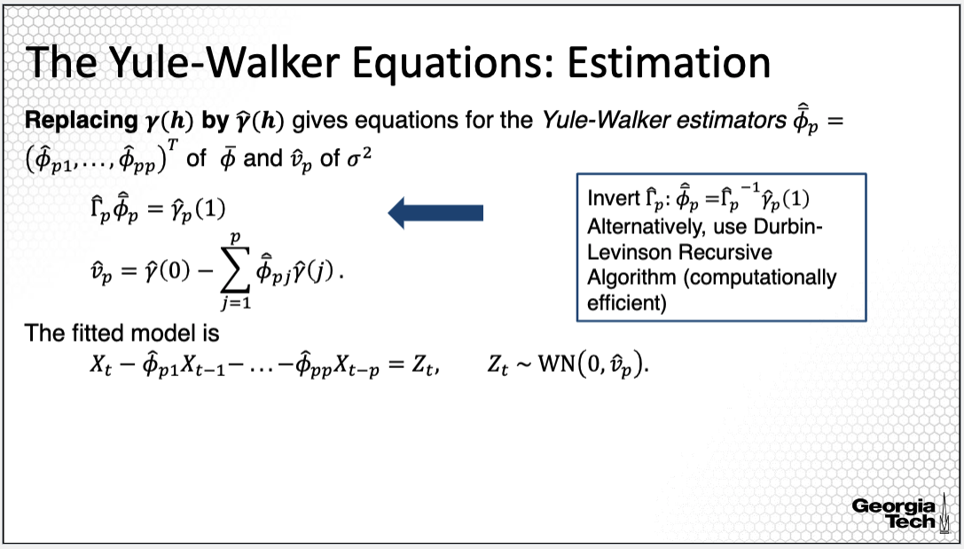

The Yule-Walker equations are expressed as a function of the autocovariance function, which is unknown and thus it needs to be estimated. Thus, in the equations provided in the previous slides, we replaced the true unknown autocovariance at lags 0 to p with the sample autocovariance. Thus, we can now estimate the AR coefficients from the system of linear equations using the sample autocovariance function.

When p is large, instead of inverting the Gamma p matrix to solve for phi's we can instead use the so-called Durbin-Levinson Recursive Algorithm, which requires little computational effort.

With the estimated AR coefficients, the fitted model is the AR model, replacing the true unknown coefficients with the estimated ones.

**The Yule-Walker Estimates: Properties**

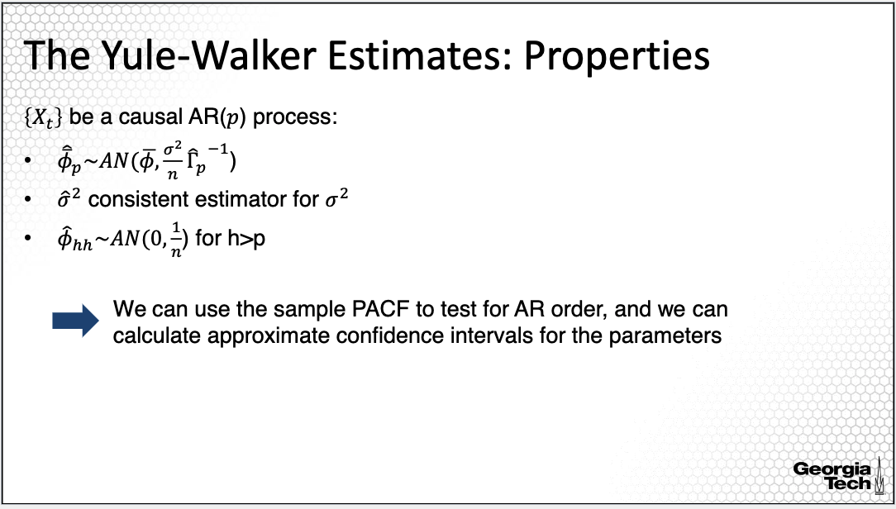

It's also important to establish the statistical properties of the estimators for statistical inference of the model to better understand when the approach will provide good estimators based on the bias and variance of the estimators. It has been shown that the estimators for the AR coefficients using the Yule-Walker equations have an asymptotic normal distribution, where asymptotic here refers to large sample size or long length of the time series. Importantly, the estimators are also asymptotically unbiased, meaning that the expectation of the estimator is equal to the true parameters,estimated under large sample size. Moreover, because the variance of the estimator depends on 1 over n, then it can be shown that the estimators for the AR coefficients are also consistent. Meaning that as we increase the sample size, the length of the time series, the estimators converge the true parameter in a probabilistic standpoint. The estimators for the variance parameters, sigma squared is also consistent.

Last, we can also show that the partial autocorrelation has an asymptotic normal distribution with mean 0 and variance 1/n for all lags larger than p, the AR order. We can use these asymptotic properties, particularly the properties of the sample PACF to test for the AR order, as illustrated in the previous lesson. We can also calculate approximate confidence intervals for the AR parameters to make inference on the AR coefficients, for example, whether they are statistically significant.

**MA Model: The Innovations Algorithm**

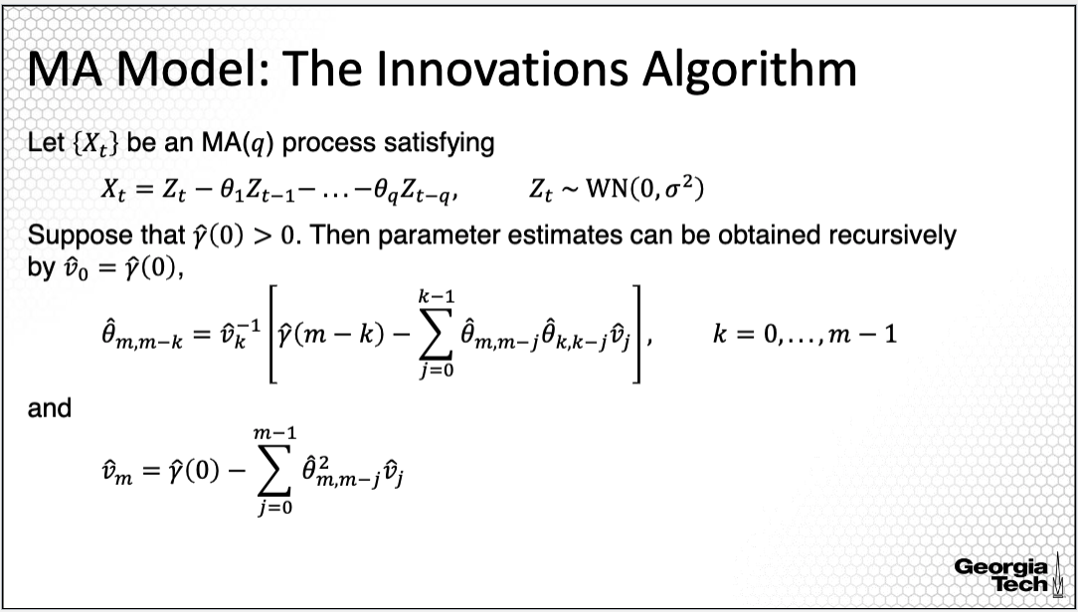

But the Yule-Walker approach does not work for an MA model or, more generally, for an ARMA process. It can lead to non-unique solutions and/or can provide high variance estimators. Thus, a different approach is used to estimate MA processes, the so-called innovation algorithm. Because MA processes are linear processes, we can use the innovation algorithm briefly introduced in the previous module, used to estimate the coefficients of a linear process recursively. Just like the Yule-Walker approach, to obtain estimates of the MA coefficients, this approach is a method of moments estimation approach. The recursive equations are on the slide. I will not review the math behind these recursive equations; I just want to point out here that this estimation approach uses low computational effort.

**The Innovations Algorithm: Properties**

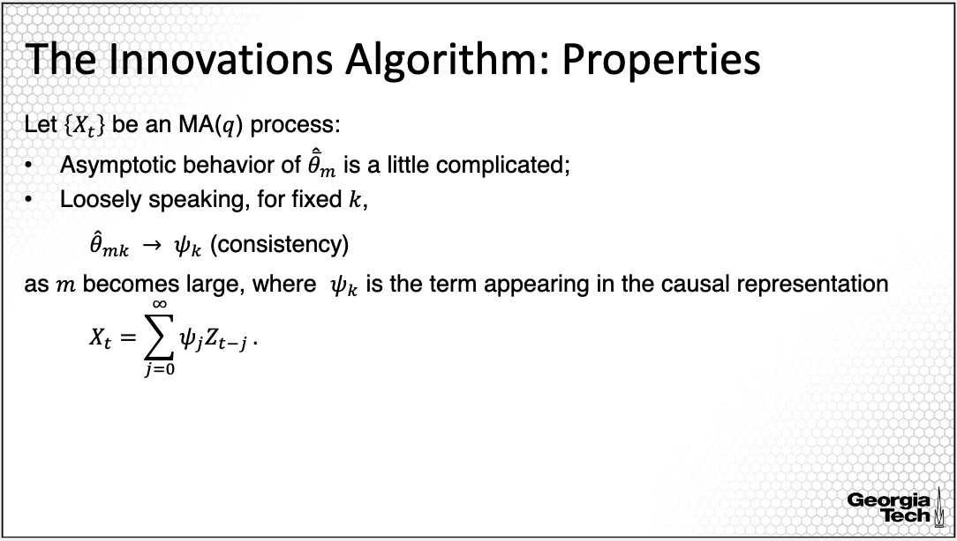

The properties of the estimators derived using the innovation algorithm are more complicated to derive. Loosely speaking, for a fixed order q, it can be shown that the estimated MA coefficients are asymptotically getting closer to the coefficients of the linear process, from which the MA process is derived. Thus, this translates to some sort of consistency of the estimated coefficients.

**ARMA Model: The Innovations Algorithm**

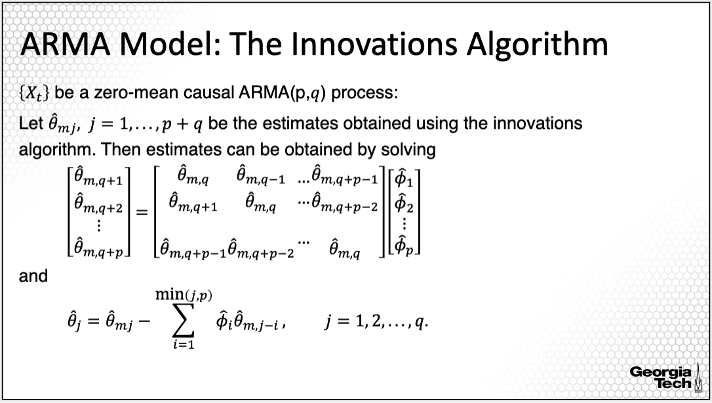

We can expand the idea of the innovation algorithm to estimate the coefficients of a more general causal ARMA process. This is because the causal ARMA process can be represented as a linear process. Thus, the innovation algorithm which applies to linear processes also, applies to causal ARMA processes as well. Note that the innovations algorithm does not apply to ARMA if not causal..

**Summary:**

In this lesson, I introduced multiple method of moments approaches for the estimation of the parameters of an ARMA model.

### 2.2.2(7) Parameter Estimation: Simulation Example

*In this lesson, I will illustrate the estimation approaches provided in the previous lesson with a simulation study using the R statistical software.*

**AR Model: Linear Regression**

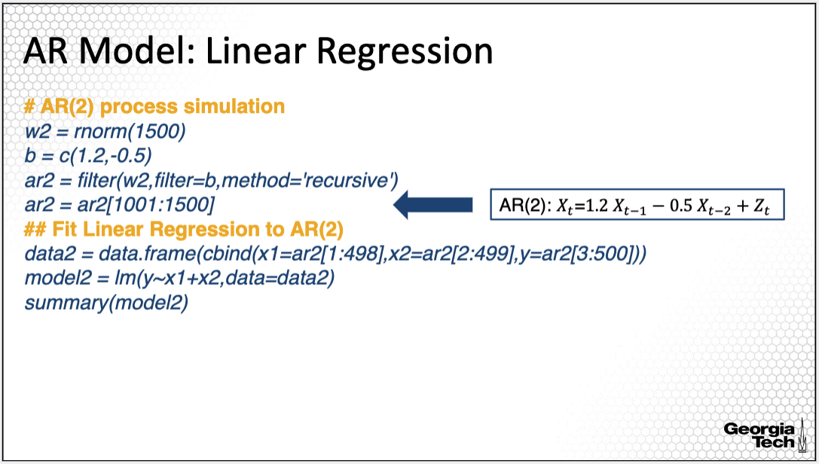

We'll first simulate an AR process of order two. The simulation in R is implemented similarly as in previous lessons using the filter() R command. The AR process has coefficients 1.2 and -0.5, and it's stationary. Further, we can define the predicting variables and the response variable in the data2 matrix defined on the slide, where x1 corresponds to xt-2, and x2 corresponds to xt-1, and y, the entire time series, is the response. We apply the lm R command to fit a linear regression model, with the input of the response on the left of tilde, and the predicting variables on the right of tilde. In order to obtain a summary of the estimated coefficients along with statistical inference and their statistical significance, we can use the summary() command with the input of the fitted model.

**AR Model: Linear Regression (cont’d)**

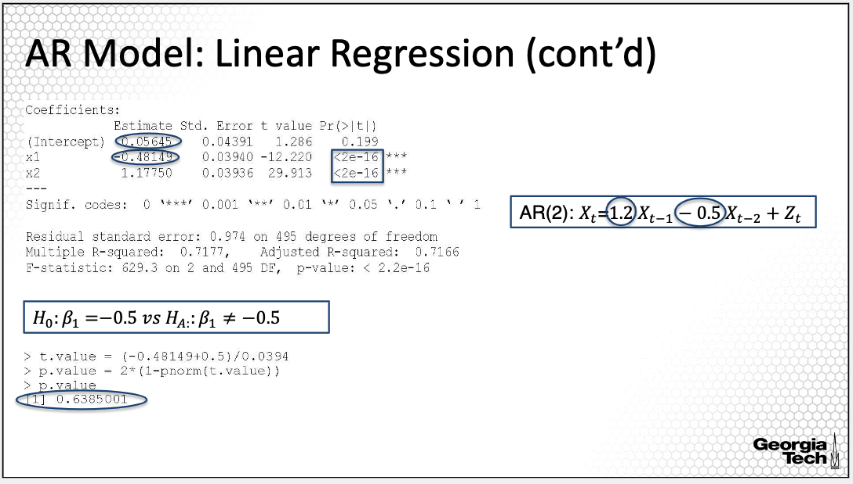

A portion of the output of the model is here. In this output, the estimated coefficients for x1 and x2 are on the second and third row of the output.

The estimated coefficients for x1, corresponding to xt-2, and for x2, corresponding to xt-1, are similar to those from the model generating the data, with slight variations, such as -0.48 instead of -0.5, and 1.17 instead of 1.2. These slight variations are due to the randomness or the uncertainty in the data. Note that the estimates are not expected to be exactly the same as the true parameters due to the randomness in the data. If the model appropriately captures the variations and patterns in the data, the estimates will be close to the true parameters.

From this output, we also find the p values for x1 and x2, provided in the last column, to be very small, indicating that the regression coefficients corresponding to those predictors are statistically significant.

We can further use the t-test to evaluate whether the coefficients are plausibly equal to the true parameters. That is, for example, if the regression coefficient for x1 is plausibly equal to -0.5. For this, we cannot use the t-test value and p-value provided in the R output; we need to recompute the t value of the t test as the difference between the estimated coefficient minus the null value, which is -0.5, divided by the standard error of the estimated coefficient available in the R output. We can then compute the p value of the test as provided on the slide.

The p value from this test is large, indicating that it's plausible for the coefficient to be equal to the true value -0.5. Such statistical inference can be learned from the regression analysis course.

**AR Model: Linear Regression: Residuals**

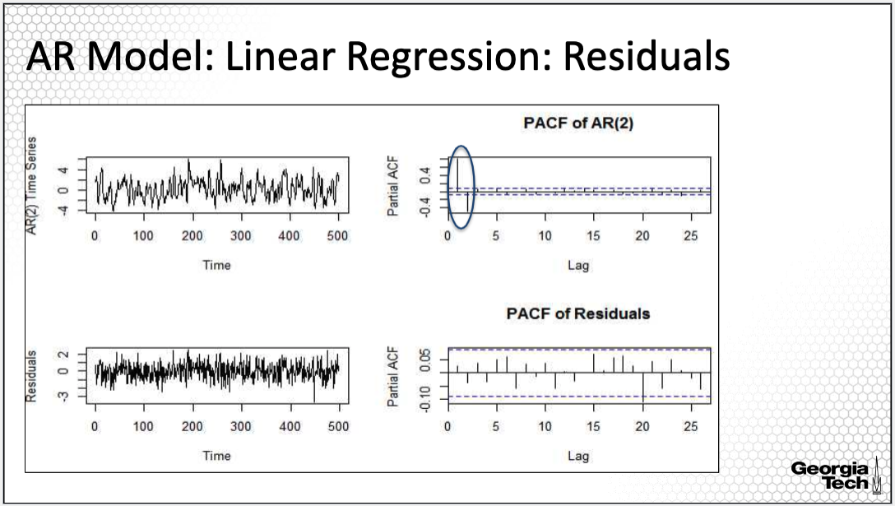

The upper plots are the time series plots of the simulated AR from the previous slide, along with the PACF plot. The the PACF plot shows the PACF is large for the first two lags, indicating an AR(2) model. The lower plots are the time series plot for the residuals from the linear regression model from the previous slide, along with the PACF plot of the residuals.

The time series plot of the residuals seems not to have a pattern. The PACF plot has all of the bars within the confidence band, indicating that the PACF is plausibly close to 0 for all lags, an indication of an AR(0) or a white noise process. Thus, the linear regression provides a good fit for the AR model.

**Linear Regression & AR Order**

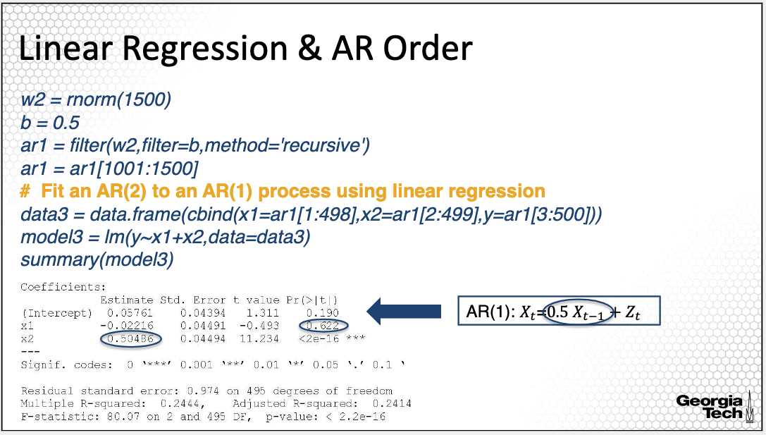

In this slide, I simulated an AR(1) model, but fitted a linear regression model with the predicting variables corresponding to xt-1 and xt-2, thus fitting an AR(2) model.

The output of this R fit for the linear regression model using the two predicting variables is provided below the code.

We contrast the estimated coefficients with the simulated model, which is an AR(1) model with AR coefficient equal to 0.5. The estimated coefficient corresponding to x2 is 0.504, which is close to the value of the true parameter.

On the other hand, the estimated coefficient corresponding to xt-2 is -0.02. And the p value for the statistical significance for this coefficient is large, indicating that this coefficient is plausibly 0 given that xt-1 is in the model. Thus, the model fit suggests an AR(1) model.

**Yule-Walker & AR Estimation**

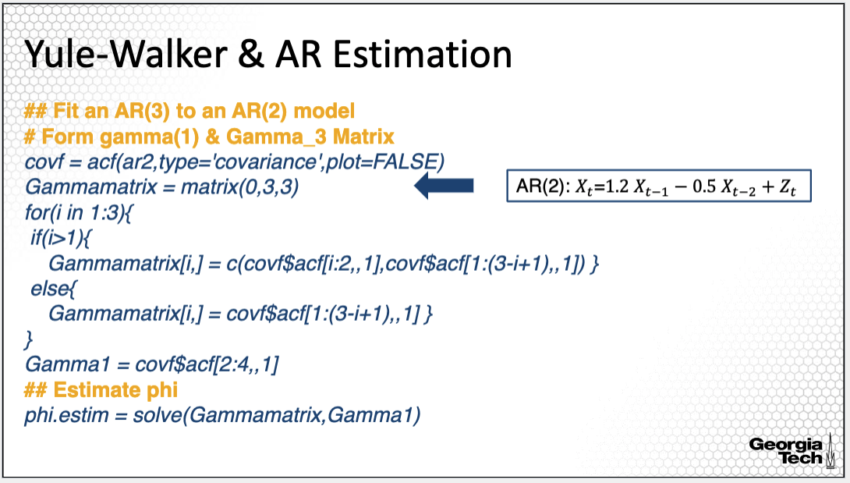

Let's also explore how we can fit an AR model using the Yule-Walker equations approach. The AR2 model has been simulated in a previous slide in this lesson, and it has coefficients 1.2 and -0.5. It is the same AR model used to illustrate estimation using the linear regression approach. Here, I'll fit an AR(2) model to the simulated time series by solving the Yule-Walker equations and assuming actually an AR(3) instead of an AR(2) model. To do so, I first need the sample auto-covariance function obtained using the acf() R command and specifying that the type is covariance, since otherwise, it outputs the autocorrelation.

Next, given the vector of the sample ACF values, l am deriving the Gamma matrix for an order three, since I'm fitting an AR(3) model. The R commands in the for-loop will fill in the Gammamatrix from the vector of sample ACF.

I'm providing the command line for Gamma1, which is the vector of the values of the sample autocovariance for h equal to 1, 2, and 3. Then I obtain the estimated AR coefficients by inverting the Gammamatrix multiplied by Gamma1, as I provided in the lesson where I introduced the Yule-Walker estimation approach. Note that solve() command in R is for inverting a matrix.

**Yule-Walker & AR Estimation (cont’d)**

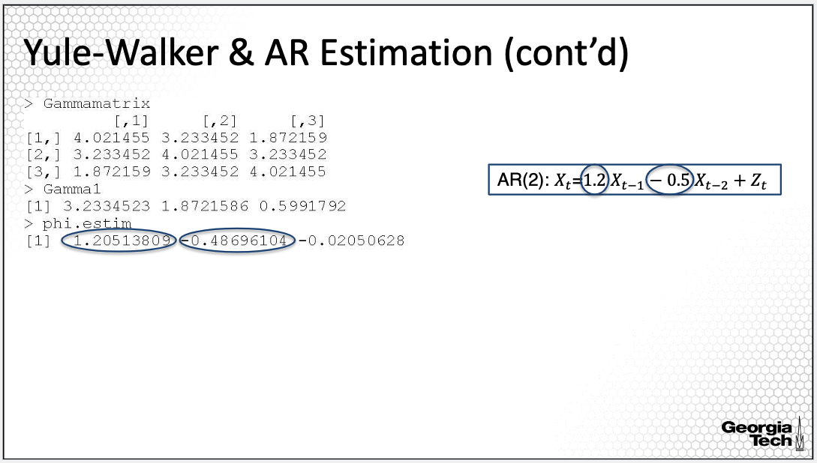

The Gammamatrix is here. It's a 3 by 3 matrix since I'm fitting an AR model of order 3. The Gamma1 vector is below, along with the estimated AR coefficients.

The estimated coefficients are not very different from the true ones of the simulated AR(2) model. The estimated phi1 is 1.205, versus the true 1.2, and the estimated phi 2 is -048 versus the true -0.5. Note also that the estimated coefficient for xt- 3 is -0.02, a small coefficient value. Recall that we are fitting an AR(3) model to an AR(2) simulated model and hence we should expect the coefficient for the X_t-3 to be small, approximately equal to 0.

**Compare Yule-Walker & AR Estimation**

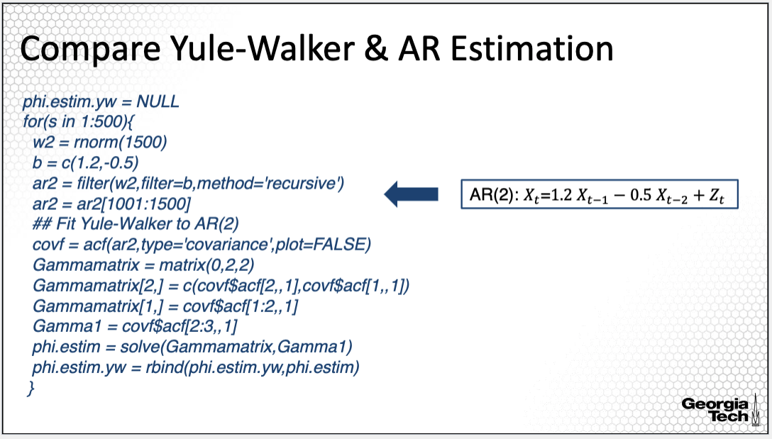

In this slide, we'll evaluate how good the estimates obtained using the linear regression and Yule-Walker estimation approaches. For this, I simulated the AR(2) process provided in the box 500 times, and I estimated the AR coefficients using the two approaches, the linear regression model and the Yule-Walker approach, for all simulated 500 AR(2) time series.

This simulation allows us to compare how effective the two estimation approaches are. Here I'm showing the code for this procedure only for the simulation using the Yule-Walker estimation approach. A similar approach is implemented for the linear regression estimation in the R code available with this lecture. In the R code provided on this slide, I iterate over the index from 1 to 500, simulating the white noise then applying the AR(2) filter.

For each simulated AR process, I derive the Gammamatrix and the vector Gamma1, then estimate thephi coefficients, which are then placed in a matrix, where each row in the matrix corresponds to the estimated coefficients of each simulated AR time series. The matrix with the estimated coefficients is the output of this simulation. The matrix consists of 500 rows and 2 columns, each row corresponding to one simulation, and each column corresponds to one phi.

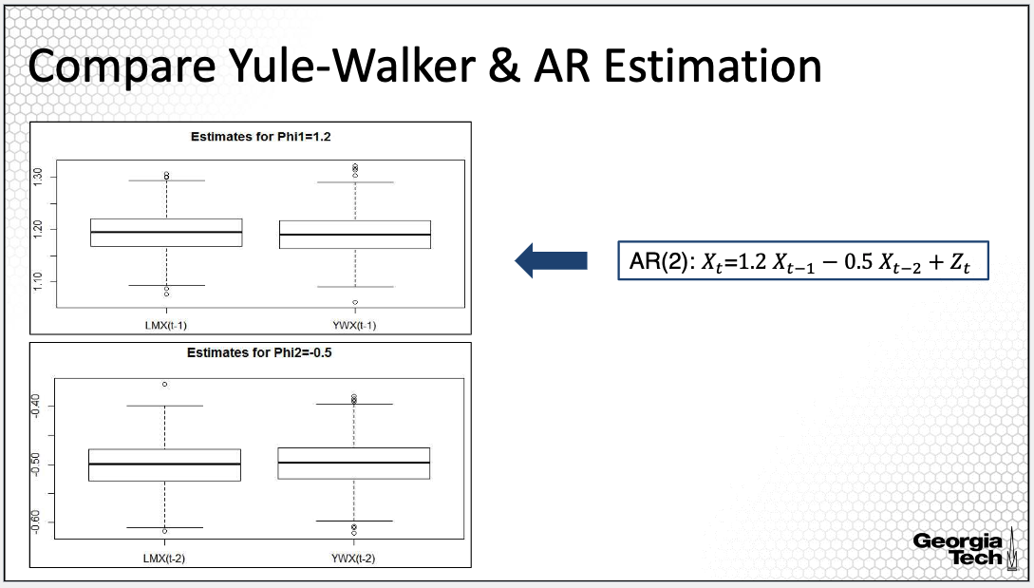

Here are the side by side box plots comparing the distributions of the estimates from the two methods for the first coefficient equal to 1.2 in the upper plot, and for the second coefficient equal to 0.5 on the bottom plot. The two methods perform similarly, with no clear winner in terms of bias and variability in the estimates.

**Summary:** In summary, in this lesson, I illustrated two estimation approaches for an AR model, which are based on method of moments, with a simulation study.

### 2.2.3(8) Parameter Estimation: Maximum Likelihood Estimation

*In this lesson, I will introduce another estimation approach for the ARMA model, the maximum likelihood estimation approach or in short MLE.*

**ARMA Model**

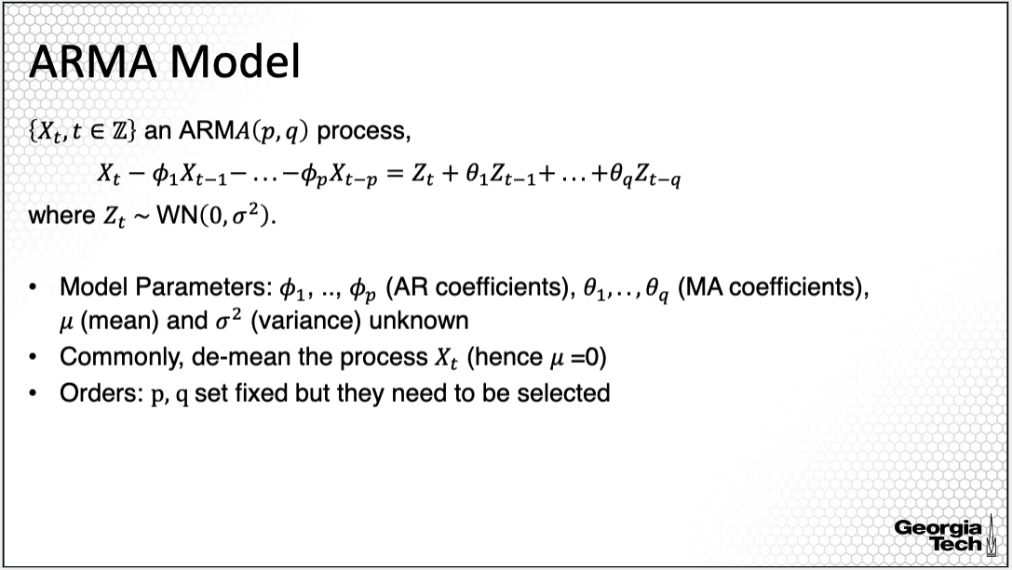

Let's review once again the parameters in the ARMA model. The AR coefficients are denoted with phi_1 to phi_p, and the MA coefficients denoted with theta_1 to theta_q. These parameters are unknown, regardless how much data we observe. If the process has non-zero mean, then mu, the mean of the process, is also a parameter along with the variance of the white noise, Zt.

Commonly, we estimate the mean parameter mu first. Then subtract it from the process, yielding a zero-mean process. Thus, we only estimate the AR and MA coefficients and the variance parameter. Importantly, we estimate the parameters assuming fixed orders p and q. But when we fit an ARMA process, it is uncommon to know exactly the orders. Thus we need to employ an approach to identify the orders p and q also. We'll discuss this aspect in the next lesson.

**Gaussian Time Series**

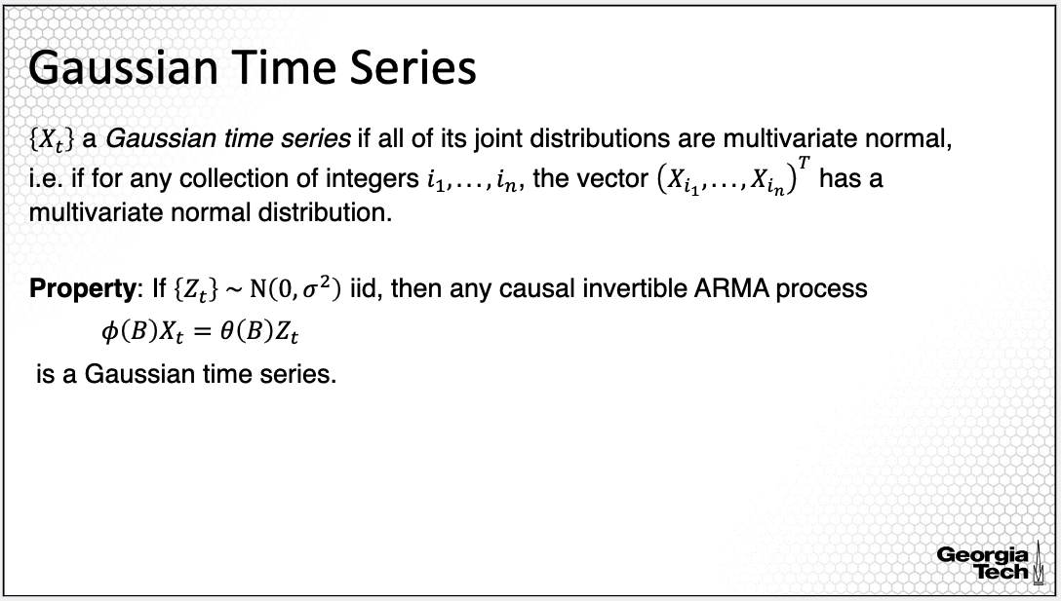

An important aspect in maximum likelihood estimation, abbreviated MLE, is that we need to assume a distribution for the time series process. Most often in time series, we'll assume that Xt has a Gaussian or normal distribution. More specifically, if the joint distribution of the stochastic process generating the time series has a normal distribution, then the time series is a realization from a Gaussian process, meaning that for any combination of time points *i1*, *i2* to *in*, the variables in a time series process corresponding to these time points have a multivariate normal distribution.

The assumption of Gaussian process is useful in the derivation of the MLEs of the model parameters, but also because of the following property: if Zt’s are independent and identically distributed with mean 0 and variance sigma squared, then any causal invertible ARMA process with Zt as the white noise is a Gaussian time series.

**Maximum Likelihood Estimation**

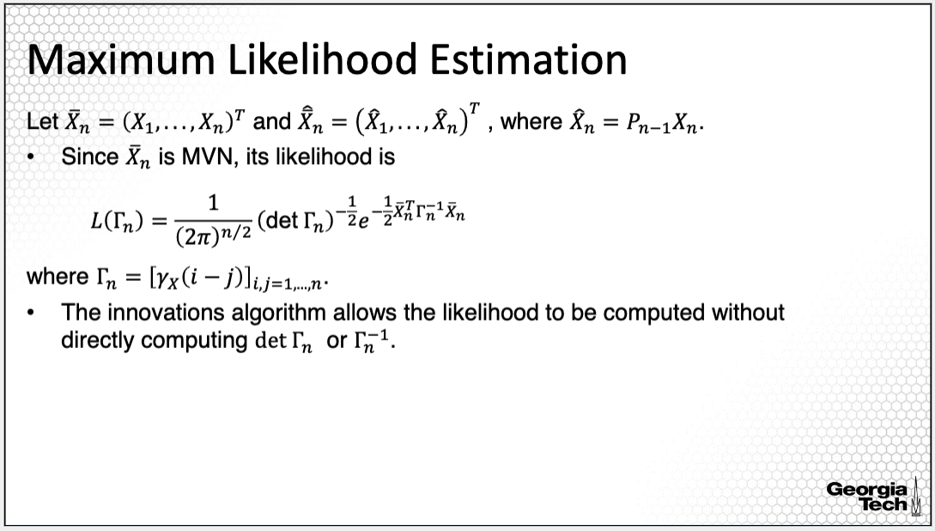

This slide provides the likelihood function of the Gaussian time series. We first denote the vector of n random variables in the time series x1 to xn. The x hat vector consists of the one lag predictions for x1 to xn. The likelihood function of the vector of time series variables is as on the slide and it depends on the gamma matrix of the autocovariances at i- j for all i and j from 1 to n. This likelihood function can be directly computed using the innovation algorithm without computing the determinant or the inverse of the gamma matrix, which could be computationally expensive.

**Maximum Likelihood Estimation (cont’d)**

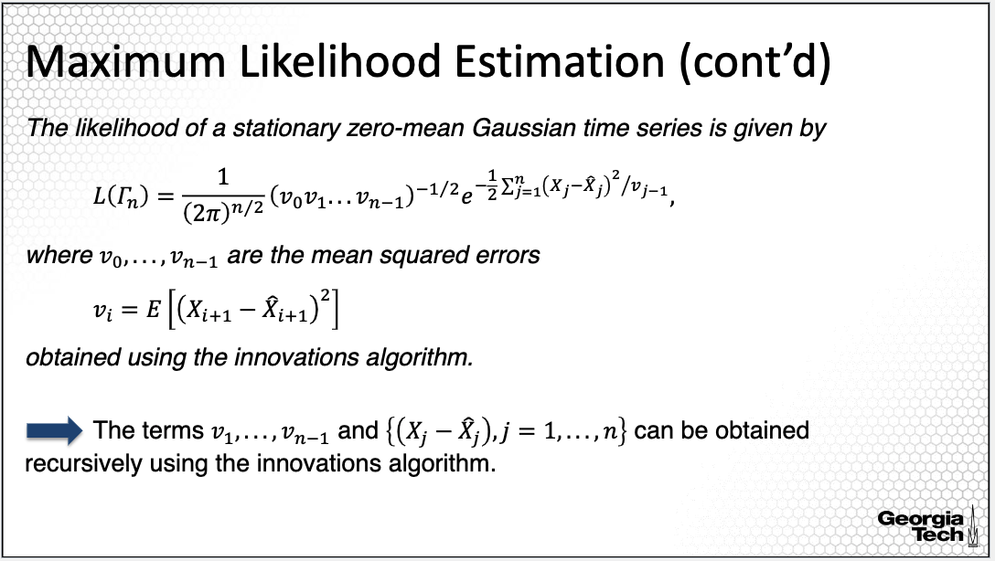

This becomes apparent in the equivalent formula for the likelihood function on this slide, which depends on the x hats or the one-lag predictions which can be derived using the innovation algorithm. We have seen a similar formula when I described the approach for obtaining best linear unbiased predictions using the innovation algorithm. To estimate the AR and MA coefficients, we minimize this likelihood function, more precisely, the log of the likelihood function.

**Example: AR Model via Linear Regression**

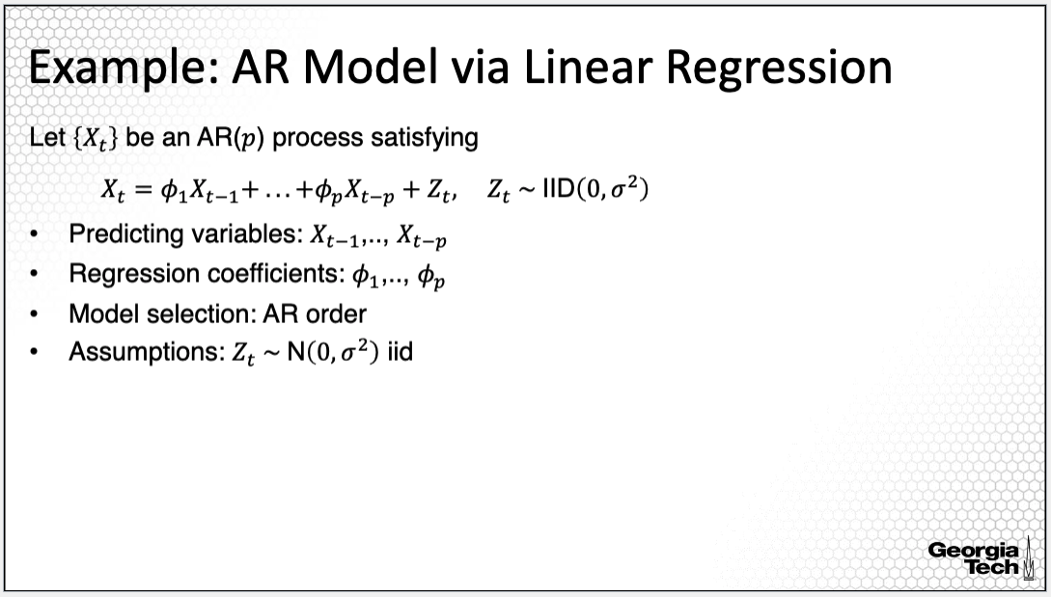

One of the most straightforward implementations is for an AR model, the linear regression approach described in one of the previous lessons in this lecture. This approach provides MLEs, maximum likelihood estimators, as soon as we assume that the error term Zt are IID with constant variance from a normal distribution.

**MLE versus Other Approaches**

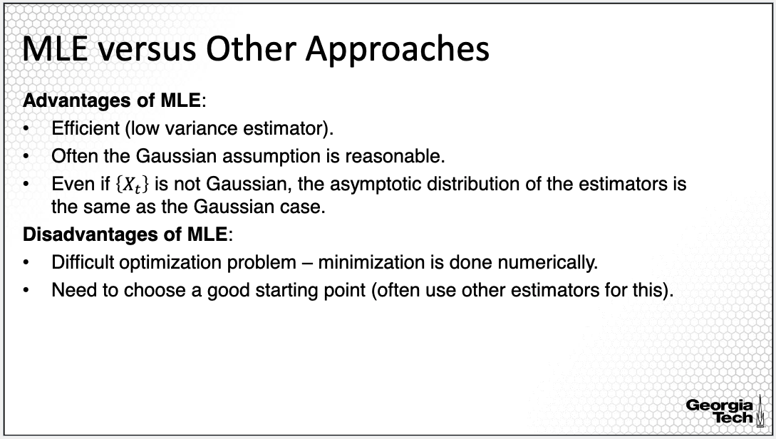

So far, we have learned about several estimation approaches. You may wonder which one to use. Here's a summary of the advantages and disadvantages of the MLE approach. Generally, the MLE provides more efficient estimates or lower variance estimates than the method of moments, which is the Yule-Walker estimation approach for AR, and the innovation algorithm for the MA process or for the more general causal ARMA. Often, for many time series, the Gaussian assumption is reasonable.

But even if we were to assume a different distribution, the asymptotic properties of the MLE hold regardless, whether we assume a Gaussian or other distribution. Some of the important disadvantages are that the estimation of MLE for correlated data, such as time-series data, involves solving a complex optimization problem that is challenging to optimize.

**MLE: Preliminary Parameter Estimates**

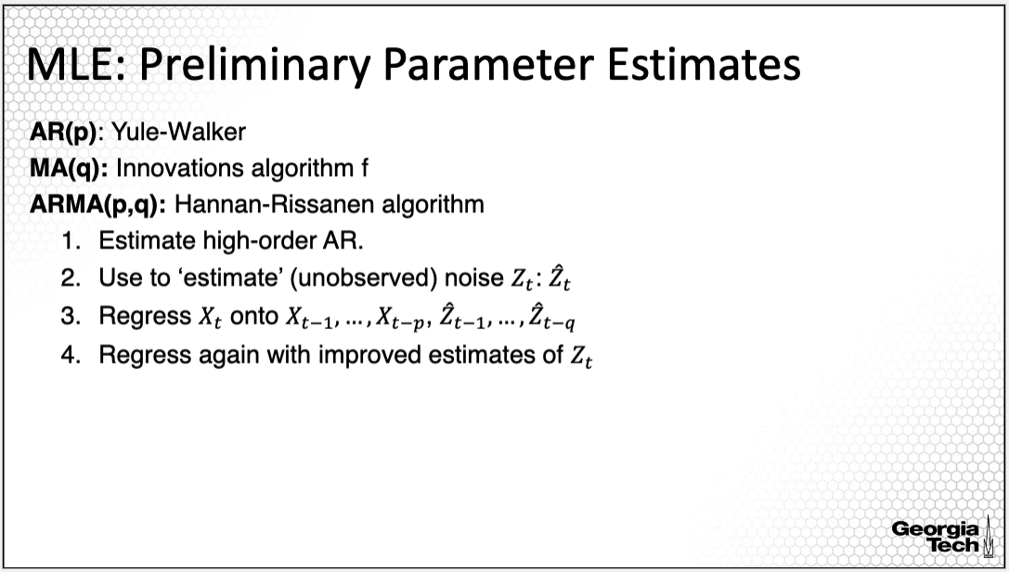

The estimation is done only numerically for ARMA models. Another limitation is that because MLE is done using numerical algorithms, we need to choose a good starting point. Often we can use other estimators derived using method of moments approaches for the initialization step. That is, for AR models, we can use a Yule-Walker estimation approach to initialize. For an MA process, we can use an innovation algorithm. Or for the more general ARMA process, we can use the innovation algorithm, or other algorithms such as the Hannan-Rissanen algorithm, which begins with estimating an AR model of higher orders, which is used to estimate or input the unobserved noise Zt, called here Zt hat.

**MLE: Statistical Property**

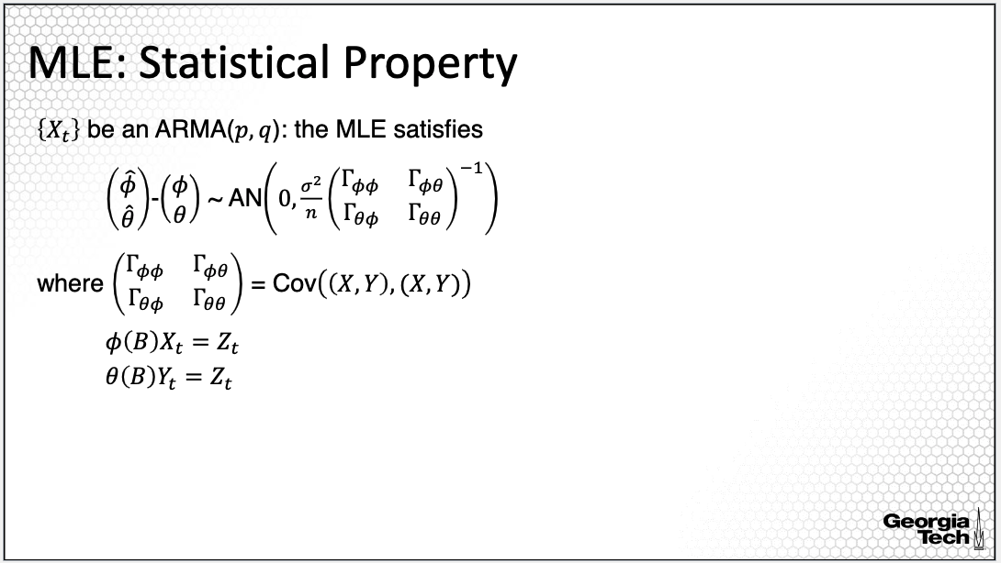

Last, we can use the property of the MLEs, the estimated maximum likelihood estimators, particularly, the property of asymptotical normal distribution of MLEs, regardless of the assumption on the noise Zt. The MLEs are asymptotically unbiased, that is, for large sample size, the expectation of the MLEs is close to the true parameter values. The covariance matrix of the estimator is directly dependent on the covariance of the time series. This asymptotic distribution can be used for statistical inference on the AR and MA coefficients, as well as for the asymptotic distribution of the ACF and PACF.

**Summary:**

In this lesson, I expanded further on another estimation approach for the ARMA model parameters, the maximum likelihood estimation approach. MLE is generally the preferred estimation approach in parametric modeling.

### 2.2.4(9) Order Selection & Residual Analysis

*In this lesson, I'll continue introducing the estimation of ARMA models focusing on order selection and residual analysis.*

**ARMA Model**

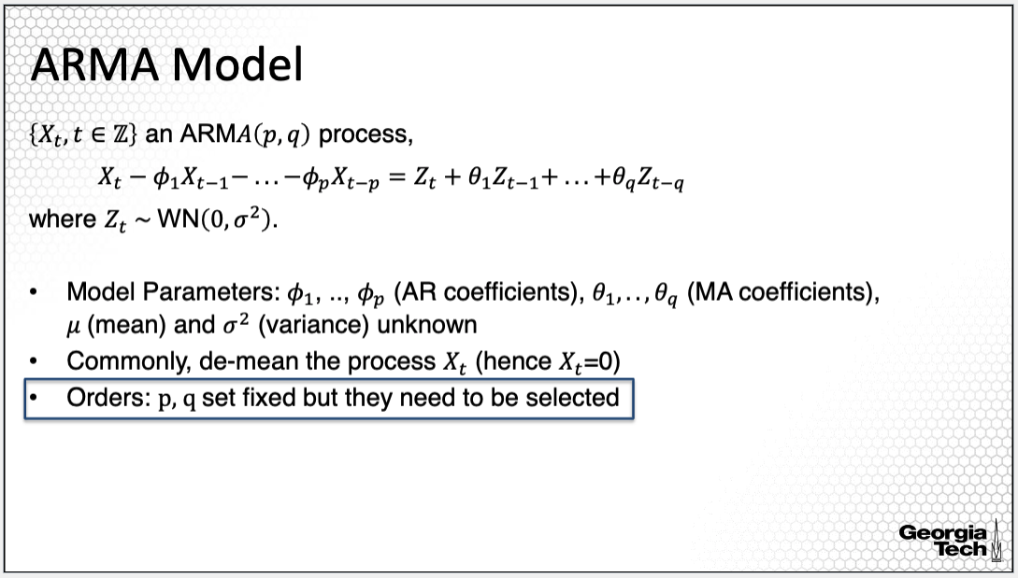

Let's review once again the parameters in the ARMA model. The AR coefficients are denoted with phi_1 to phi_p, and the MA coefficients denoted with theta_1 to theta_q. These parameters are unknown, regardless how much data we observe. We estimate the AR and MA parameters assuming fixed orders p and q.

But when we fit an ARMA process, it is uncommon to know exactly the orders. Thus, we need to employ an approach to identify the orders p and q also. We discuss this aspect in this lesson.

**Order Selection: AICC**

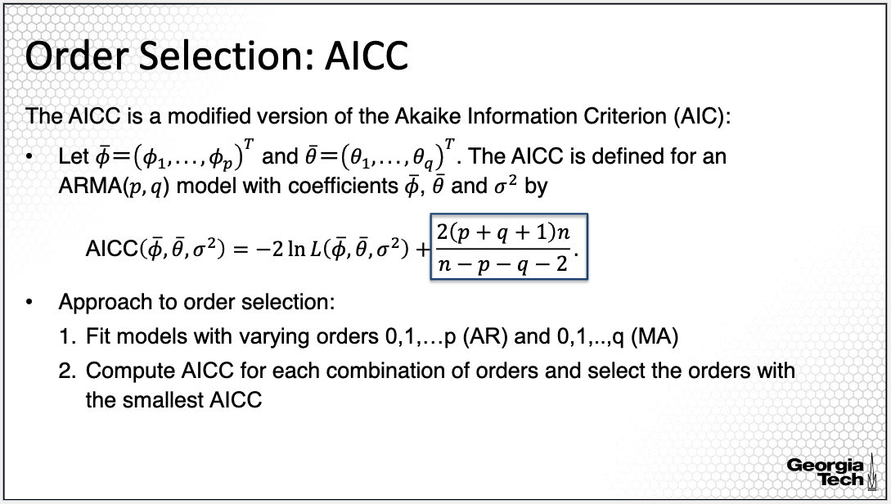

One approach uses a modified version of the Akaike Information Criterion, AIC. In the regression analysis online course, you will find an entire lecture on model selection. The AIC approach is one of the most common criteria for selecting among multiple models. The procedure is to fit multiple models and then compute the AIC value for each fitted model; then select the model with the smallest AIC value. This procedure also applies to order selection for orders in ARMA modeling, since AIC is a likelihood-based criterion.

For ARMA models, the complexity penalty is different from the penalty commonly used for the classic AIC approach. This modification of the AIC complexity criterion has been shown to improve on the order selection over the classic penalty. Please note that there are other criteria that can be used to select the ARMA orders, most of them being different in the specification of the penalty. For example, another criterion is the so-called Bayesian Information Criterion or BIC.

The approach to order selection is as follows. Fit ARMA models with varying AR orders 0, 1, up to p, and varying MA orders 0, 1, up to q. Compute the AICC for each combination of orders, and select the orders with the smallest AICC value. If the maximum orders p and q are large, this can be quite computationally expensive. However, generally, we work with small order ARMA models. While there are some other empirical approaches such as the so-called Extended AutoCorrelation Function, I recommend using this more computationally expensive approach to select the order of ARMA models.

**Residual Analysis**

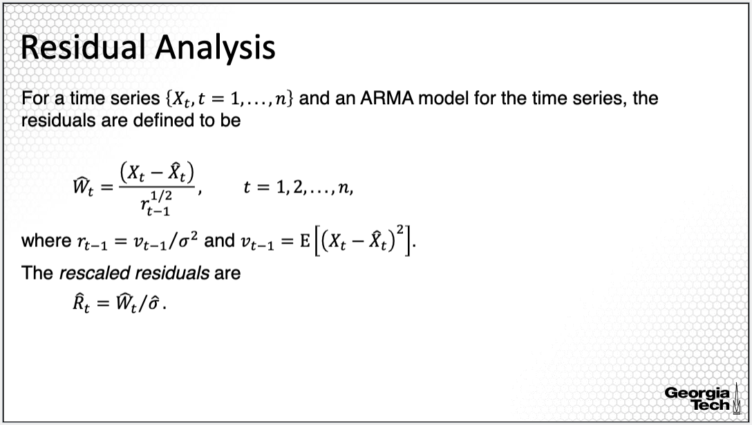

In order to assess the goodness of fit of an ARMA model, we can assess the model's assumptions using the model residuals in a similar manner as for linear regression models. Because the variance of the residuals is not constant over time, it is important to standardize the residuals. Moreover, it may be useful to rescale the residuals to identify outliers.

**Residual Analysis (cont’d)**

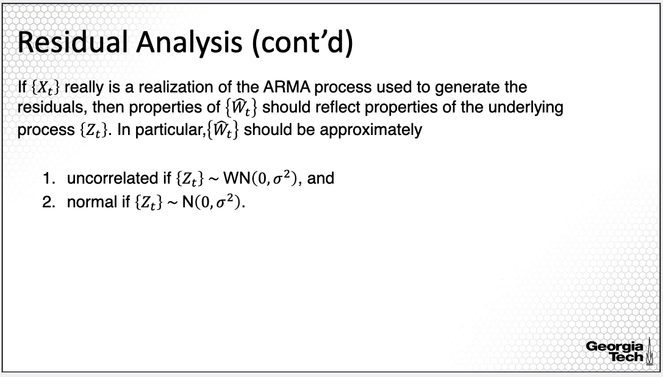

How can we use the residuals to assess goodness of fit for an ARMA model. The properties of the residuals should reflect the properties of the underlying process Zt. In particular, the residuals should be approximately uncorrelated if Zt is white noise, or normal if Zt is normal. Note that you will have to first understand the assumptions of the model you are fitting then evaluate the assumptions using the model residuals.

**Diagnostics: Uncorrelated Residuals**

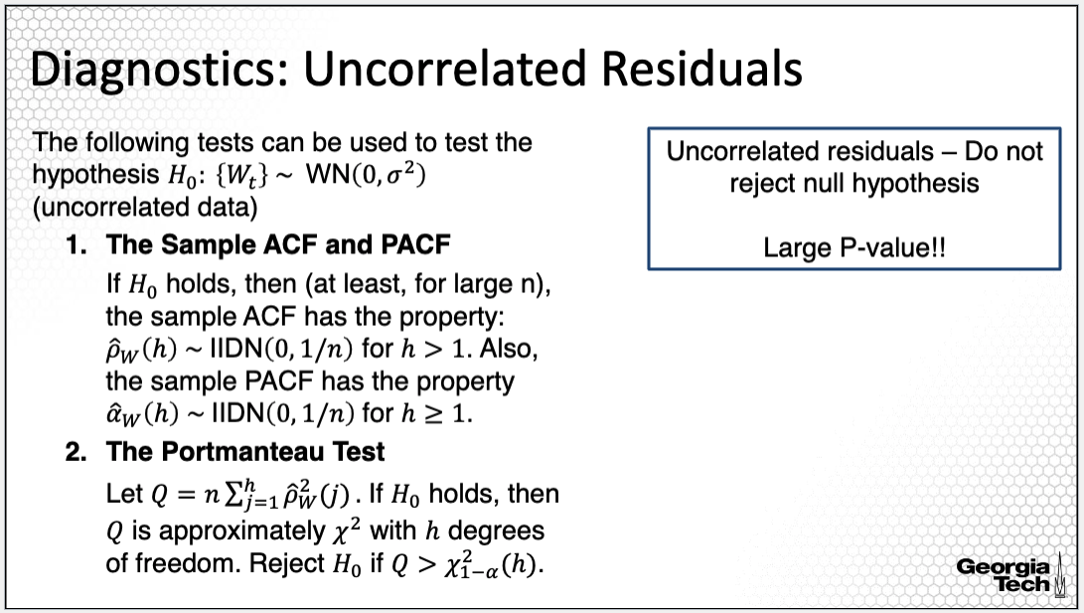

For example, an assumption in ARMA modeling is that Z_t is white noise hence the variables in the Z_t process are assumed uncorrelated. If we want to establish whether the residuals are uncorrelated, implying that Z_t are uncorrelated, then we can use the sample ACF and PACF plots along with hypothesis testing procedures.

One hypothesis testing procedure is the Portmanteau test. The null hypothesis in this test is that the input data are uncorrelated; when applying this test in residual analysis, the input data would be the residuals hence the null hypothesis is that the residuals are uncorrelated. For the Portmanteau test, the test statistic is the sum of squared sample ACF values up to lag h hence the test can be applied with different lag values. Generally, we apply the test for multiple lag values to evaluate uncorrelated data within different lags. Assuming uncorrelated data, the test statistic follows a chi-square distribution. If the test value is large, larger than the quantile of the chi-square distribution, then we reject the null hypothesis.

We seek not to reject the null hypothesis for a good model fit. We can also compute the p-value of the test; if the p-value is small, then we reject the null hypothesis of uncorrelated data, thus conclude that the model is not a good fit since the residuals are correlated. If the p-value is large, then we conclude that it is plausible that the residuals not to be correlated, thus plausibly a good model fit. Thus you need to recall that for such tests, we seek large p-values for good fit!

**Diagnostics: Uncorrelated Residuals (cont’d)**

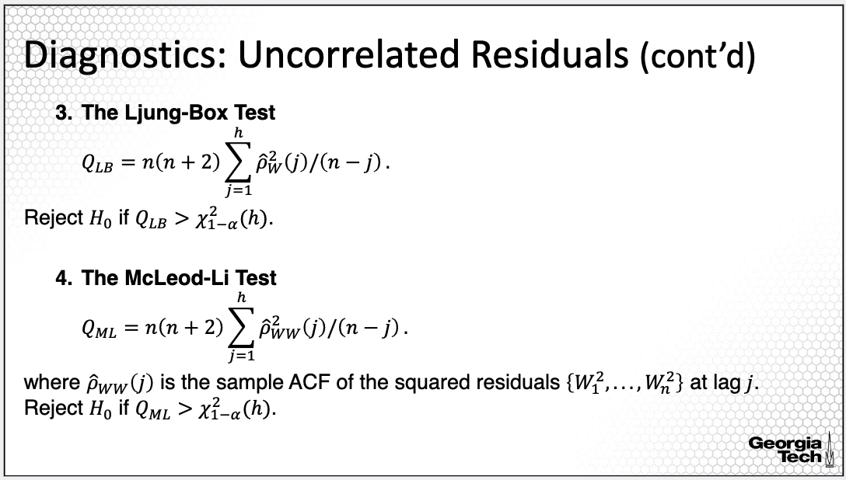

Two other tests commonly used to test for uncorrelated data are the Ljung-Box test, which is a slight variation of the Portmanteau test, and the McLeod-Li test, which is based on the sample autocorrelation of the squared residuals. A similar inference approach would be applied when using these other two tests. The null hypothesis remains the same, specifically that the residuals are uncorrelated. Similarly, we seek large p-values, an indication of plausibly a good model fit.

**Diagnostics: Normality Assumption**

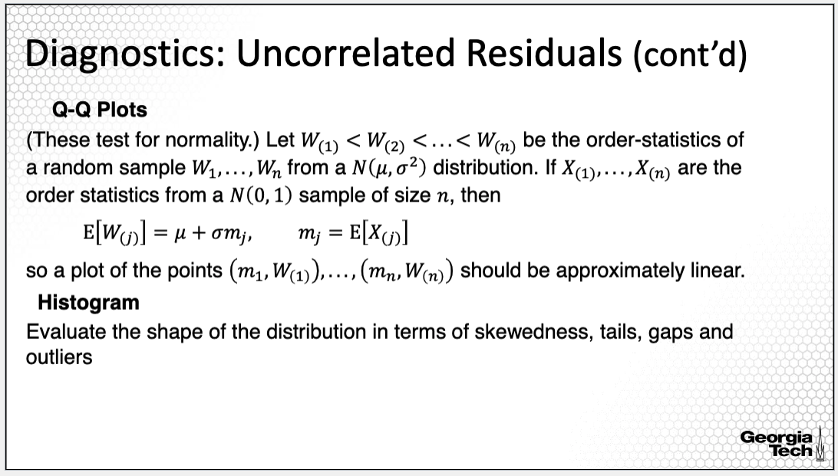

In order to evaluate the goodness of fit with respect to a distribution, for example the normal distribution, we can use the quantile-quantile plot, which contrasts the quantiles of the distribution, for example, normal, versus the quantile of the process of interest, in this case, of the residuals. I recommend accompanying the Q-Q plot with a histogram of the residuals for a more detailed assessment of the distribution of the residuals.

**Diagnostics: Normality Assumption (cont’d)**

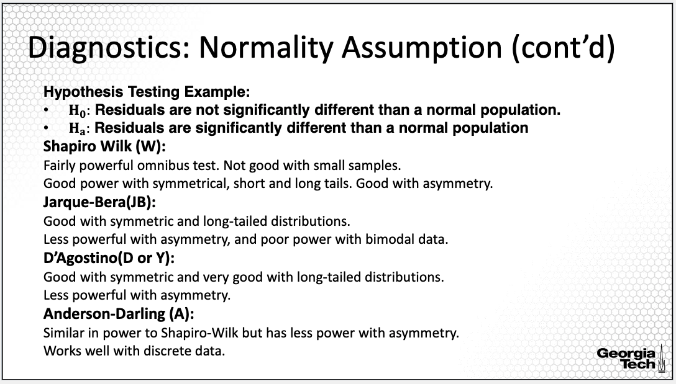

There are also many hypothesis testing procedures that could be used to test for normality for example, with the null hypothesis being that the residuals are not significantly different from normally distributed data. As shown on the slide there are many different testing procedure, which perform better or worse depending on the data characteristics.

For example, a classic, widely used test is Shapiro-Wilks test; however, it is known that this test does not work well with small sample size data. The Jarque-Bera test performs well when trying to distinguish between heavy tailed distributions vs normal distributions but it does not do well with skewed data. This slide provides two other tests. The four tests provided here are not the only normality tests! There are others although those four are most commonly employed in residual analysis. We will illustrate such testing procedures in other lessons in this course.

**Outliers**

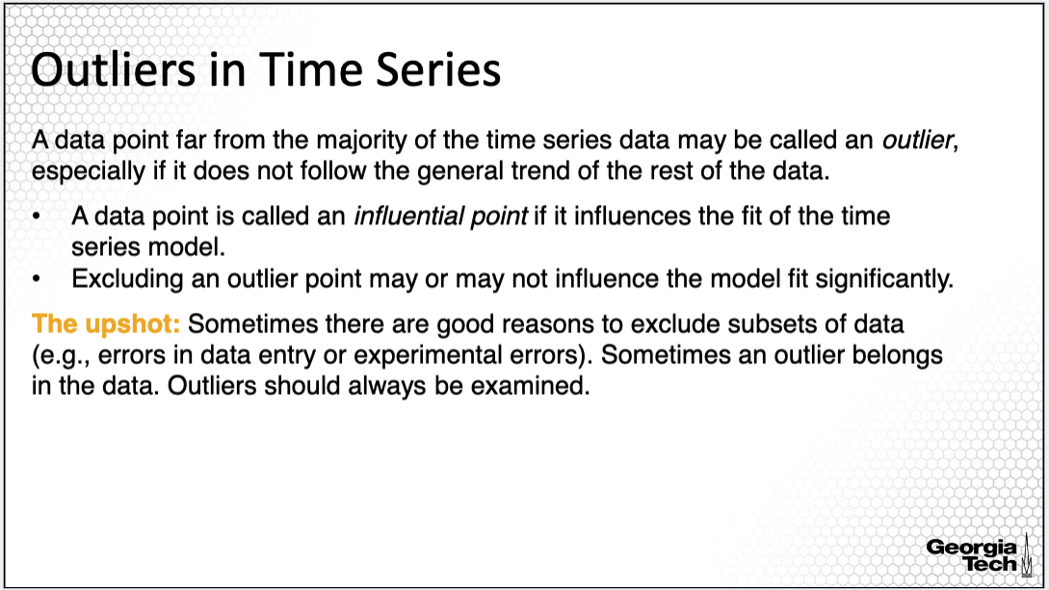

An important aspect in time series modeling is the presence of outliers, which are data points far from the majority of the time series data. An outlying data point that is far from the time series data is called **influential point** if it influences the model fit significantly. They can change the value of the estimated parameters, the statistical significance, the magnitude of the estimated parameters, or even the sign. It is important to note that an outlier may or may not impact the model fit significantly, thus it may or may not be an influential point.

It is tempting to just discard outliers. But sometimes the outliers belong to the data. Other times, there are good reasons for excluding subsets of points when there are errors in a data entry or in the experiment. When outliers belong in the data, you will have to perform the statistical analysis with and without the outliers and inform the reader about how an outlier influences the regression fit.

**Transformations**

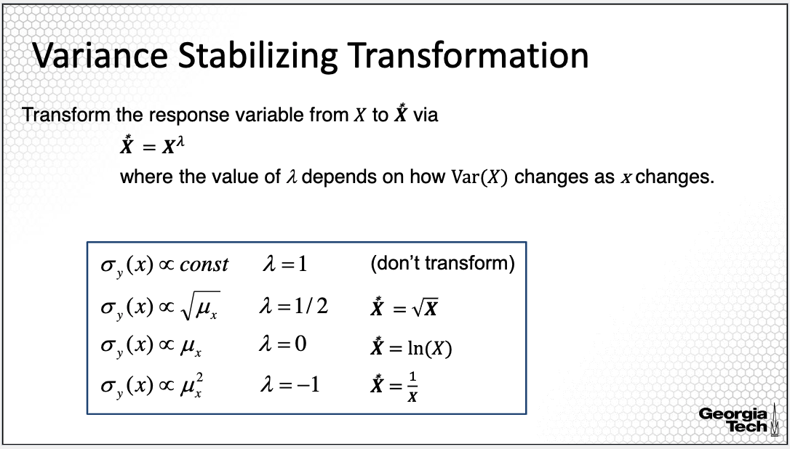

Often, we use a transformation for variance-stabilization since the variance may vary with time. This is particularly the case when a time series is observed over a long period of time, for example, 50+ years. A common transformation is a power transformation of y. If for example, the power lambda is equal to 1, we do not transform. If lambda is equal to 0, we actually use the normal logarithmic transformation, which is used in transforming financial indicators. If lambda is equal to -1 use the inverse of y, this is called the Box-Cox Transformation. After transforming Y, you will need to fit the model again and evaluate the residuals for departures from assumptions. If the transformation did not address these departures from assumptions, you will need to consider other transformations.

**Summary:** In summary, in this lesson, I introduced the classic approach for order selection and how to perform residual analysis in ARMA modeling.

## 2.2.5(10) ARMA Modeling: Data Example

In this lesson, I will illustrate ARMA estimation and order selection with a data example.

**Emergency Department Care**



In this lesson, I will return to the emergency care data example used to illustrate basic time series modeling. In this example time series models can be used to forecast future ED patient volume to provide forecasts for proactive bed and staff management, and for facilitating patient flow.

**Case Study Overview**

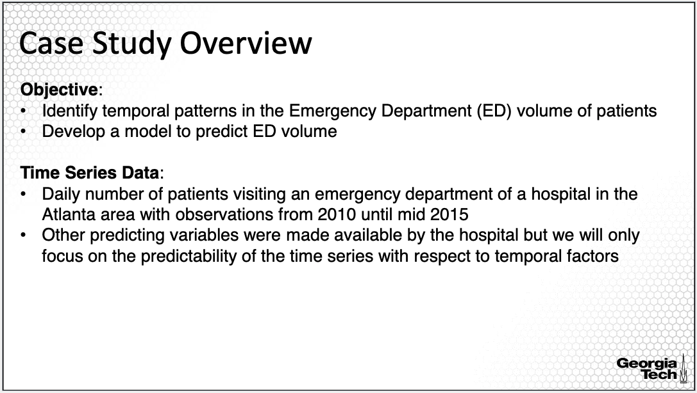

A number of factors can influence daily ED visits; the patient’s visits forecasting model should include those factors. Previous studies have shown that ED visits present cyclical variations according to calendar variables such as day of the week, time of the year, and the occurrence of public holidays. The objective ofthis analysis is to develop models for identifyingtemporal patterns, and for predicting the volume of patients in an emergency department.

The data consist of daily number of patients seeking ED care in a hospital in Georgia, in the United States. The ED volume was observed over a period of more than five years from 2010 until about mid 2015. In this study we'll consider temporal factors, although other factors can be used, for example external factors such as temperature, rainfall, major holidays, school season among others.

**Model Trend and Seasonality**

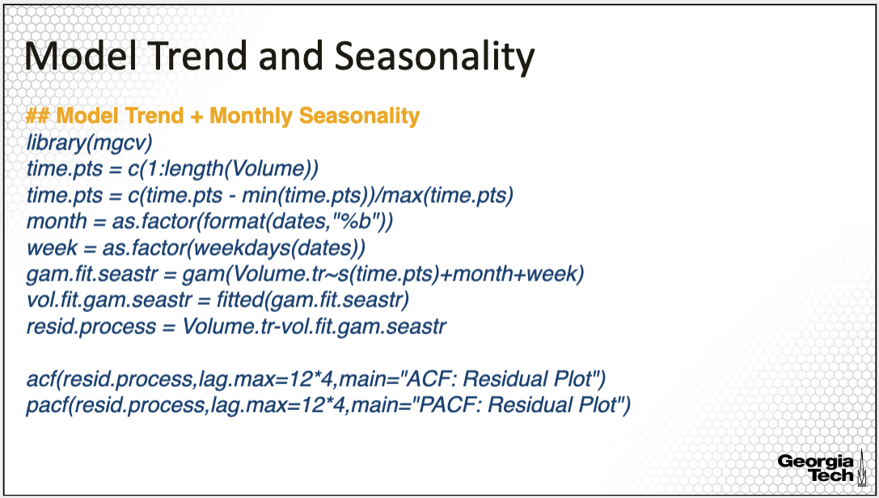

In the previous module, I illustrated how to estimate the trend and seasonality for this particular data example. Note that we applied the modeling of the time series on the transformed time series since the observations in the time series are counts, and thus with a Poisson distribution, potentially indicating non constant variance over time.

The model I selected here to use for removing the trend and seasonality is the model using the non-parametric trend estimation using spline smoothing, along with modelling monthly, and weekly seasonality. Specifically, I'm using the gam() R command available in the mgcv library to fit the trend and seasonality. For this, I defined the vector of equally spaced time points along with qualitative variables specifying the month, and day of the week for each observation to be all integrated into the estimation of the trend and seasonality, simultaneously using the gam function.

Last, we take the difference between the transformed ED volume counts, and the estimated trend and seasonality to obtain the residual process to be further analyzed using the ARMA modeling. Note that here, we estimate the trend and seasonality in order to reduce the time series to a stationary process. We want to subtract/eliminate the trend and seasonality, and we'll analyze the residual process using the ARMA modeling. Let's take a closer look at the ACF and PACF plots to assess stationarity.

**Model Trend and Seasonality**

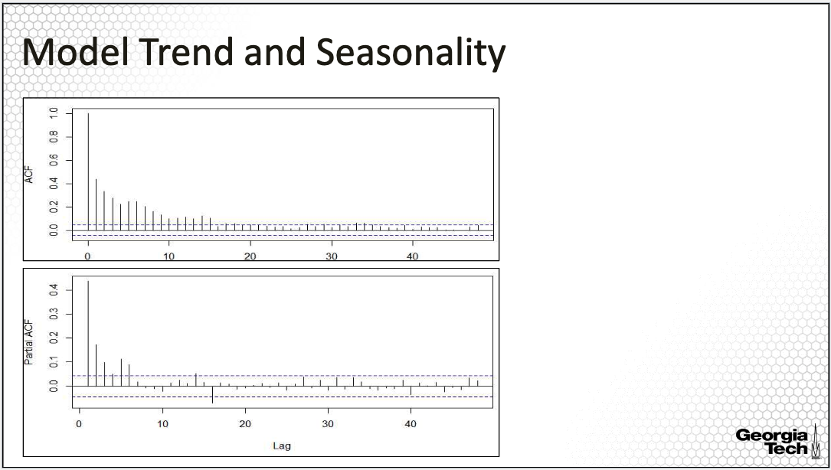

The ACF is displayed on the upper plot, and PACF is displayed on the lower plot. For both, we see that a relatively small number of lags have a large number of ACF and PACF values, indicating that the trend has been removed. For evaluating the performance of the model after removing the seasonality, we need to plot the sample ACF for a larger number of lags to capture two or more seasonality periods. The ACF and PACF are thus plotted over more than 40 lags.

**Fitting an AR process**

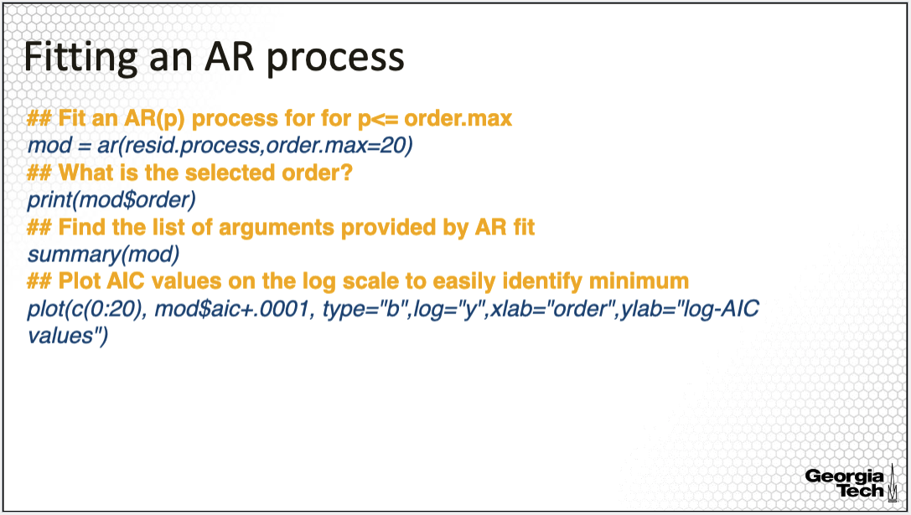

Next we'll fit an AR model only. The R function is AR with an input consisting of the time series, the residual process for this example, and the maximum order for which to fit the AR model. Here the maximum order is set to 20. In order to display the output for this model fit, you can use the summary command to get the order selected for the best fit according to AIC, the value is mod$order, and it is equal to six for this model. I also plotted the AIC values, but on the log scale, to better see where the minimum of AIC is reached.

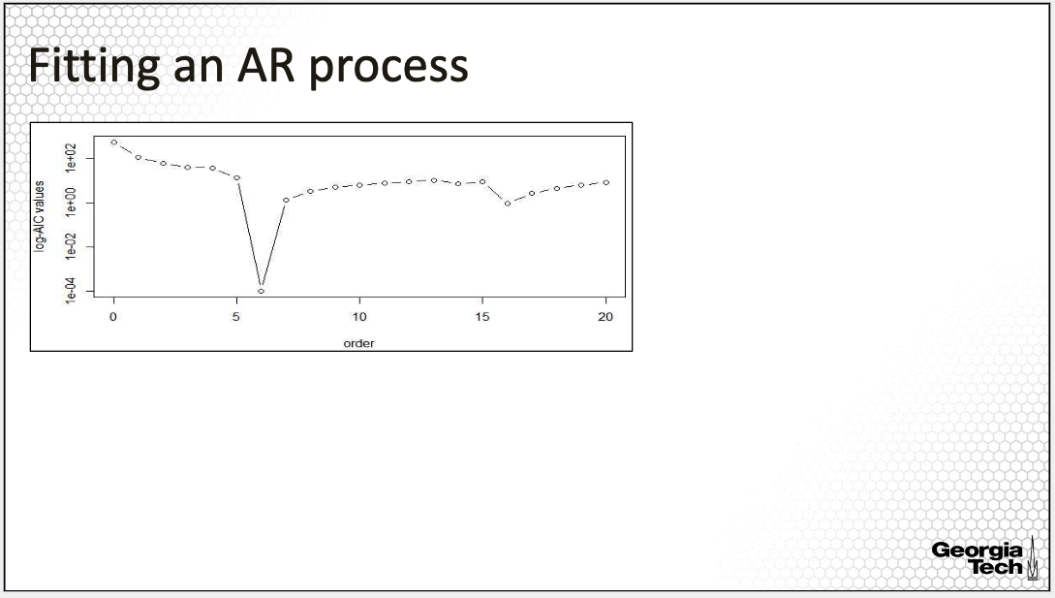

The AIC plot is here. Again, the selected order is six, as also shown by this graph. This AIC value is minimum at this order.

**Fitted AR process: Properties**

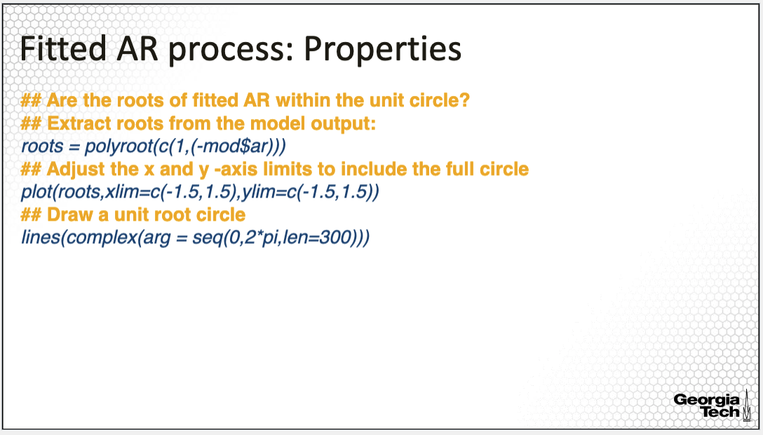

Let's consider the property of stationarity, and whether the fitted model is a causal process. For that, we need to extract the roots of the AR polynomial, and check whether they are not on the unit circle, indicating stationarity, and whether the roots are all outside of the unit circle indicating a causal process. To get the roots, we can use the R command polyroot along with the AR coefficients in the reversed order since polyroot begins with the coefficients of higher order. We also need to add the coefficient one for the constant. Using the plot and lines commands provided on the slide, we can point where the points of the roots are on the xy graph, along with the line of the unit root circle for comparison.

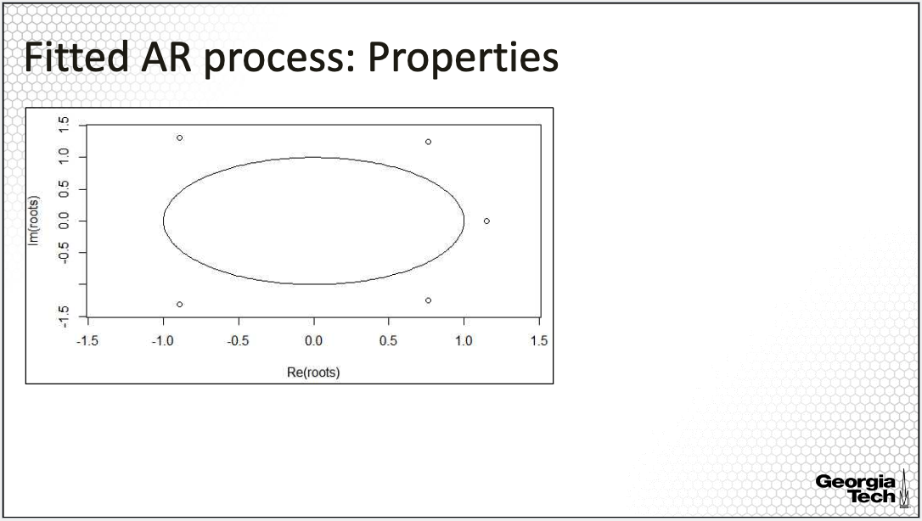

From the resulting plot, all the roots of the AR polynomial are not on the unit circle, thus the fitted AR process is stationary. Moreover, all the roots are outside the unit circle, thus the process is causal.

**Fitted AR process: Residual Analysis**

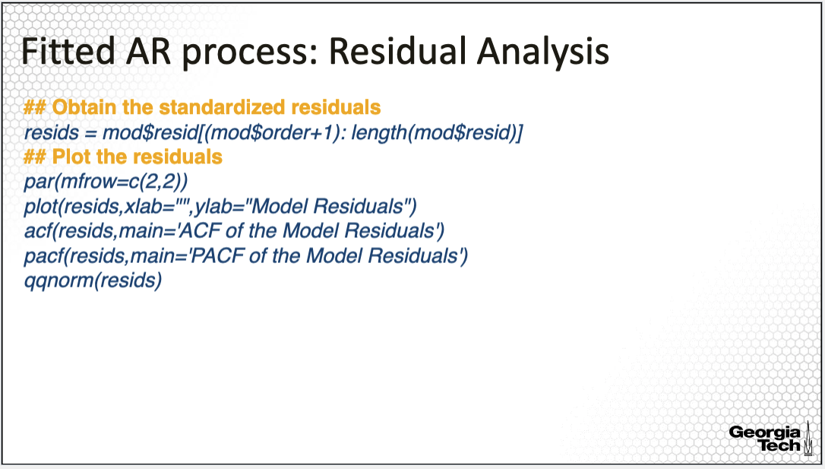

Further we can evaluate the residuals for stationarity, and other properties. For this, we extract the residuals from the fitted model, and then plot the residuals, the acf, and the pacf of the model residuals, and the quantile-quantile normality plot.

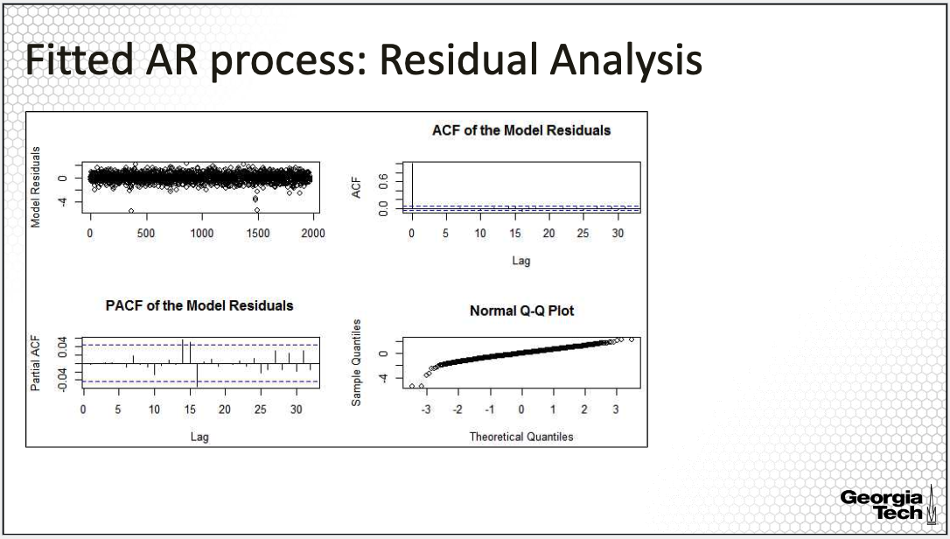

The plots are on the slide. The residual plot shown in the first figure does not show a pattern in the variability over time. The ACF plot has only the first lag equal to one, where all other values of the lags are small within the confidence band. The same for the sample PACF; most values are within the confidence band, with a few exceptions for which the sample partial autocorrelation is small close to the confidence bands. The Q-Q Norm Plot shows a tail on the left but overall seems approximately normal.

**Fit an ARMA Model**

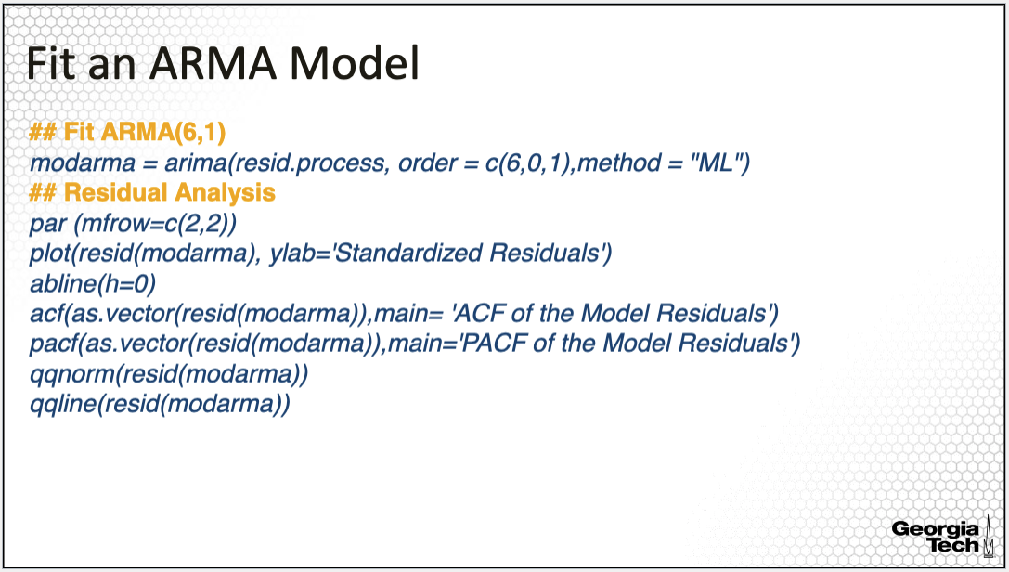

Finally, we’ll fit an ARMA model, not only an AR model. The R command for fitting an ARMA model is arima(), where we specify the time series, in this case the residual time series, after removing the trend and seasonality. We also need to specify the orders for the AR, and MA components of the model. For this fit, I'm using order 6 for AR, as specified by the best AR model fitted previously, and order 1 for the MA part. Last, we can specify the estimation method. If we specify ML, this means that we fit using maximum likelihood assuming normality.

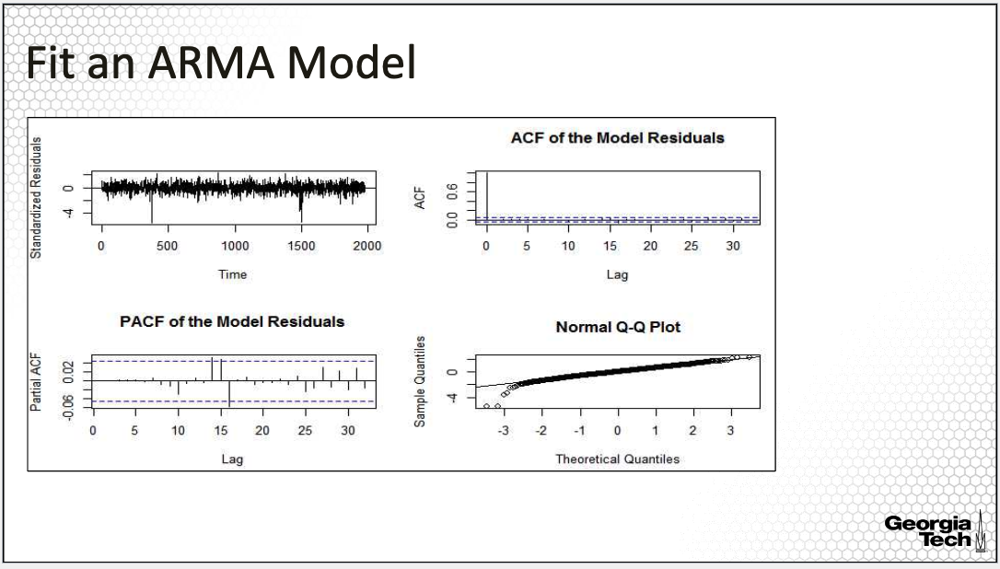

Last, let's look at the residual plots of this fitted model. The residual plot does not show to have a pattern. The variance of the residuals is also constant. The ACF plot has only the first lag equal to one where all others are small within the confidence bands of the sample ACF. The same for the sample PACF, the values are within the confidence band. The Q-Q norm plot shows a tail on the left. These are similar observations from fitting the AR model alone. And it's not surprising since we only added, an MA(1) part, to the AR(6) of the model.

**ARMA Model: Order Selection**

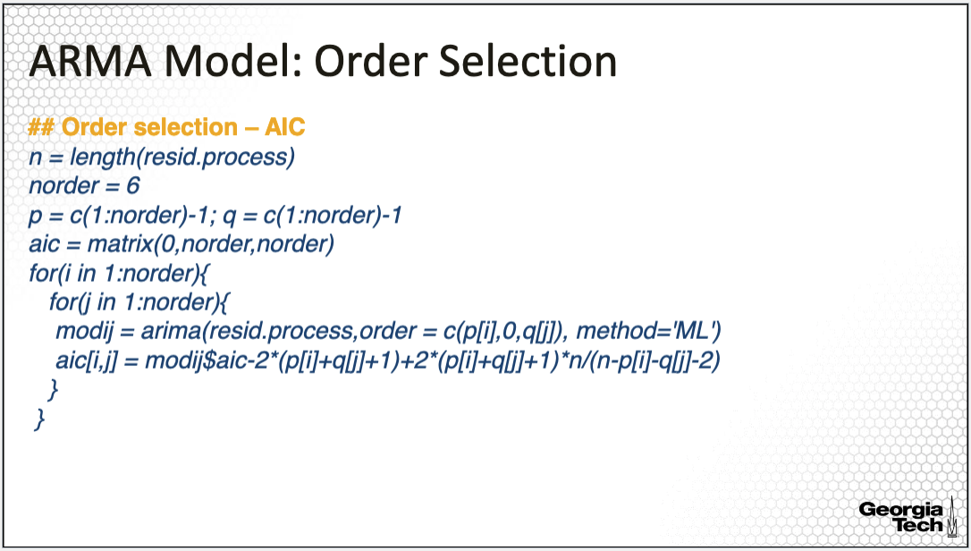

Note that the orders used in fitting the models in the previous slides are not necessarily better in terms of model fit than other orders. In fact, the question we'd like to address is, what are the orders that provide the best fit? We can apply the method discussed in the previous lesson. Specifically, we can select the orders using the minimum AIC approach. For this, we need to fit the ARMA model for all combinations of AR and MA orders, up to a maximum order for both orders p & q. Here, I set the maximum order to be 5, and consider orders from 0 to 5, for both the AR and MA components. Note that I specified here, norder is equal to 6 but because I start at 0, then we consider an order up to 5. I looped over all combinations of the orders, and fit the ARMA Model for each combination of orders, then save the AIC values in a matrix.

**ARMA Model: Order Selection (cont’d)**

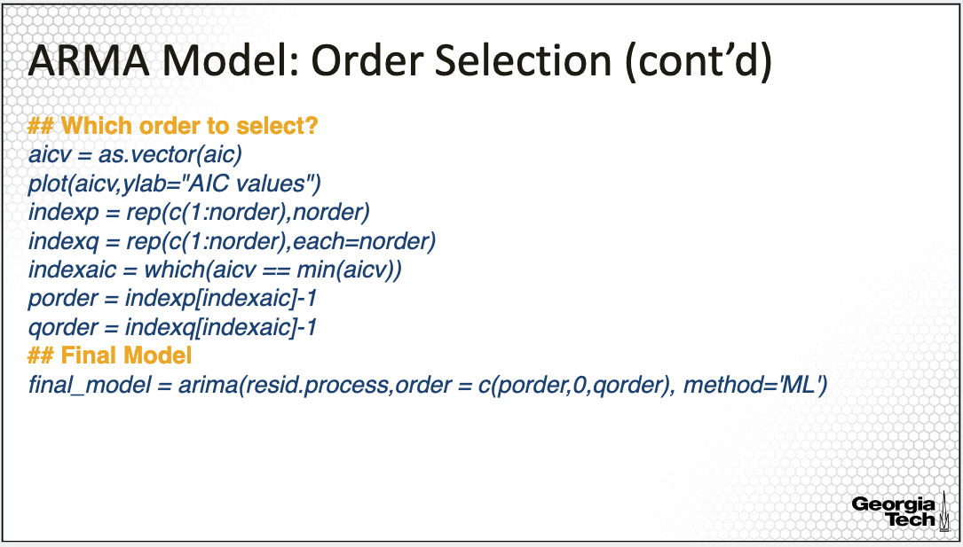

The R code provided here first labels each AIC value with its corresponding p and q orders, then the which() command finds the index in the vector of AIC values at the minimum, then extracts the p and q orders for this minimum. The selected orders are p equal to five, and q equal to five, the largest orders allowed. Last we fit the model for the selected orders called here the final model.

**ARMA Model: Residual Analysis**

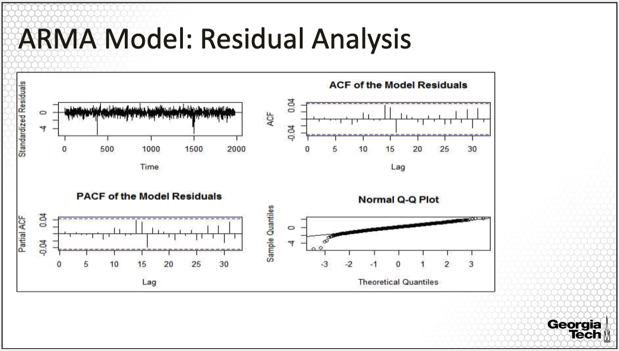

These are the residual plots for the ARMA(5,5) fitted. The residuals do not improve or change significantly from the smaller models AR(6) or ARMA(6,1). Less complex models, in other words, those with smaller AR and MA orders are preferred to avoid over-fitting, or to obtain better predictions.

**Testing for Uncorrelated Residuals**

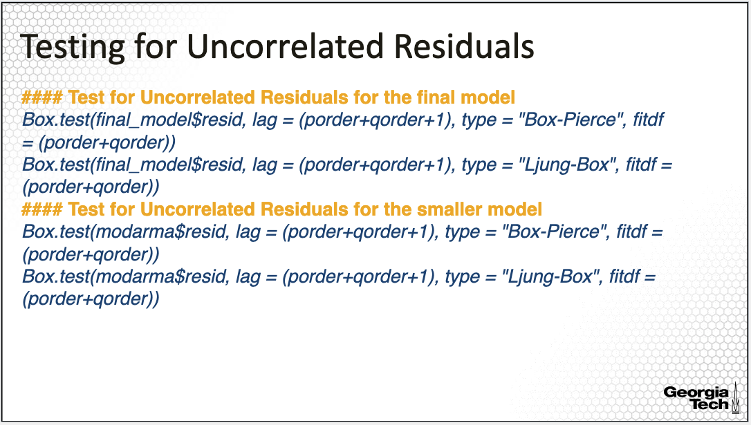

The R command used for testing for uncorrelated residuals is the Box.test with the specification of the time series to be tested whether uncorrelated, and the maximum lag to be used for the test statistic, here the maximum lag is the sum of the two orders plus one. We also can specify the type of the test. Here, I specified the Box-Pierce test in the first line and the Box-Ljung in the second line. Last, we also need to input the degrees of freedom of the fit, which is the sum of the number of orders. I applied these tests for both the ARMA(5,5) final model, as well for the smaller ARMA(6,1) model.

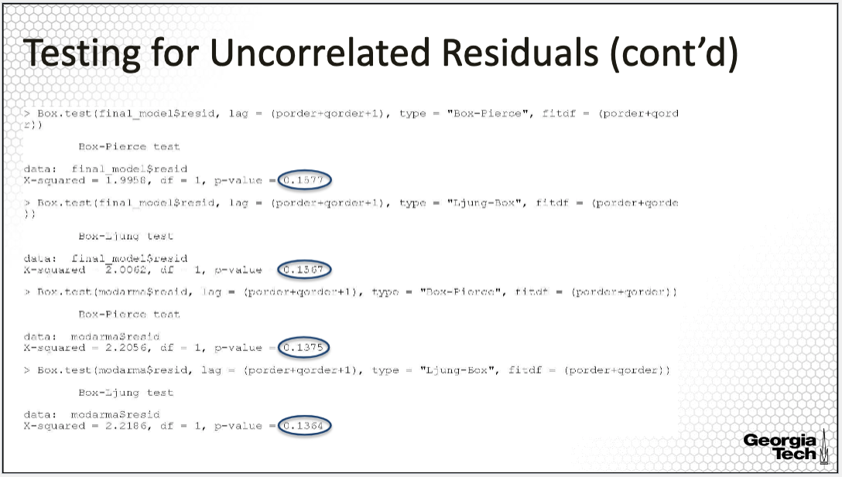

This is the output for this implementation with a summary of each of the tests.

The P values are all large, indicating that a null hypothesis of uncorrelated residuals is plausible. Thus, according to these tests, both models perform well in modeling the temporal correlation in the time series process since the residuals are uncorrelated.

**Summary:**

In summary, in this lesson, I illustrated ARMA modeling estimation and order selection with the data example analyzing the time series of the emergency department patient volume.

## 2.3: Other Models

### 2.3.1(11) Other ARMA Models

*In this lesson, I'll introduce extensions of ARMA models for non-stationary time series.*

**ARMA Model**

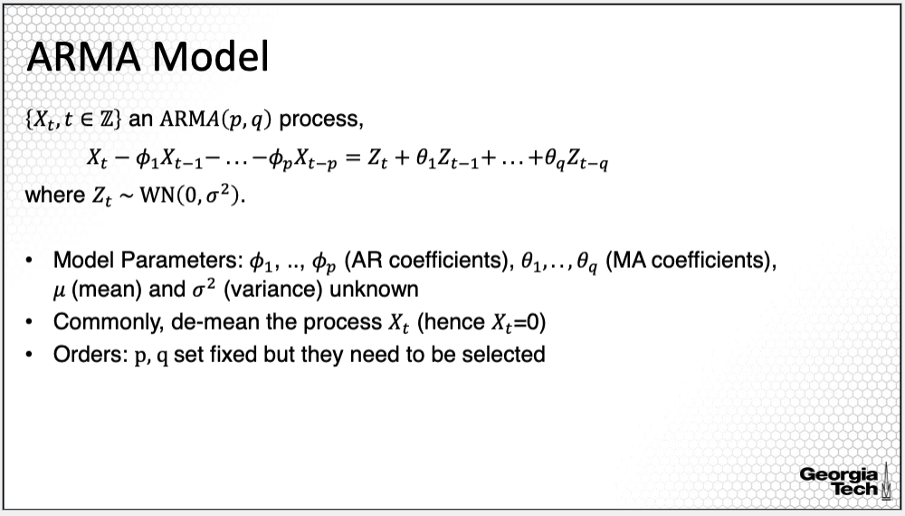

Let's return to the ARMA model. To review, the ARMA model consists of two components, joined AR and MA models. We'll expand this model further as I will provide in a next slide.

**ARIMA Model**

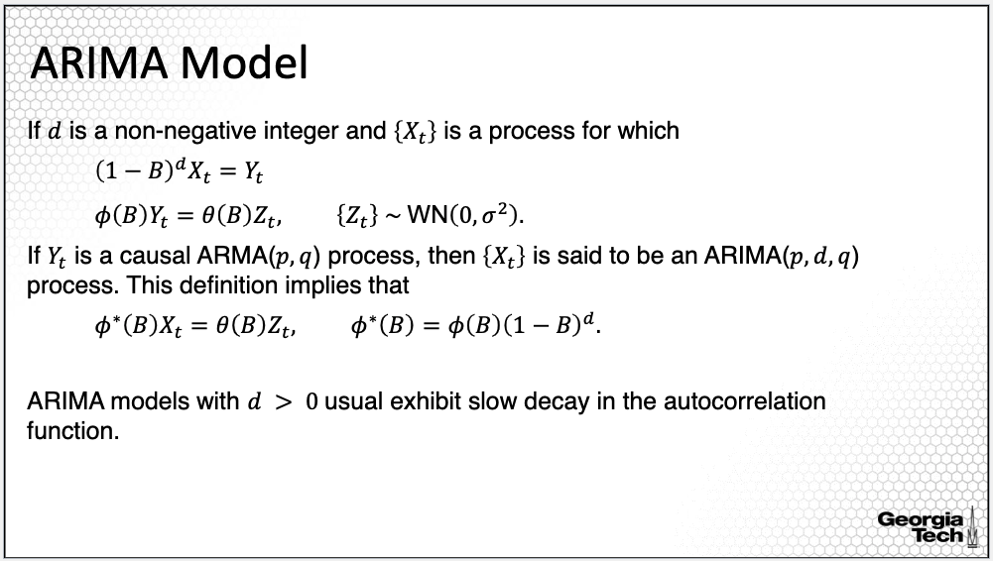

A generalization of the ARMA model is the auto regressive integrated moving average, or abbreviated ARIMA. The ARIMA model can be used to model non-stationary processes.

The non-stationarity is eliminated by a differencing step corresponding to the integrated part of the model. This ARIMA model can be used when there's trend in the time series. The trend can be eliminated through differencing. The differencing can be applied more than once until the resulting differenced time series is stationary.

How can we express this formally? Given a time series Xt we apply the differencing polynomial 1- B to the power of d where B again is backward operator; when this operator is applied to Xt, we move the index of Xt back one time unit giving Xt-1. The resulting process after differencing Xt denoted Yt is further modeled using an ARMA process. If the process Yt is a causal process then Xt is said to be an ARIMA process of orders p, d, q.

In the notation below, we can see that we can write the ARIMA process as an ARMA process. Specifically, if we multiply the AR polynomial, phi(B) with the differencing polynomial 1-B to the power of d, we obtain the polynomial phi*(B). Thus, the ARIMA model can be written using a similar structure as the ARMA process, except that the phi*(B) polynomial of ARIMA has d zeroes on the unit circle hence not stationary.

**Forecasting ARIMA Model**

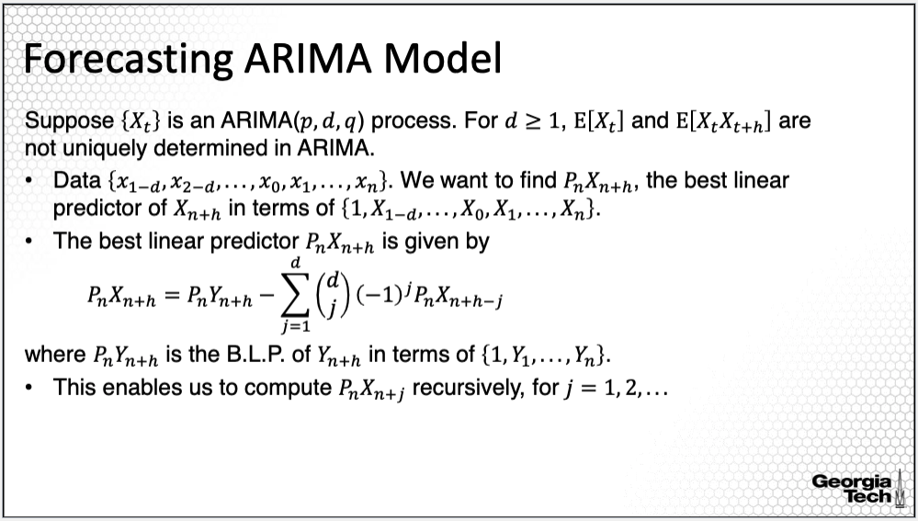

To recall from previous lessons, in order to obtain the best linear prediction for an ARMA process, we assume that the ARMA process is a causal process. For an ARIMA process, this assumption does not hold, and thus we cannot apply the prediction methodology for ARMA. Importantly, the expectation and the covariance of the ARIMA process are not uniquely determined.

In order to obtain the best linear predictor for Xn+h, given the past observations of the time series, we need to first obtain the best linear predictor for Yn+h of the Yt process defined on the previous slide; this is also the differenced process that is further modeled using a causal ARMA. The prediction formula for Xn+h is provided here. It is the difference between the base linear predictor of the Yn+h and the weighted sum of the predictions of the lower lag predictions, Xn+h-j. Thus, to obtain the prediction in lag h, we need to solve this recursively.

**Forecasting ARIMA Model (cont’d)**

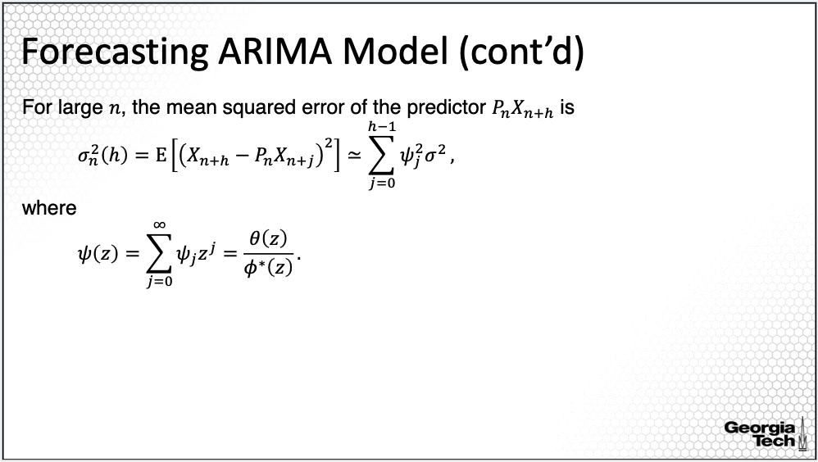

For this prediction of the ARIMA model, the variance can be estimated approximately as the sum of the squared coefficients psi times the variance of the white noise process Zt, where the coefficients psi are derived similarly to the coefficients of a causal process.

**Seasonal ARMA Models**

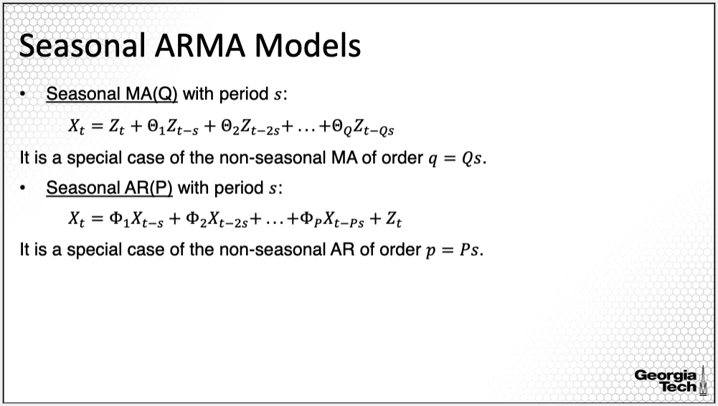

Another extension to the ARMA model is the seasonal ARMA, which can be used when there is seasonality. In order to model seasonal time series, we use different lags in the AR and MA components. For example, for the seasonal MA process of order capital Q, we do not use Zt-1, Zt-2 to Zt-Q lag, but we use Zt-s, Zt- 2s up to Zt- Qs, where s is the period. Similarly, for a seasonal AR process, we use the lags of Xt-s, Xt-2s, Xt-Ps. Combining this decomposition gives us the seasonal ARMA process.

**Seasonal ARMA Models (cont’d)**

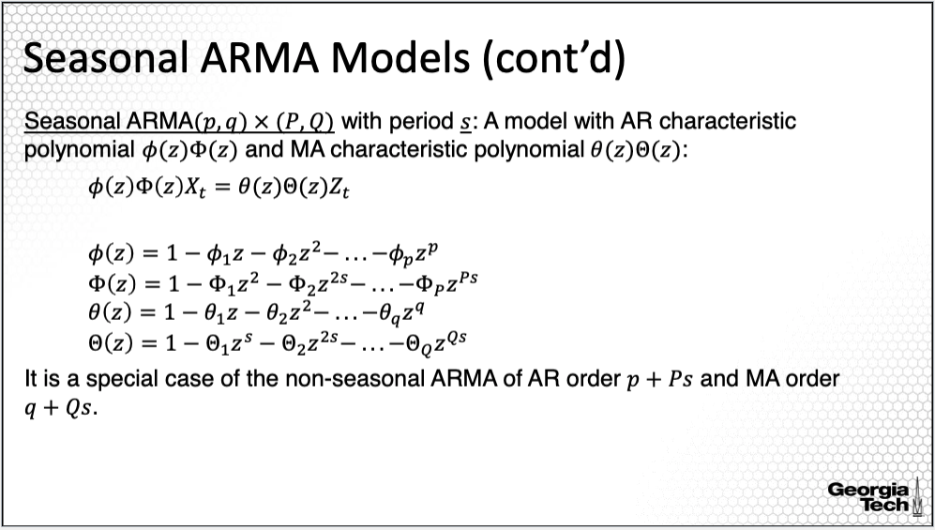

In this slide, I'm providing a more formal representation of the seasonal ARMA process. We have now four different orders for the seasonal ARMA: small p and small q for the stationary process along with capital P and capital Q, the orders used to model seasonality as in the previous slide. To express this in the model equations, we define the four polynomials as provided on this slide with the first two defining the autoregressive models and the second two defining the moving average models.

Using these four polynomials, we can express the AR characteristic polynomial consisting of the AR polynomial for the stationary process multiplied by the AR polynomial for modeling seasonality and similarly we can express the MA characteristic polynomial consisting of the MA polynomial for the stationary process multiplied by the MA polynomial for modeling seasonality. All in all, we can write the seasonal ARMA model using a similar representation as the ARMA model while this model representing a non-stationary process due to the seasonality.

**Seasonal ARIMA Models**

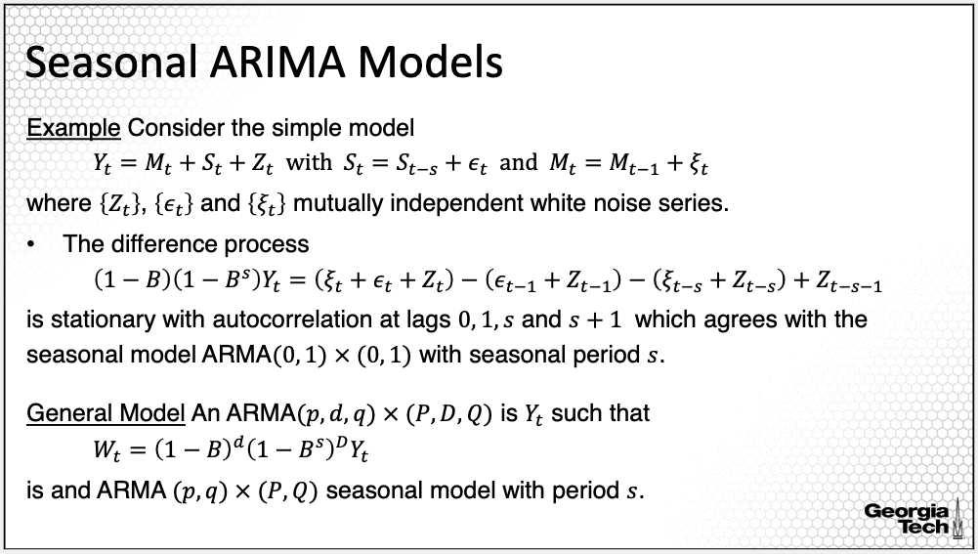

We can now combine the two models, ARIMA with seasonal ARMA to obtain the seasonal ARIMA. Let's take a closer look with one example. Consider the basic decomposition discussed in a previous lecture, that is decompose a time series into a trend component Mt, seasonality component St, and the residual process, Zt. Assume further a model for the trend and seasonality where the trend only depends on the previous lag, and the period of the seasonality is s.

If we apply the differencing 1- B for the trend, and 1- B to the power of s for seasonality, then the residual process is stationary with autocorrelation at lags lags 0, 1, s, and s+1, which agrees with the seasonal model ARMA (0,1) for the stationary component and (0,1) for the seasonal component with seasonal period s. This is one particular example of a seasonal ARIMA. More generally, we can consider 1-B to the power d differencing polynomial for the trend and 1-B to the power of s all to the power of capital D for seasonality. Because there are many orders to determine those of ARIMA P, D, Q, along with those of a seasonal ARIMA, capital P, capital D, capital Q, such a model is difficult to implement.

**Summary**

In summary, in this lesson I introduced two extensions of the ARMA model, the ARIMA model, which is an extension of the ARMA for a non-stationarity process due to the trend, and a seasonal ARMA, which is an extension for a non-stationarity process due to seasonality.

### 2.3.2(12) ARIMA Modeling: Data Example

In this lesson, I will illustrate ARMA Modeling for non-stationary processes with a data example.

**Emergency Department Care**  


I'll return to the Emergency Care data example used to illustrate basic time series modeling. In this example, time series modeling can be used to forecast future ED patient volume.

**Differencing Time Series**

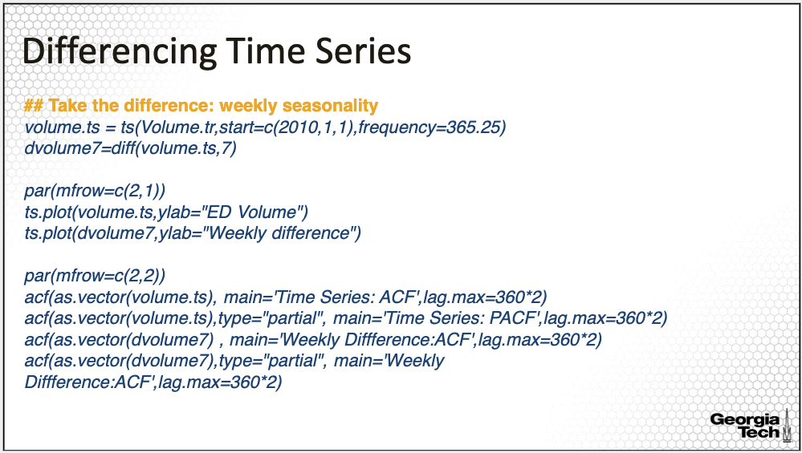

So far, we estimated the trend and seasonality of this time series and then subtracted the estimated trend and seasonality from the time series to obtain an approximately stationary process to be modeled with ARMA. In this lesson, we'll consider the differencing approach.

First, let's consider the differenced time series to account for seasonality. Note that we've identified both monthly and day of the week seasonality. For the day-of-the-week seasonality, we can difference with frequency equal to seven, which will apply the difference from consecutive Mondays, Tuesdays, and so on. Note that in order to apply the difference R command, I transformed the time series using the TS command with frequency equal to 365.25, indicating that this is daily data.

I am illustrating here only the differenced time series for weekly stationarity since it is a regular differencing as the data are observed daily. We next compare the time series plots for the original time series versus the difference time series plot along with their ACF plots. These are the time series plots.

**Time Series: Weekly Seasonality**

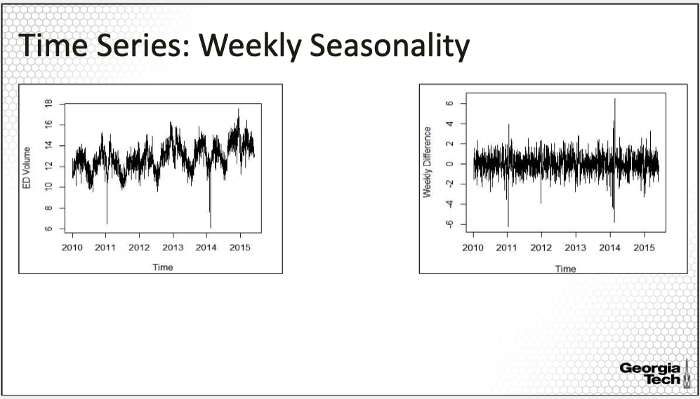

The plot of the first time series is for the transform ED volume. The second is for day of the week differencing. While we see clear periodic patterns in the original time series, the pattern is not evident in the time series plot of the differencing process.

**Differencing Time Series: ACF & PACF**

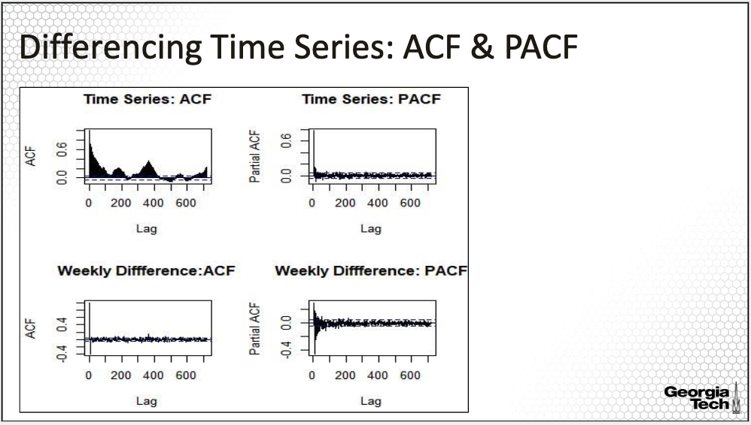

These are the ACF and PACF plots for the two time series. The upper plots are the plots for the original time series, whereas, the bottom ones are the plots for the differencing process. The ACF plot of the original time series clearly shows a periodic pattern while the PACF does not. The ACF plot for the weekly differencing shows an improvement in terms of removing the seasonality. The PACF plot looks similar to that for the original time series.

**Seasonal ARIMA Model Fit**

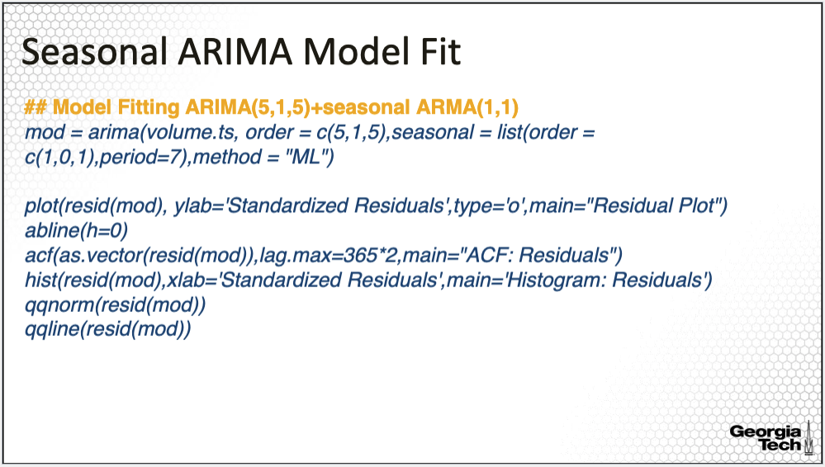

Next, I am fitting a seasonal ARIMA. Because we have both trend and seasonality, we need to fit an ARIMA to account for the trend and the seasonal ARMA to account for seasonality jointly. The R command is the same as for ARMA fit, specifically, the arima() command, except that now, we are fitting multiple orders both for the ARMA and for the seasonal ARMA.

The input orders for the ARMA model are p=5, d=1, and q=5, meaning that we have an AR order of 5, a differencing order equal to 1, and MA order equal to 5. We also use a seasonal order of (1,0,1) which means that we're fitting a seasonal ARMA with AR order equal to 1, and MA order equal to 1. Note that one limitation of the seasonal ARMA is that it only can model one type of seasonality. In this data example, we established both weekly and monthly seasonality and thus, it would be more appropriate to fit both types of seasonality.

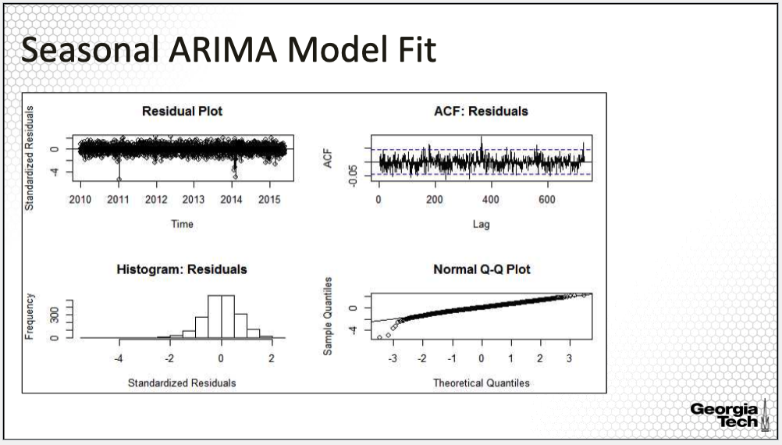

These are the residual plots. The first one displays standardized residuals vs time. From this plot, we identify a relatively constant variance over time. The upper plot on the right is the ACF plot of the residuals. Note that for this, I specify a large lag to identify any other potential seasonality. The residuals are all small, most of them within the confidence band, an indication that the residuals may be white noise, indicating that modeling the weekly seasonality may be sufficient. The bottom plots investigate the assumption of normality, which is assumed for the maximumlikelihood fit. The residuals do show skewness although it is not very severe.

**Forecasting with ARIMA**

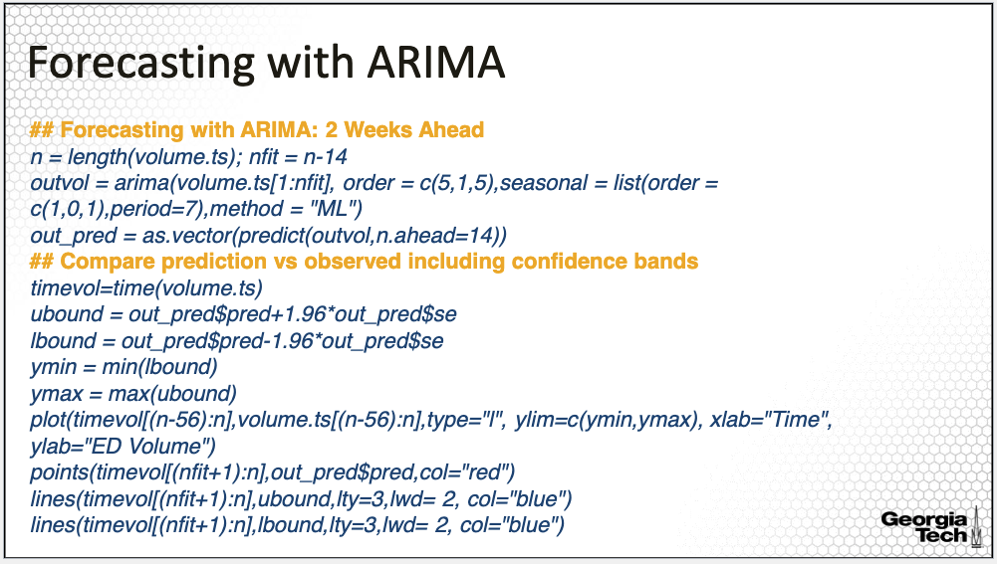

Last, let's see how we can forecast with ARIMA. For this forecasting exercise, I left out two weeks of the data, the last two weeks in the time series. Then I fitted the same ARIMA model as provided in the previous slide, but this time, to the time series without the last two weeks of data. Last, I applied the prediction command in R that allows us to predict given the fitted model as input and given the number of lags ahead to obtain the prediction, in this case, two weeks.

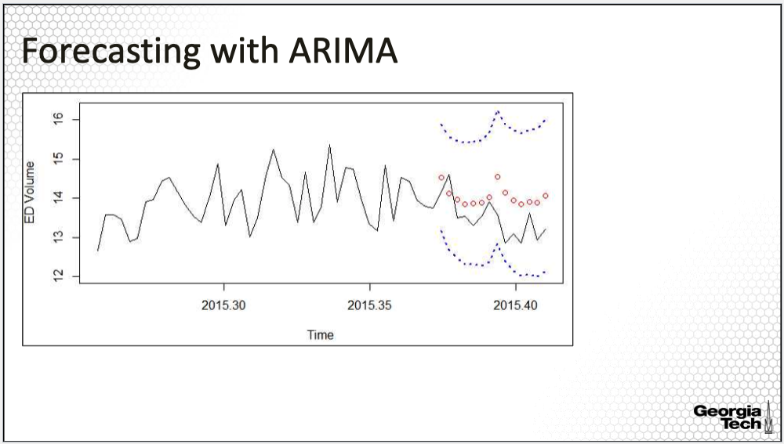

We next compare the predictions for the two weeks with the observed time series. We first form the confidence band of the prediction with the upper band provided by ubound and the lower band provided by lbound. Then we plot the time series data. We do not plot the entire history of the time series but only the last four weeks of data. We overlay the predicted values in red along with the confidence band in blue.

The corresponding plot is here. The black line is the observed time series, the red points are the predicted values, along with the confidence band in blue. All the observed values are within the confidence band. The predicted values are somewhere close to the observed values, except that they do not capture the volatility in the observed time series.

**Summary**:

In summary, in this lesson, I concluded the lesson on the concepts of ARMA modeling, with an illustrative example for fitting seasonal ARIMA.